many=dev,some-testers, one/two-ba,scrum master,product owner,client

agile can be done by using scrum and Kanban

scrum methodology:

client->product owner about objectives

large feature called as epics which will be broken to user stories

scrum master is facilitator

monitering

progress

daily stand up call

knowing any blockers

project owner

budget

time

scope

interact wit dev team

team size

GIT:

VCS-version control system

back up everthing we do

do create versions control(writing different versions what are all we created on different dates)(checks for conflict)

types of vcs:

centralized vcs:there will be on central server

distributed vcs:

there will be multiple backups for every one

branching and merging

git is a dvcs

features:

own account

open sources

dvcs

can handle small to lasrge prjects with speed and efficiency

protection or security

git is a technology git hub is a software

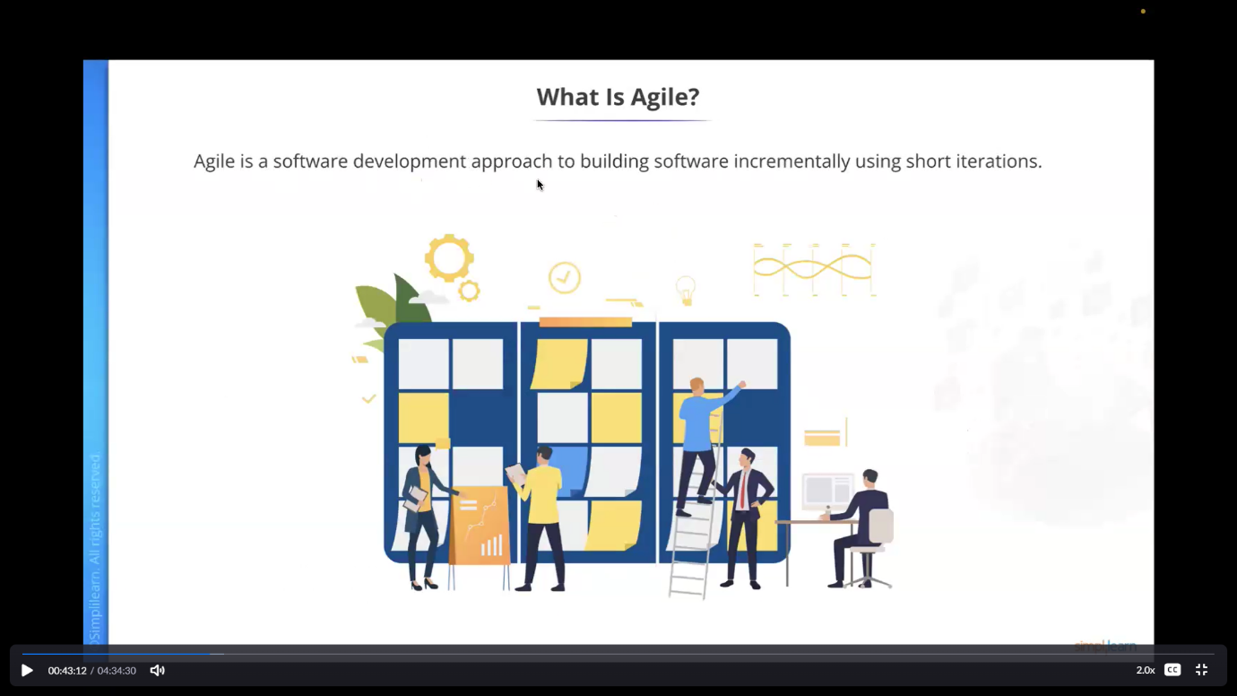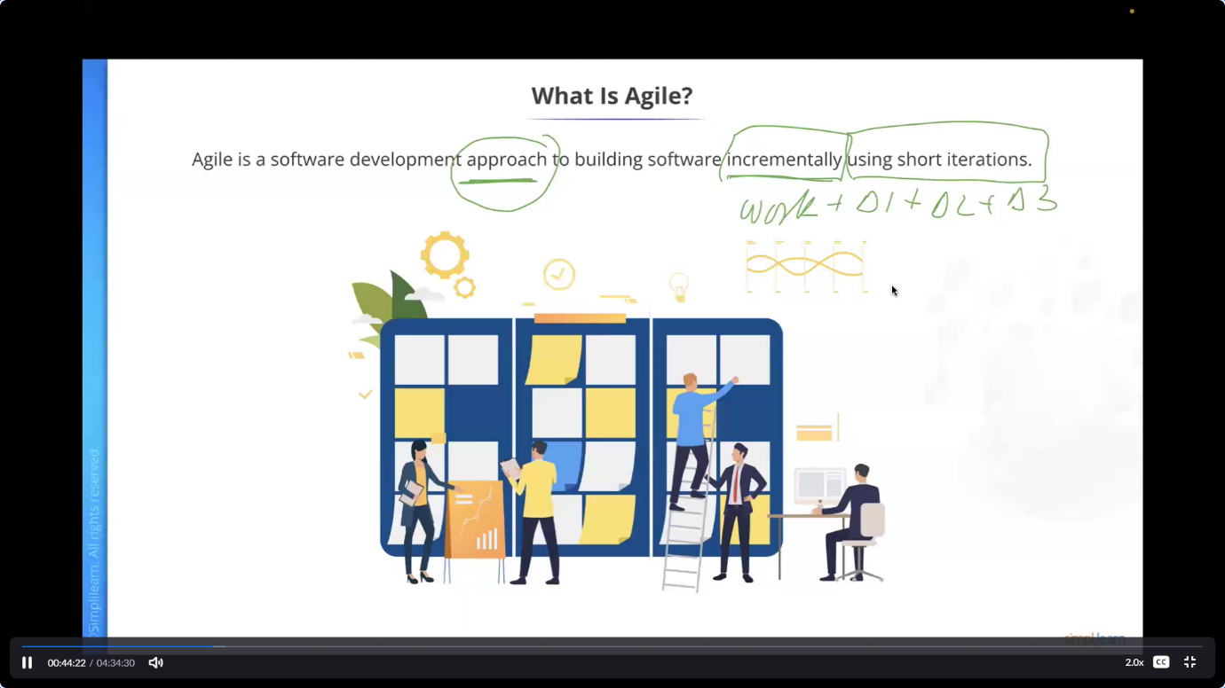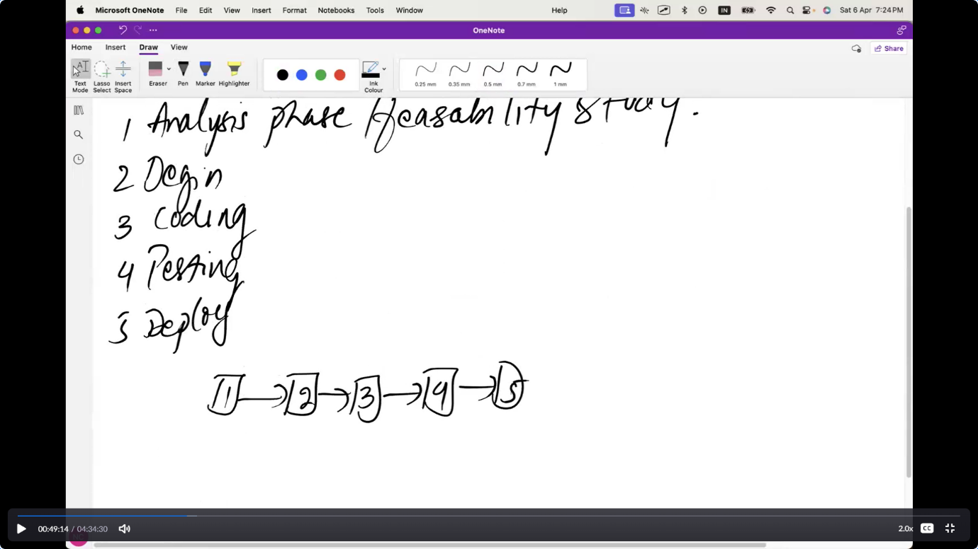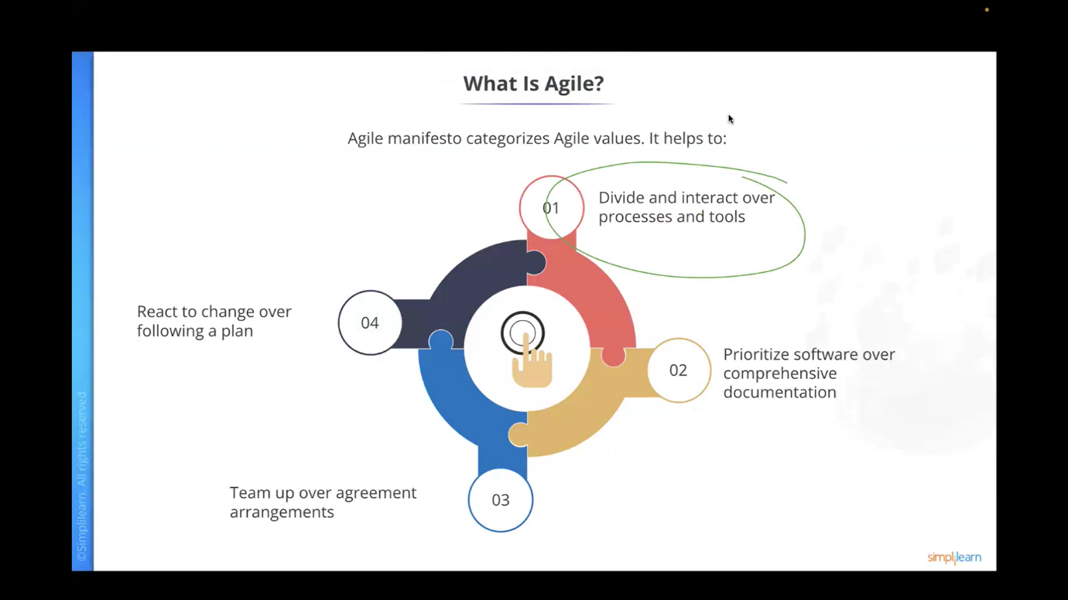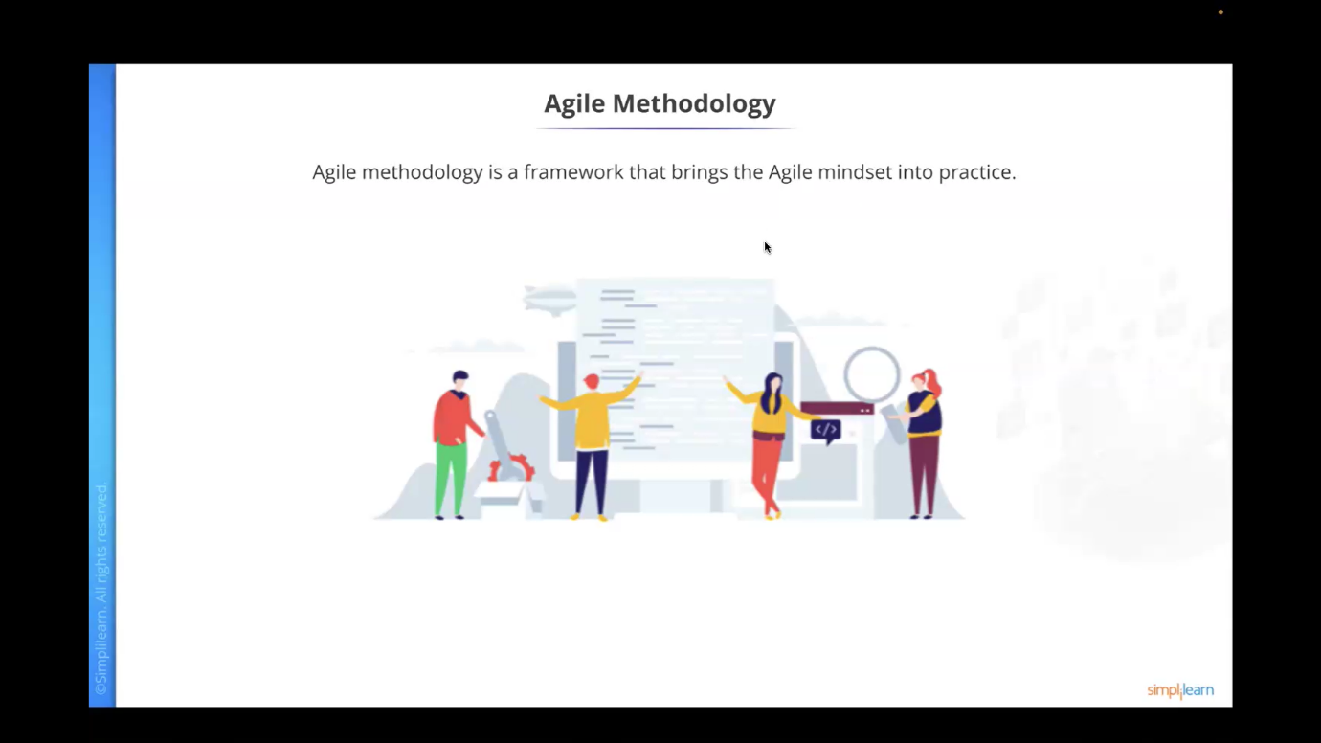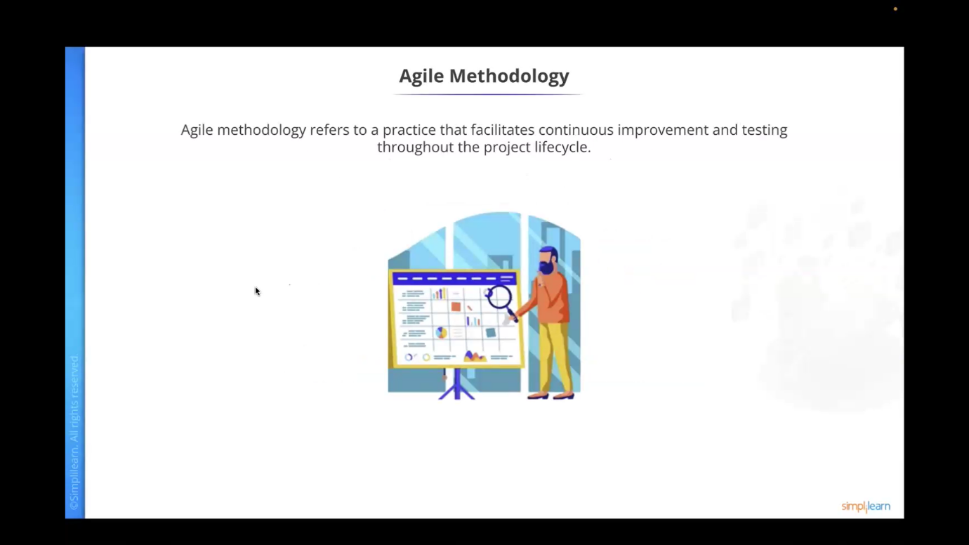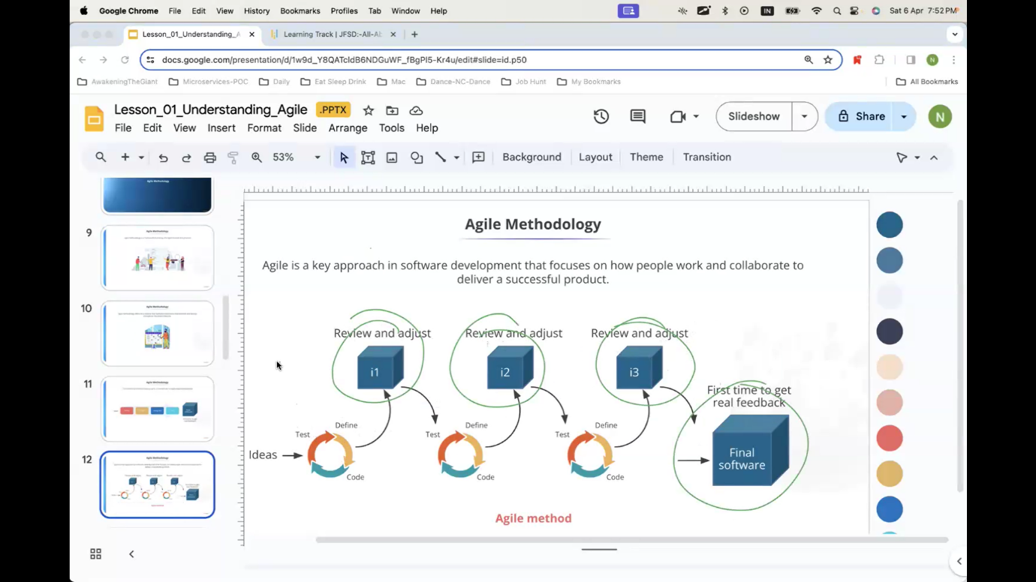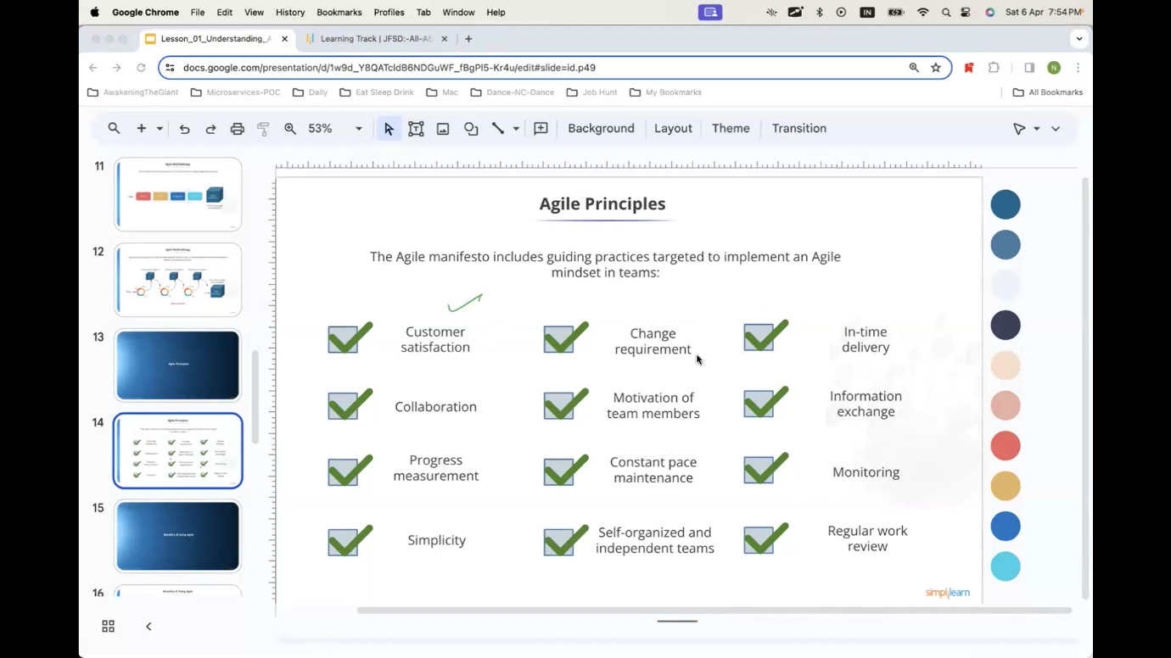

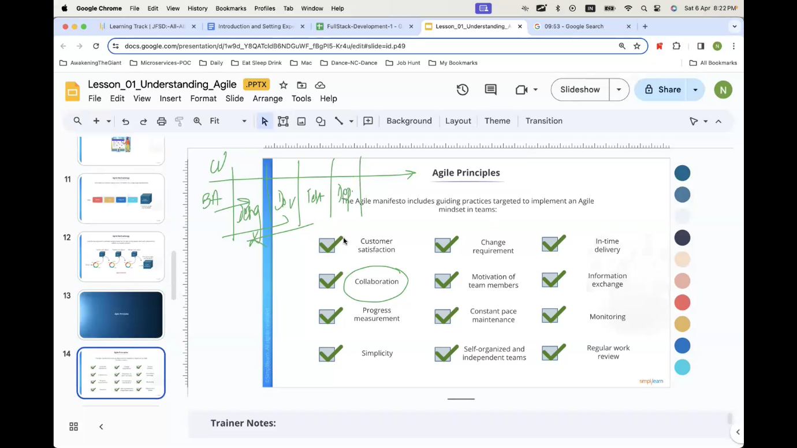

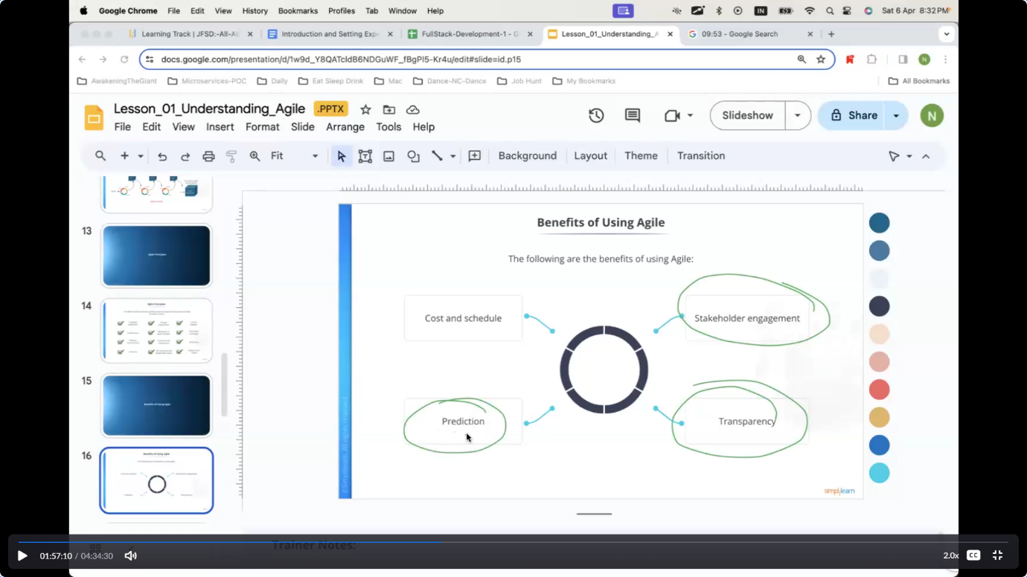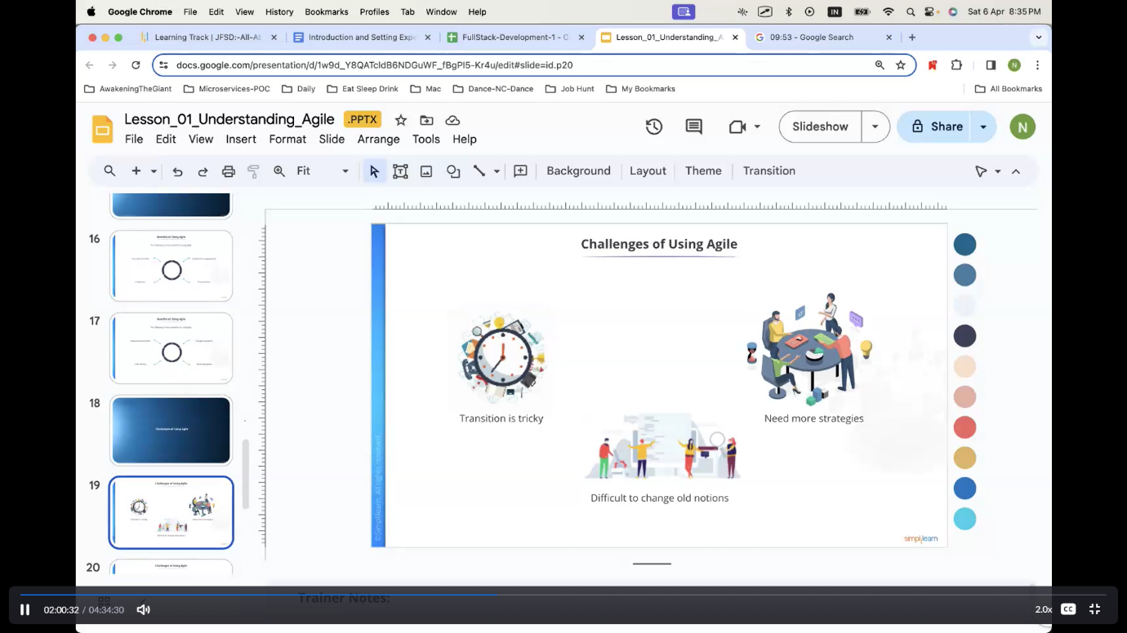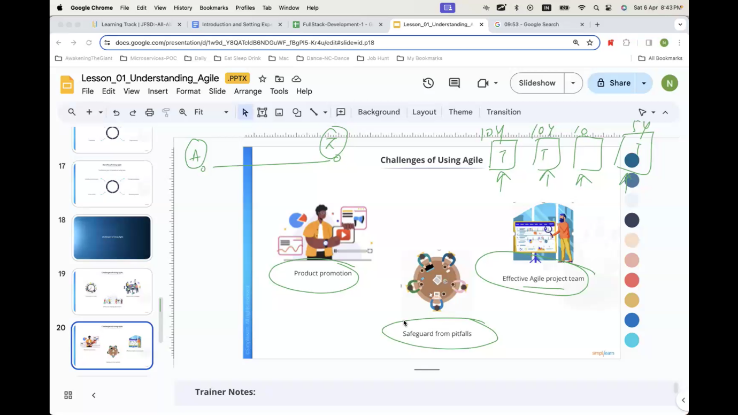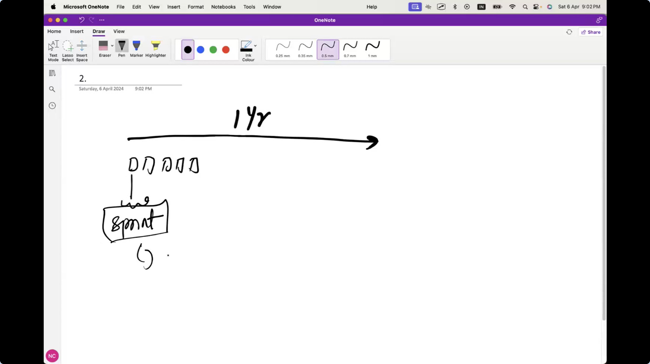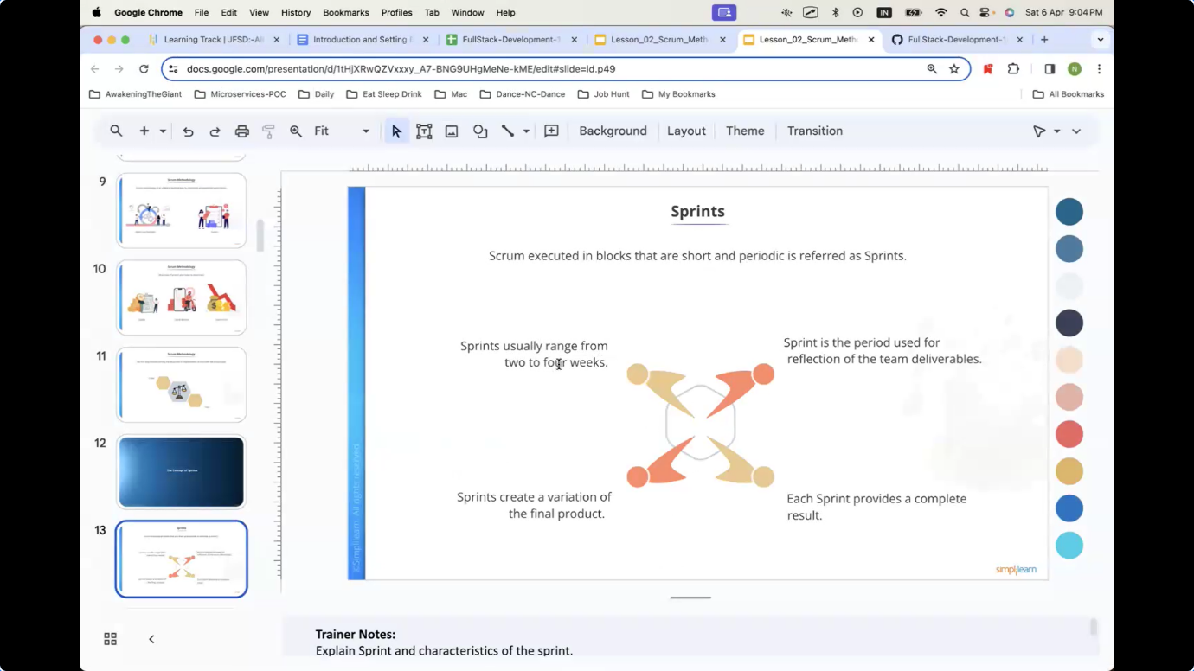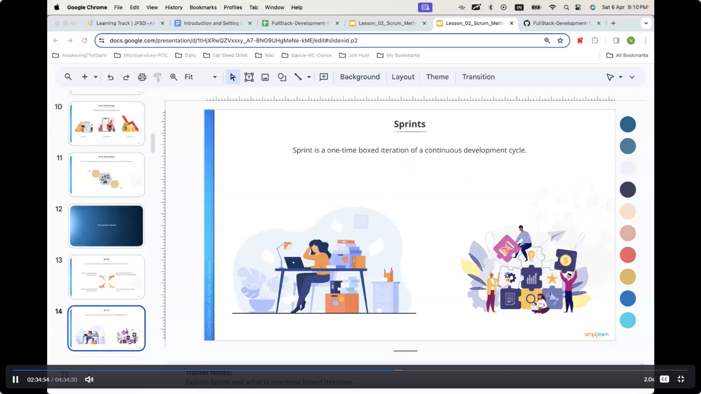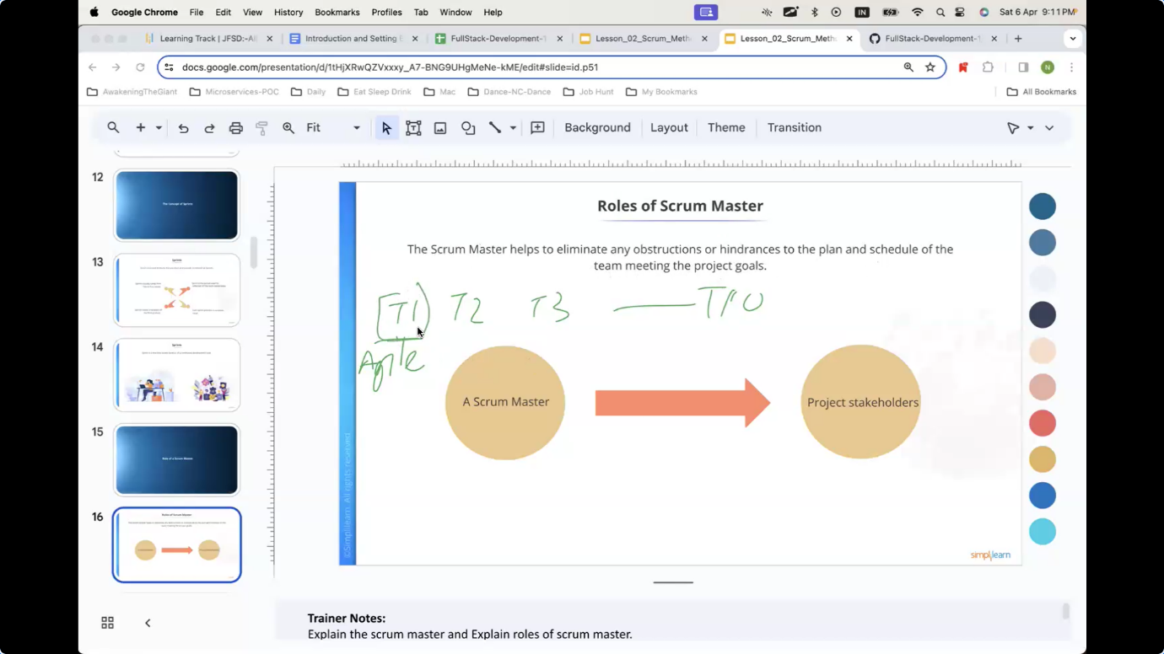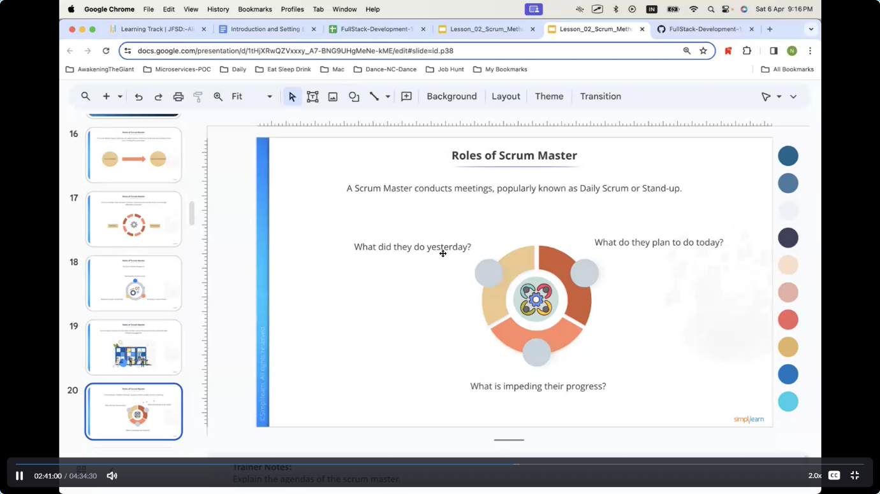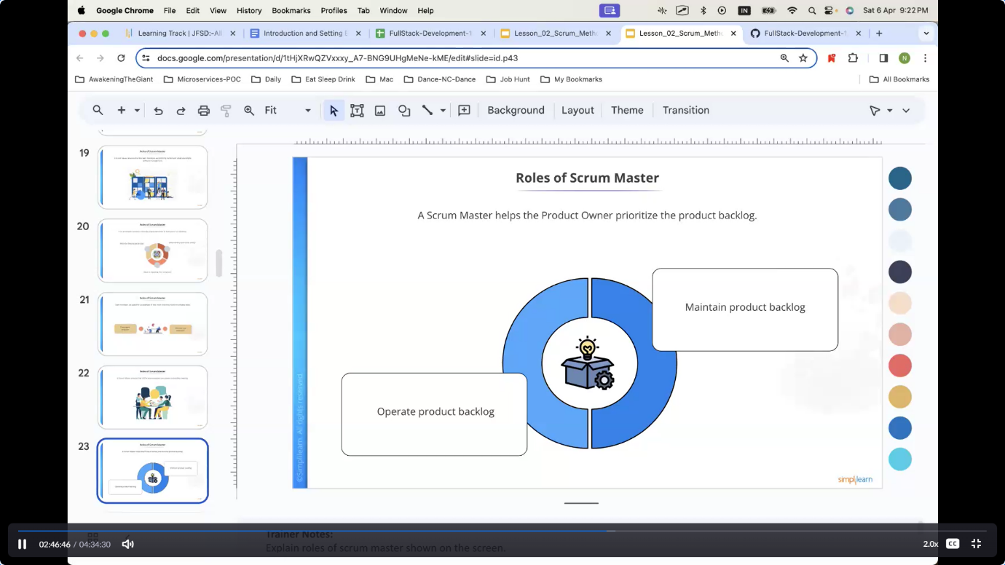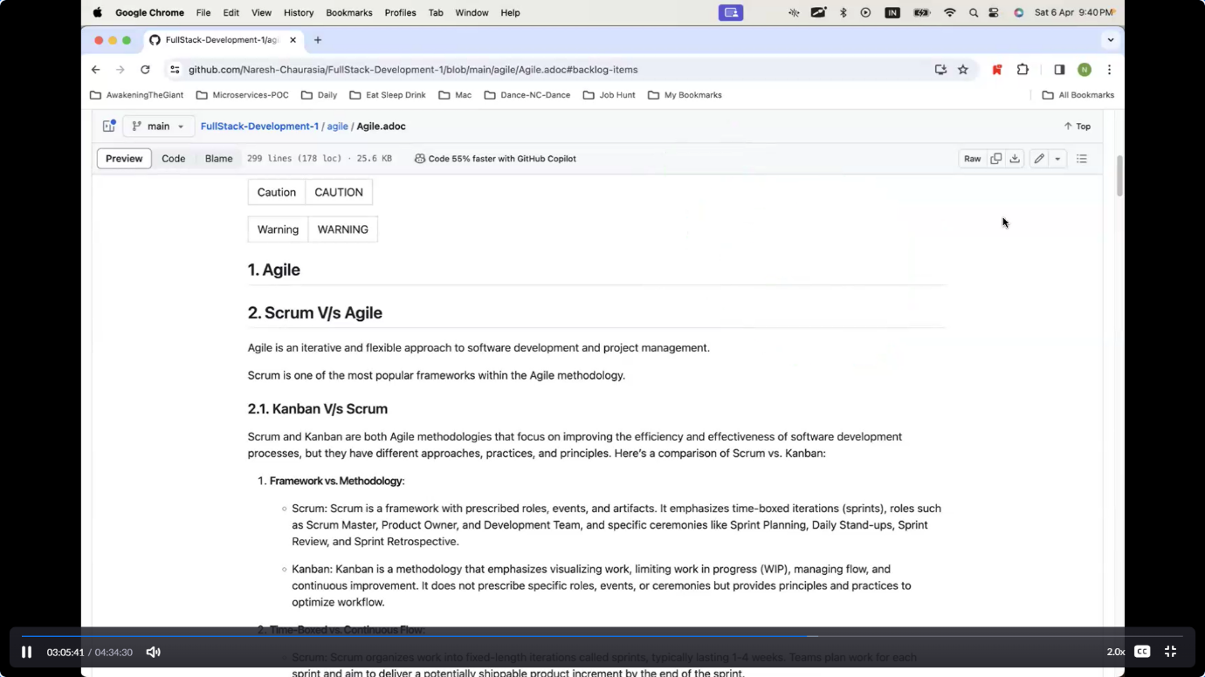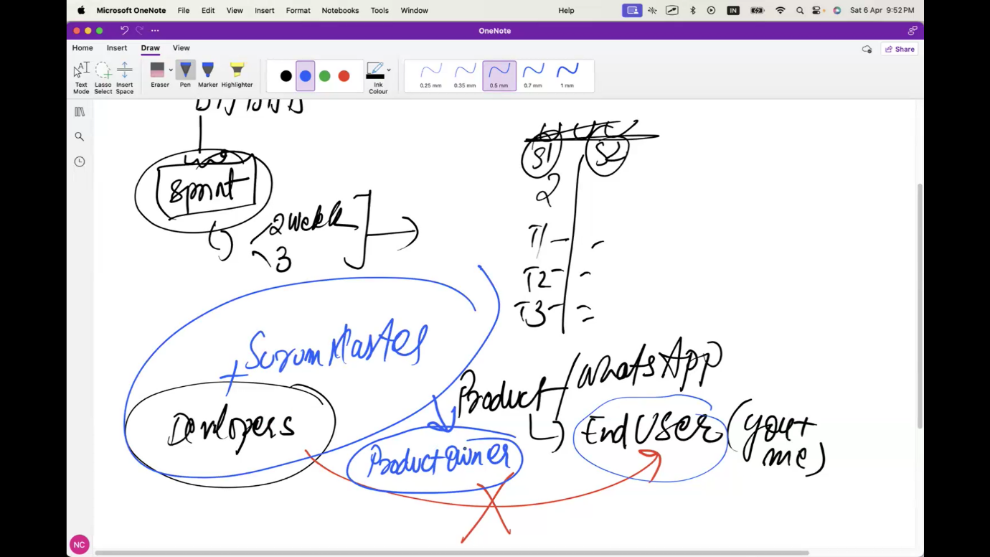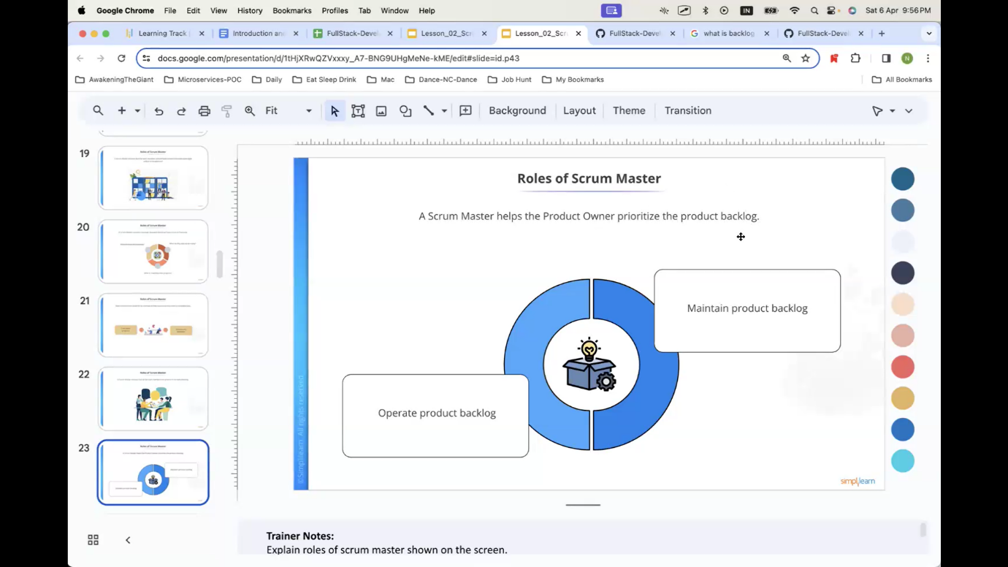

Roles of Scrum Master :

The Scrum Master helps the team members understand and use the Scrum methodology effectively

The Scrum Master engages in: Teaching the scrum process Keeping the team morale high and Bringing in a new mindset

A Scrum Master conducts meetings, popularly known as Daily Scrum or Stand-up

Team members are asked for an estimate of how much time they need to complete tasks.

A Scrum Master ensures that all the team members are present in the daily meeting.

A Scrum Master helps the Product Owner prioritize the product backlog.

The Scrum Master works with the Product Owner to maintain the items in the backlog with the information collected from the daily meetings.

A Scrum Master is also a mentor and teacher to new employees and team members

Roles of Development:

Team A development team is responsible for executing a Sprint

After Sprint planning meeting, the team gets a Sprint backlog and an objective that is expected to execute.

A development team is also responsible for grooming the product backlog

The team is equally responsible for planning the Sprint together with the Scrum Master.

The development team is part of all Sprint Planning meetings alongside the Product Owner and Scrum Master.

The development team also helps the Product Owner in formulating the objective or goal of Sprint.

Jiraa link:

<https://www.atlassian.com/software/jira/free>

SQL:

Table of Contents

* [1. What is ACID](https://github.com/Naresh-Chaurasia/FullStack-Development-1/blob/main/mysql/MYSQL.adoc#what-is-acid)
* [2. "HaaS," "PaaS," and "SaaS"](https://github.com/Naresh-Chaurasia/FullStack-Development-1/blob/main/mysql/MYSQL.adoc#haas-paas-and-saas)
* [3. What is Database](https://github.com/Naresh-Chaurasia/FullStack-Development-1/blob/main/mysql/MYSQL.adoc#what-is-database)
* [4. Database V/s Spreadsheet](https://github.com/Naresh-Chaurasia/FullStack-Development-1/blob/main/mysql/MYSQL.adoc#database-vs-spreadsheet)
* [5. ANSI](https://github.com/Naresh-Chaurasia/FullStack-Development-1/blob/main/mysql/MYSQL.adoc#ansi)
* [6. Data Types](https://github.com/Naresh-Chaurasia/FullStack-Development-1/blob/main/mysql/MYSQL.adoc#data-types)
  + [6.1. String](https://github.com/Naresh-Chaurasia/FullStack-Development-1/blob/main/mysql/MYSQL.adoc#string)
  + [6.2. Numeric Data](https://github.com/Naresh-Chaurasia/FullStack-Development-1/blob/main/mysql/MYSQL.adoc#numeric-data)
* [7. Database and Table Privileges](https://github.com/Naresh-Chaurasia/FullStack-Development-1/blob/main/mysql/MYSQL.adoc#database-and-table-privileges)
  + [7.1. Database-Level Privileges:](https://github.com/Naresh-Chaurasia/FullStack-Development-1/blob/main/mysql/MYSQL.adoc#database-level-privileges)
  + [7.2. Table-Level Privileges:](https://github.com/Naresh-Chaurasia/FullStack-Development-1/blob/main/mysql/MYSQL.adoc#table-level-privileges)
* [8. SQL Queries](https://github.com/Naresh-Chaurasia/FullStack-Development-1/blob/main/mysql/MYSQL.adoc#sql-queries)
  + [8.1. CREATE TABLE](https://github.com/Naresh-Chaurasia/FullStack-Development-1/blob/main/mysql/MYSQL.adoc#create-table)
  + [8.2. DROP TABLE](https://github.com/Naresh-Chaurasia/FullStack-Development-1/blob/main/mysql/MYSQL.adoc#drop-table)
  + [8.3. TRUNCATE TABLE](https://github.com/Naresh-Chaurasia/FullStack-Development-1/blob/main/mysql/MYSQL.adoc#truncate-table)
  + [8.4. INSERT SAMPLE RECORDS INTO THE STUDENTS TABLE](https://github.com/Naresh-Chaurasia/FullStack-Development-1/blob/main/mysql/MYSQL.adoc#insert-sample-records-into-the-students-table)
  + [8.5. UPDATE COLUMN IN STUDENT TABLE](https://github.com/Naresh-Chaurasia/FullStack-Development-1/blob/main/mysql/MYSQL.adoc#update-column-in-student-table)
  + [8.6. DELETE A RECORD FROM STUDENT TABLE](https://github.com/Naresh-Chaurasia/FullStack-Development-1/blob/main/mysql/MYSQL.adoc#delete-a-record-from-student-table)
  + [8.7. ALTER COLUMN NAME FROM STUDENT TABLE](https://github.com/Naresh-Chaurasia/FullStack-Development-1/blob/main/mysql/MYSQL.adoc#alter-column-name-from-student-table)
  + [8.8. ORDER BY](https://github.com/Naresh-Chaurasia/FullStack-Development-1/blob/main/mysql/MYSQL.adoc#order-by)
  + [8.9. GROUP BY](https://github.com/Naresh-Chaurasia/FullStack-Development-1/blob/main/mysql/MYSQL.adoc#group-by)
  + [8.10. GROUP BY AND HAVING](https://github.com/Naresh-Chaurasia/FullStack-Development-1/blob/main/mysql/MYSQL.adoc#group-by-and-having)
  + [8.11. UNIQUE KEY](https://github.com/Naresh-Chaurasia/FullStack-Development-1/blob/main/mysql/MYSQL.adoc#unique-key)
  + [8.12. FOREIGN KEY CONSTRAINT](https://github.com/Naresh-Chaurasia/FullStack-Development-1/blob/main/mysql/MYSQL.adoc#foreign-key-constraint)
  + [8.13. DISTINCT](https://github.com/Naresh-Chaurasia/FullStack-Development-1/blob/main/mysql/MYSQL.adoc#distinct)
  + [8.14. LAST_INSERT_ID()](https://github.com/Naresh-Chaurasia/FullStack-Development-1/blob/main/mysql/MYSQL.adoc#last_insert_id)
  + [8.15. SELF JOIN](https://github.com/Naresh-Chaurasia/FullStack-Development-1/blob/main/mysql/MYSQL.adoc#self-join)
  + [8.16. INNER JOIN](https://github.com/Naresh-Chaurasia/FullStack-Development-1/blob/main/mysql/MYSQL.adoc#inner-join)
  + [8.17. LEFT JOIN](https://github.com/Naresh-Chaurasia/FullStack-Development-1/blob/main/mysql/MYSQL.adoc#left-join)
  + [8.18. RIGHT JOIN](https://github.com/Naresh-Chaurasia/FullStack-Development-1/blob/main/mysql/MYSQL.adoc#right-join)
  + [8.19. FULL JOIN](https://github.com/Naresh-Chaurasia/FullStack-Development-1/blob/main/mysql/MYSQL.adoc#full-join)
  + [8.20. ROLLBACK](https://github.com/Naresh-Chaurasia/FullStack-Development-1/blob/main/mysql/MYSQL.adoc#rollback)
  + [8.21. SAVEPOINT](https://github.com/Naresh-Chaurasia/FullStack-Development-1/blob/main/mysql/MYSQL.adoc#savepoint)
  + [8.22. BLOB](https://github.com/Naresh-Chaurasia/FullStack-Development-1/blob/main/mysql/MYSQL.adoc#blob)
  + [8.23. How to Create User.](https://github.com/Naresh-Chaurasia/FullStack-Development-1/blob/main/mysql/MYSQL.adoc#how-to-create-user)
  + [8.24. How to connect to DB](https://github.com/Naresh-Chaurasia/FullStack-Development-1/blob/main/mysql/MYSQL.adoc#how-to-connect-to-db)

## 1. What is ACID

Sure! Let’s use a simple example to explain ACID in the context of MySQL:

1. **Atomicity**: Imagine you’re transferring money from one bank account to another using MySQL. Atomicity ensures that either the entire transaction of transferring money happens successfully or none of it happens at all. So, if you’re transferring $100 from Account A to Account B, MySQL ensures that either $100 is deducted from Account A and added to Account B completely, or nothing happens if there’s an error. It’s like all or nothing, no in-between state.
2. **Consistency**: Now, let’s say you have a rule that no account balance should go below $0. Consistency ensures that this rule is always maintained, even during a transaction. So, if you’re transferring $100 from Account A to Account B, MySQL ensures that after the transfer, both accounts still follow this rule. None of the accounts will end up with a negative balance.
3. **Isolation**: Imagine you and your friend are both transferring money from different accounts at the same time. Isolation ensures that your transaction doesn’t interfere with your friend’s transaction, and vice versa. So, even if you both are transferring money simultaneously, MySQL ensures that each transaction is processed independently without affecting the other.
4. **Durability**: Lastly, durability ensures that once a transaction is completed and confirmed, it stays that way even if there’s a system crash or power outage. So, if your money transfer transaction is successful, MySQL makes sure that the changes made (like the deduction from Account A and addition to Account B) are permanent and not lost due to any unforeseen circumstances.

In essence, ACID ensures that your transactions in MySQL are reliable, secure, and consistent, even in challenging situations.

## 2. "HaaS," "PaaS," and "SaaS"

In the realm of cloud computing, "HaaS," "PaaS," and "SaaS" are three different models that represent various levels of service and responsibility for users. Let’s break them down:

1. **HaaS (Hardware as a Service)**: In this model, the cloud provider offers physical hardware infrastructure, such as servers, storage, and networking equipment, to users on a subscription basis. Users typically rent these resources rather than owning them outright. HaaS allows businesses to avoid the upfront costs and maintenance associated with purchasing and managing physical hardware. Instead, they can scale resources up or down based on their needs, paying only for what they use. Examples of HaaS providers include Amazon Web Services (AWS), Microsoft Azure, and Google Cloud Platform (GCP).
2. **PaaS (Platform as a Service)**: PaaS provides a platform allowing customers to develop, run, and manage applications without the complexity of building and maintaining the underlying infrastructure. The cloud provider manages the infrastructure, including servers, storage, and networking, while users focus on developing and deploying their applications. PaaS offerings often include development tools, databases, middleware, and runtime environments. This model enables faster application development, scalability, and flexibility for developers. Examples of PaaS providers include Heroku, Microsoft Azure App Service, and Google App Engine.
3. **SaaS (Software as a Service)**: SaaS delivers software applications over the internet on a subscription basis, eliminating the need for users to install, maintain, and update the software locally on their devices. Users access the software through a web browser or an API, and the cloud provider hosts and manages everything, including infrastructure, software, and data. SaaS applications cover a wide range of functions, including email, customer relationship management (CRM), productivity tools, and enterprise resource planning (ERP). Examples of SaaS offerings include Google Workspace (formerly G Suite), Microsoft Office 365, Salesforce, and Dropbox.

These three models—HaaS, PaaS, and SaaS—offer varying levels of abstraction and management responsibilities, allowing organizations to choose the level of control and flexibility that best suits their needs and resources.

## 3. What is Database

Certainly! In simple terms, a **database** is like a well-organized digital filing cabinet where we store and manage information. Here are the key points:

1. **What is Data?**
   * **Data** refers to raw and unprocessed information. For example, names, class, marks, etc.
   * In computer language, data is any piece of information that can be translated into a form for efficient movement and processing.
2. **What is a Database?**
   * A **database** is a structured collection of data that can be accessed or stored in a computer system.
   * It’s like a digital warehouse where we keep related information organized.
   * Databases are managed using a **Database Management System (DBMS)**, which is software designed to handle data efficiently.
   * Think of it as a way to store a large amount of data in one place and easily retrieve specific pieces of information.
3. **How Does It Work?**
   * In a database, data is organized into **tables** consisting of rows and columns.
   * Each row represents a specific record (like a student’s details or a product), and each column represents a specific attribute (like name, age, or price).
   * Databases are indexed, allowing for easy updates, expansions, and deletions of data.
4. **Types of Databases:**
   * **Relational Database**: Made up of tables with data fitting predefined categories.
   * **Distributed Database**: Portions stored in multiple locations, with processing dispersed across a network.
   * **Cloud Database**: Runs on cloud computing platforms, providing access to data transparently.

In summary, a database is where we keep our digital treasures organized, making it easier to manage information, analyze facts, and make informed decisions!

## 4. Database V/s Spreadsheet

**How is database different compared to spreadsheet**

Certainly! Let’s explore the key differences between a **database** and a **spreadsheet**:

1. **What is a Spreadsheet?**
   * A spreadsheet is like an electronic ledger—a digital version of paper accounting worksheets.
   * It was created to store accounting information in tabular form digitally.
   * Spreadsheets allow you to create tables, perform calculations using formulas, and manage data about one subject area.
   * Examples include Microsoft Excel and Google Sheets.
2. **What is a Database?**
   * A database is significantly more complex than a spreadsheet.
   * It’s a collection of data organized and managed using **Structured Query Language (SQL)**.
   * Databases are typically formatted in rows and columns, similar to spreadsheets, but their capabilities extend far beyond.
   * Unlike spreadsheets, databases can vary greatly in size—from small files on your desktop to massive cloud clusters.
3. **Key Differences:**
   * **Data Structure**:
   * Spreadsheets store a single table of data, while databases break data into multiple tables linked using special keys.
   * **Functionality**:
   * Spreadsheets are great for basic calculations and simple data analysis.
   * Databases offer more advanced features like querying, indexing, and handling large datasets.
   * **Scalability**:
   * Databases can handle vast amounts of data, whereas spreadsheets are limited by the number of cells they can hold.
4. **Pros and Cons:**
   * **Spreadsheets**:
   * **Advantages**: Simple to use, suitable for small datasets, and easy calculations.
   * **Disadvantages**: Limited scalability, less robust for complex data.
   * **Databases**:
   * **Advantages**: Powerful, scalable, efficient for large datasets, and better for data integrity.
   * **Disadvantages**: May require more technical expertise.

In summary, if you need to track numbers or occasionally share lists, a spreadsheet suffices. For more complex data management or multi-purpose use, a database is the better choice!

## 5. ANSI

**ANSI SQL (Structured Query Language)**

ANSI SQL stands for American National Standards Institute Structured Query Language. It’s a standardized language used for managing data in Relational Database Management Systems (RDBMS).

## 6. Data Types

### 6.1. String

**Types**: MySQL offers several string data types:

* **CHAR**: Fixed-length string, up to 255 characters.
* **VARCHAR**: Variable-length string, up to 65,535 characters.
* **TEXT**: Variable-length string with a maximum length of 65,535 characters.
* **BLOB**: Binary large object for storing large binary data, such as images or documents.

**Fixed vs. Variable Length**:

**CHAR**: CHAR stores fixed-length strings. When you define a CHAR column, you specify the maximum length of the string it can hold. If the actual string is shorter than the specified length, it is padded with spaces to fill the fixed length.

**VARCHAR**: VARCHAR stores variable-length strings. It only uses the amount of storage required for the actual string plus one or two bytes to store the length of the string. It doesn’t pad spaces, so it can be more space-efficient for shorter strings.

-- Create a table with CHAR and VARCHAR columns

CREATE TABLE char_vs_varchar_example (

id INT AUTO_INCREMENT PRIMARY KEY,

char_column CHAR(10),

varchar_column VARCHAR(10)

);

-- Insert data into the CHAR and VARCHAR columns

INSERT INTO char_vs_varchar_example (char_column, varchar_column) VALUES

('hello', 'hello'), -- 'hello' will be padded with spaces to fit 10 characters in the CHAR column

('world', 'world'); -- 'world' will be stored as it is in the VARCHAR column

### 6.2. Numeric Data

-- Create a table with INT and FLOAT columns

CREATE TABLE int_float_example (

id INT AUTO_INCREMENT PRIMARY KEY,

int_column INT,

float_column FLOAT

);

-- Insert data into the INT and FLOAT columns

INSERT INTO int_float_example (int_column, float_column) VALUES

(10, 3.14),

(20, 6.28),

(30, 9.42);

-- Create a table with DATE and TIMESTAMP columns

CREATE TABLE date_timestamp_example (

id INT AUTO_INCREMENT PRIMARY KEY,

date_column DATE,

timestamp_column TIMESTAMP

);

-- Insert data into the DATE and TIMESTAMP columns

INSERT INTO date_timestamp_example (date_column, timestamp_column) VALUES

('2024-04-12', '2024-04-12 12:00:00'),

('2024-04-13', '2024-04-13 13:30:00'),

('2024-04-14', '2024-04-14 15:45:00');

## 7. Database and Table Privileges

Certainly! MySQL provides a range of privileges that can be assigned to users on a database or table level. Here are the specific privileges related to databases and tables:

### 7.1. Database-Level Privileges:

* **CREATE DATABASE**: Allows the user to create new databases.
* **DROP DATABASE**: Allows the user to delete databases.
* **ALTER DATABASE**: Allows the user to modify the structure of existing databases.
* **SHOW DATABASES**: Allows the user to see a list of available databases.

### 7.2. Table-Level Privileges:

* **SELECT**: Allows the user to retrieve data from tables.
* **INSERT**: Allows the user to add new rows to tables.
* **UPDATE**: Allows the user to modify existing rows in tables.
* **DELETE**: Allows the user to remove rows from tables.
* **CREATE**: Allows the user to create new tables.
* **DROP**: Allows the user to delete tables.
* **ALTER**: Allows the user to modify the structure of existing tables.

These privileges can be granted or revoked using SQL commands like GRANT and REVOKE, providing fine-grained control over who can perform specific actions on databases and tables within a MySQL server.

## 8. SQL Queries

### 8.1. CREATE TABLE

CREATE TABLE students (

first_name VARCHAR(50),

last_name VARCHAR(50),

age INT,

grade VARCHAR(10)

);

### 8.2. DROP TABLE

* Deleting the table.

DROP TABLE employees;

### 8.3. TRUNCATE TABLE

TRUNCATE TABLE employees;

### 8.4. INSERT SAMPLE RECORDS INTO THE STUDENTS TABLE

INSERT INTO students (first_name, last_name, age, grade) VALUES

('John', 'Doe', 18, 'Senior'),

('Jane', 'Smith', 17, 'Junior'),

('Michael', 'Johnson', 16, 'Sophomore'),

('Emily', 'Williams', 15, 'Freshman');

### 8.5. UPDATE COLUMN IN STUDENT TABLE

UPDATE students

SET grade = 'Senior2'

WHERE age >16 and first_name='John';

### 8.6. DELETE A RECORD FROM STUDENT TABLE

DELETE FROM students

WHERE age < 16;

### 8.7. ALTER COLUMN NAME FROM STUDENT TABLE

ALTER TABLE students

RENAME COLUMN grade TO student_grade;

### 8.8. ORDER BY

SELECT *

FROM students

ORDER BY age DESC;

### 8.9. GROUP BY

CREATE TABLE orders (

order_id INT AUTO_INCREMENT PRIMARY KEY,

product_id INT,

quantity INT

);

INSERT INTO orders (product_id, quantity) VALUES

(1, 10),

(1, 15),

(2, 20),

(2, 25),

(3, 30),

(3, 35);

SELECT product_id, SUM(quantity) AS total_quantity

FROM orders

GROUP BY product_id;

### 8.10. GROUP BY AND HAVING

SELECT product_id, SUM(quantity) AS total_quantity

FROM orders

GROUP BY product_id

HAVING SUM(quantity) > 30;

Certainly! Let’s provide some sample data for the orders table and then demonstrate the examples I provided earlier:

First, let’s create the orders table and insert some sample data:

-- Create the orders table

CREATE TABLE orders (

order_id INT AUTO_INCREMENT PRIMARY KEY,

customer_name VARCHAR(50),

total_amount DECIMAL(10, 2),

order_status VARCHAR(20)

);

-- Insert sample data into the orders table

INSERT INTO orders (customer_name, total_amount, order_status) VALUES

('Alice', 100.00, 'complete'),

('Alice', 200.00, 'pending'),

('Bob', 300.00, 'complete'),

('Bob', 400.00, 'complete'),

('Bob', 500.00, 'pending'),

('Charlie', 600.00, 'complete'),

('Charlie', 700.00, 'complete'),

('Charlie', 800.00, 'complete'),

('David', 900.00, 'pending'),

('David', 1000.00, 'complete'),

('David', 1100.00, 'complete');

Now that we have inserted sample data into the orders table, let’s run the queries from earlier to demonstrate the use of HAVING clause:

1. Example using aggregate function in HAVING:

SELECT

customer_name,

COUNT(*) AS order_count

FROM

orders

GROUP BY

customer_name

HAVING

COUNT(*) > 5;

This query will return customers who have placed more than 5 orders.

1. Example without using aggregate function in HAVING:

SELECT

customer_name,

order_status

FROM

orders

GROUP BY

customer_name

HAVING

MAX(order_status) = 'complete';

This query will return customers whose maximum order status is 'complete'.

You can execute these queries against the sample orders table to see the results based on the provided sample data.

### 8.11. UNIQUE KEY

CREATE TABLE employees (

id INT PRIMARY KEY,

name VARCHAR(100),

email VARCHAR(100) UNIQUE,

department VARCHAR(100)

);

INSERT INTO employees (id, name, email, department) VALUES

(null,'John Doe', null, 'HR'),

(5,'John Doe', null, 'HR'),

(1,'John Doe', 'john@example.com', 'HR'),

(2,'Jane Smith', 'jane@example.com', 'IT'),

(3,'Michael Johnson', 'michael@example.com', 'Finance'),

(4,'Emily Brown', 'emily@example.com', 'Marketing');

**COMPOSITE KEY**

CREATE TABLE employees (

employee_id INT,

department_id INT,

first_name VARCHAR(50),

last_name VARCHAR(50),

PRIMARY KEY (employee_id, department_id)

);

INSERT INTO employees (employee_id, department_id, first_name, last_name)

VALUES

(1, 1, 'John', 'Doe'),

(2, 1, 'Jane', 'Smith'),

(3, 2, 'Michael', 'Johnson'),

(4, 2, 'Emily', 'Williams');

-- This record violates the composite key constraint

INSERT INTO employees (employee_id, department_id, first_name, last_name)

VALUES

(1, 1, 'John', 'Doe');

### 8.12. FOREIGN KEY CONSTRAINT

-- Create the departments table

CREATE TABLE departments (

department_id INT PRIMARY KEY,

department_name VARCHAR(100)

);

-- Create the employees table with a foreign key constraint

CREATE TABLE employees (

employee_id INT PRIMARY KEY,

first_name VARCHAR(50),

last_name VARCHAR(50),

department_id INT,

FOREIGN KEY (department_id) REFERENCES departments(department_id)

);

-- Insert data into the departments table

INSERT INTO departments (department_id, department_name) VALUES

(1, 'Sales'),

(2, 'Marketing'),

(3, 'Human Resources');

-- Insert data into the employees table

INSERT INTO employees (employee_id, first_name, last_name, department_id) VALUES

(1, 'John', 'Doe', 1), -- Employee John Doe belongs to Sales department

(2, 'Jane', 'Smith', 2), -- Employee Jane Smith belongs to Marketing department

(3, 'Michael', 'Johnson', 1), -- Employee Michael Johnson belongs to Sales department

(4, 'Emily', 'Williams', 3); -- Employee Emily Williams belongs to Human Resources department

* We first insert data into the departments table, specifying the department_id and department_name.
* Then, we insert data into the employees table, specifying the employee_id, first_name, last_name, and department_id. Note that the department_id values we insert must exist in the departments table due to the foreign key constraint.

### 8.13. DISTINCT

-- Create the employees table

CREATE TABLE employees (

id INT AUTO_INCREMENT PRIMARY KEY,

name VARCHAR(50),

department VARCHAR(50)

);

-- Insert sample data into the employees table

INSERT INTO employees (name, department) VALUES

('Alice', 'Sales'),

('Bob', 'Marketing'),

('Charlie', 'Sales'),

('David', 'HR'),

('Eve', 'Marketing'),

('Frank', 'HR');

SELECT DISTINCT department

FROM employees;

### 8.14. LAST_INSERT_ID()

-- Create a table with an auto-increment primary key

CREATE TABLE example_table (

id INT AUTO_INCREMENT PRIMARY KEY,

name VARCHAR(50)

);

-- Insert a record into the table

INSERT INTO example_table (name) VALUES ('John');

-- Retrieve the last automatically generated ID

SELECT LAST_INSERT_ID();

Certainly! LAST_INSERT_ID() is a MySQL function that returns the last automatically generated value that was inserted into an AUTO_INCREMENT column. It’s typically used after an INSERT statement to get the value of the last automatically generated ID.

In this example:

* We create a table named example_table with an id column that is an AUTO_INCREMENT primary key.
* We insert a record into the table with the name 'John'.
* We then use LAST_INSERT_ID() to retrieve the value of the last automatically generated ID, which is the id of the record we just inserted.

LAST_INSERT_ID() is often used in scenarios where you need to insert records into multiple tables with foreign key relationships, and you need to retrieve the generated IDs to maintain referential integrity between the tables.

### 8.15. SELF JOIN

Certainly! Let’s provide some sample data for the employees table and then demonstrate the self join:

First, let’s create the employees table and insert some sample data:

-- Create the employees table

CREATE TABLE employees (

employee_id INT AUTO_INCREMENT PRIMARY KEY,

employee_name VARCHAR(50),

job_title VARCHAR(50),

manager_id INT

);

-- Insert sample data into the employees table

INSERT INTO employees (employee_name, job_title, manager_id) VALUES

('John Doe', 'Manager', NULL), -- John Doe is the manager (manager_id is NULL)

('Jane Smith', 'Employee', 1), -- Jane Smith reports to John Doe (manager_id is 1)

('Alice Johnson', 'Employee', 1),-- Alice Johnson also reports to John Doe

('Bob Brown', 'Employee', 2); -- Bob Brown reports to Jane Smith (manager_id is 2)

Now that we have inserted sample data into the employees table, let’s run the self join query:

SELECT e.employee_name, m.employee_name AS manager_name

FROM employees e

JOIN employees m ON e.manager_id = m.employee_id;

This query will return a list of employees along with the names of their managers based on the matching manager_id and employee_id. Here’s the expected result:

| **employee_name** | **manager_name** |
| --- | --- |
| John Doe | NULL |
| Jane Smith | John Doe |
| Alice Johnson | John Doe |
| Bob Brown | Jane Smith |

You can see that each employee’s manager_name corresponds to the employee_name of their manager, achieved through the self join.

### 8.16. INNER JOIN

An inner join is used to return rows from both tables that satisfy the join condition.

-- Create the employees table

CREATE TABLE employees (

employee_id INT PRIMARY KEY,

employee_name VARCHAR(50),

department_id INT

);

-- Insert sample data into the employees table

INSERT INTO employees (employee_id, employee_name, department_id) VALUES

(1, 'John', 1), -- John belongs to department 1

(2, 'Jane', 1), -- Jane also belongs to department 1

(3, 'Michael', 2); -- Michael belongs to department 2

-- Create the departments table

CREATE TABLE departments (

department_id INT PRIMARY KEY,

department_name VARCHAR(50)

);

-- Insert sample data into the departments table

INSERT INTO departments (department_id, department_name) VALUES

(1, 'Sales'),

(2, 'Marketing');

SELECT e.employee_name, d.department_name

FROM employees e

INNER JOIN departments d ON e.department_id = d.department_id;

### 8.17. LEFT JOIN

Sure! Let’s create an example with sample data and demonstrate a LEFT JOIN query.

Suppose we have two tables: employees and departments. The employees table contains information about employees, including their names and the department they belong to. The departments table contains information about departments, including their names and IDs.

Here’s how we can create the tables and insert some sample data:

-- Create the employees table

CREATE TABLE employees (

employee_id INT AUTO_INCREMENT PRIMARY KEY,

employee_name VARCHAR(50),

department_id INT

);

-- Insert sample data into the employees table

INSERT INTO employees (employee_name, department_id) VALUES

('John Doe', 1), -- John Doe belongs to department 1

('Jane Smith', 2), -- Jane Smith belongs to department 2

('Alice Johnson', 1),-- Alice Johnson also belongs to department 1

('Bob Brown', NULL);-- Bob Brown's department is unknown

-- Create the departments table

CREATE TABLE departments (

department_id INT AUTO_INCREMENT PRIMARY KEY,

department_name VARCHAR(50)

);

-- Insert sample data into the departments table

INSERT INTO departments (department_name) VALUES

('HR'), -- Department ID 1 is HR

('IT'); -- Department ID 2 is IT

Now, let’s say we want to retrieve a list of all employees along with their department names. We can use a LEFT JOIN to ensure that all employees are included in the result, even if their department is unknown.

Here’s the LEFT JOIN query:

SELECT e.employee_name, d.department_name

FROM employees e

LEFT JOIN departments d ON e.department_id = d.department_id;

This query will return a list of all employees along with their department names. If an employee’s department is unknown (i.e., their department_id is NULL), the corresponding department name will also be NULL. Here’s the expected result:

+---------------+----------------+

| employee_name | department_name|

+---------------+----------------+

| John Doe | HR |

| Jane Smith | IT |

| Alice Johnson | HR |

| Bob Brown | NULL |

+---------------+----------------+

In this result:

* John Doe and Alice Johnson belong to the HR department.
* Jane Smith belongs to the IT department.
* Bob Brown’s department is unknown, so the department name is NULL.

### 8.18. RIGHT JOIN

Of course! Let’s continue with the same example of the employees and departments tables, but this time we’ll demonstrate a RIGHT JOIN query.

Suppose we want to retrieve a list of all departments along with the names of employees who belong to each department. We want to ensure that all departments are included in the result, even if they have no employees.

Here’s how we can achieve this using a RIGHT JOIN:

SELECT d.department_name, e.employee_name

FROM departments d

RIGHT JOIN employees e ON d.department_id = e.department_id;

This query will return a list of all departments along with the names of employees who belong to each department. If a department has no employees, the corresponding employee name will be NULL.

Here’s the expected result based on the provided sample data:

+----------------+---------------+

| department_name| employee_name |

+----------------+---------------+

| HR | John Doe |

| HR | Alice Johnson |

| IT | Jane Smith |

| NULL | Bob Brown |

+----------------+---------------+

In this result:

* The HR department has two employees: John Doe and Alice Johnson.
* The IT department has one employee: Jane Smith.
* There is a department with no employees, indicated by the NULL value in the department_name column, and Bob Brown is listed as having no department affiliation.

### 8.19. FULL JOIN

Certainly! MySQL doesn’t have a direct FULL JOIN syntax like some other database systems, but you can achieve the same result by combining a LEFT JOIN, a RIGHT JOIN, and a UNION. Let’s demonstrate this with sample data.

Suppose we have two tables: departments and employees. Here’s how you might perform a FULL JOIN to get all departments along with their associated employees:

-- Create sample tables

CREATE TABLE departments (

id INT,

name VARCHAR(50)

);

CREATE TABLE employees (

id INT,

name VARCHAR(50),

department_id INT

);

-- Insert sample data

INSERT INTO departments (id, name) VALUES

(1, 'Sales'),

(2, 'Marketing'),

(3, 'HR');

INSERT INTO employees (id, name, department_id) VALUES

(101, 'Alice', 1),

(102, 'Bob', 2),

(103, 'Charlie', 1),

(104, 'David', 3),

(105, 'Eve', 2),

(106, 'Frank', NULL); -- An employee without a department

-- Perform the FULL JOIN

SELECT d.id AS department_id, d.name AS department_name, e.id AS employee_id, e.name AS employee_name

FROM departments d

LEFT JOIN employees e ON d.id = e.department_id

UNION

SELECT d.id AS department_id, d.name AS department_name, e.id AS employee_id, e.name AS employee_name

FROM departments d

RIGHT JOIN employees e ON d.id = e.department_id

WHERE d.id IS NULL;

In this example: - We create two tables: departments and employees. - We insert sample data into both tables. - We use a LEFT JOIN to get all departments along with their associated employees. - We use a RIGHT JOIN to get all employees along with their associated departments. - We use UNION to combine the results of the two joins. - We use a WHERE clause to filter out departments that already have matching employees, leaving only the departments without employees. - We alias the columns to make the result set clearer.

After executing this SQL script, you’ll get a result set containing all departments along with their associated employees, including departments without employees.

### 8.20. ROLLBACK

INSERT INTO orders (customer_name, total_amount, order_status) VALUES ('Alice1', 101.00, 'completed')

### 8.21. SAVEPOINT

CREATE TABLE customers (

id INT AUTO_INCREMENT PRIMARY KEY,

name VARCHAR(100),

email VARCHAR(100)

);

-- Start a transaction

START TRANSACTION;

-- Update the email of customer with id 1

UPDATE customers SET email = 'john.doe@example.com' WHERE id = 1;

-- Create a savepoint named 'update1'

SAVEPOINT update1;

-- Update the email of customer with id 2

UPDATE customers SET email = 'jane.smith@example.com' WHERE id = 2;

-- Oops! Something went wrong

-- We want to roll back to the 'update1' savepoint

ROLLBACK TO update1;

-- Commit the transaction

COMMIT;

### 8.22. BLOB

In MySQL, the BLOB (Binary Large OBject) data type is used to store large binary data, such as images, audio, video, or other files. The size of a BLOB column is determined by the maximum packet size (max_allowed_packet) parameter in the MySQL server configuration.

By default, the maximum packet size in MySQL is set to 4MB (megabytes). This means that you can store BLOBs up to 4MB in size in a single column if you haven’t changed the default configuration.

However, you can increase the maximum packet size to allow for larger BLOBs to be stored. Keep in mind that increasing the maximum packet size can have implications for memory usage and network traffic, so it’s important to consider the potential impact on your MySQL server.

As for the maximum size of a file you can store in a BLOB column, it depends on the maximum packet size and the specific configuration of your MySQL server. If you have increased the maximum packet size, you can store larger files accordingly. For example, if you increase the maximum packet size to 16MB, you can theoretically store BLOBs up to 16MB in size.

However, it’s worth noting that storing very large files directly in a MySQL database can have performance and scalability implications. For storing very large files, it’s often recommended to use a file system or a specialized file storage system instead of storing the files directly in the database.

### 8.23. How to Create User.

### 8.24. How to connect to DB

# switching to root user

sudo su root

# connect to mysql

mysql -u root

show databases;

create database my_sql_db;

use my_sql_db;

The Importance of Data

Imagine that a digital marketer is hired and the organization does not have a database. The organization has its previous customer’s information and a few prospective buyers’ information, stored in a Microsoft spreadsheet.

HTML:

Table of Contents

* [1. Pre-Requisite](https://github.com/Naresh-Chaurasia/FullStack-Development-1/blob/main/html/HTML.adoc#pre-requisite)
* [2. HTML](https://github.com/Naresh-Chaurasia/FullStack-Development-1/blob/main/html/HTML.adoc#html)
  + [2.1. First HTML](https://github.com/Naresh-Chaurasia/FullStack-Development-1/blob/main/html/HTML.adoc#first-html)
  + [2.2. H Tags](https://github.com/Naresh-Chaurasia/FullStack-Development-1/blob/main/html/HTML.adoc#h-tags)
  + [2.3. Text Formatting](https://github.com/Naresh-Chaurasia/FullStack-Development-1/blob/main/html/HTML.adoc#text-formatting)
  + [2.4. HTML List](https://github.com/Naresh-Chaurasia/FullStack-Development-1/blob/main/html/HTML.adoc#html-list)
  + [2.5. Image Example](https://github.com/Naresh-Chaurasia/FullStack-Development-1/blob/main/html/HTML.adoc#image-example)
  + [2.6. DOCTYPE](https://github.com/Naresh-Chaurasia/FullStack-Development-1/blob/main/html/HTML.adoc#doctype)
  + [2.7. iFrame](https://github.com/Naresh-Chaurasia/FullStack-Development-1/blob/main/html/HTML.adoc#iframe)
  + [2.8. Anchor link](https://github.com/Naresh-Chaurasia/FullStack-Development-1/blob/main/html/HTML.adoc#anchor-link)
  + [2.9. Tables](https://github.com/Naresh-Chaurasia/FullStack-Development-1/blob/main/html/HTML.adoc#tables)
  + [2.10. Simple Table](https://github.com/Naresh-Chaurasia/FullStack-Development-1/blob/main/html/HTML.adoc#simple-table)
    - [Table 1](https://github.com/Naresh-Chaurasia/FullStack-Development-1/blob/main/html/HTML.adoc#table-1)
    - [Table 2 - Alignment](https://github.com/Naresh-Chaurasia/FullStack-Development-1/blob/main/html/HTML.adoc#table-2-alignment)
  + [2.11. HTML form](https://github.com/Naresh-Chaurasia/FullStack-Development-1/blob/main/html/HTML.adoc#html-form)
  + [2.12. HTTP Get](https://github.com/Naresh-Chaurasia/FullStack-Development-1/blob/main/html/HTML.adoc#http-get)
  + [2.13. HTTP Post](https://github.com/Naresh-Chaurasia/FullStack-Development-1/blob/main/html/HTML.adoc#http-post)
  + [2.14. HTTP GET V/s POST](https://github.com/Naresh-Chaurasia/FullStack-Development-1/blob/main/html/HTML.adoc#http-get-vs-post)
  + [2.15. Escape Characters in HTML](https://github.com/Naresh-Chaurasia/FullStack-Development-1/blob/main/html/HTML.adoc#escape-characters-in-html)
  + [2.16. Video Tag](https://github.com/Naresh-Chaurasia/FullStack-Development-1/blob/main/html/HTML.adoc#video-tag)
  + [2.17. Video Tag: YouTube](https://github.com/Naresh-Chaurasia/FullStack-Development-1/blob/main/html/HTML.adoc#video-tag-youtube)
  + [2.18. Flash](https://github.com/Naresh-Chaurasia/FullStack-Development-1/blob/main/html/HTML.adoc#flash)
  + [2.19. HTML: select, textarea](https://github.com/Naresh-Chaurasia/FullStack-Development-1/blob/main/html/HTML.adoc#html-select-textarea)
  + [2.20. Buttons: button, submit](https://github.com/Naresh-Chaurasia/FullStack-Development-1/blob/main/html/HTML.adoc#buttons-button-submit)
  + [2.21. Buttons: reset](https://github.com/Naresh-Chaurasia/FullStack-Development-1/blob/main/html/HTML.adoc#buttons-reset)
  + [2.22. HTML: Meta](https://github.com/Naresh-Chaurasia/FullStack-Development-1/blob/main/html/HTML.adoc#html-meta)
* [3. CSS](https://github.com/Naresh-Chaurasia/FullStack-Development-1/blob/main/html/HTML.adoc#css)
  + [3.1. CSS Cascading](https://github.com/Naresh-Chaurasia/FullStack-Development-1/blob/main/html/HTML.adoc#css-cascading)
  + [3.2. CSS Types of Selector](https://github.com/Naresh-Chaurasia/FullStack-Development-1/blob/main/html/HTML.adoc#css-types-of-selector)
    - [HTML Element Selector:](https://github.com/Naresh-Chaurasia/FullStack-Development-1/blob/main/html/HTML.adoc#html-element-selector)
    - [ID Selector:](https://github.com/Naresh-Chaurasia/FullStack-Development-1/blob/main/html/HTML.adoc#id-selector)
    - [Class Selector:](https://github.com/Naresh-Chaurasia/FullStack-Development-1/blob/main/html/HTML.adoc#class-selector)
    - [Attribute Selector:](https://github.com/Naresh-Chaurasia/FullStack-Development-1/blob/main/html/HTML.adoc#attribute-selector)
  + [3.3. Universal Selector](https://github.com/Naresh-Chaurasia/FullStack-Development-1/blob/main/html/HTML.adoc#universal-selector)
  + [3.4. CSS combinators](https://github.com/Naresh-Chaurasia/FullStack-Development-1/blob/main/html/HTML.adoc#css-combinators)
  + [3.5. Pseudo Classes](https://github.com/Naresh-Chaurasia/FullStack-Development-1/blob/main/html/HTML.adoc#pseudo-classes)
  + [3.6. Animation 1](https://github.com/Naresh-Chaurasia/FullStack-Development-1/blob/main/html/HTML.adoc#animation-1)
  + [3.7. Animation 2](https://github.com/Naresh-Chaurasia/FullStack-Development-1/blob/main/html/HTML.adoc#animation-2)
  + [3.8. Media Queries](https://github.com/Naresh-Chaurasia/FullStack-Development-1/blob/main/html/HTML.adoc#media-queries)
  + [3.9. CSS Bootstrap](https://github.com/Naresh-Chaurasia/FullStack-Development-1/blob/main/html/HTML.adoc#css-bootstrap)
  + [3.10. Div Tag](https://github.com/Naresh-Chaurasia/FullStack-Development-1/blob/main/html/HTML.adoc#div-tag)
  + [3.11. Inline and Block Elements](https://github.com/Naresh-Chaurasia/FullStack-Development-1/blob/main/html/HTML.adoc#inline-and-block-elements)
  + [3.12. Content Types](https://github.com/Naresh-Chaurasia/FullStack-Development-1/blob/main/html/HTML.adoc#content-types)
  + [3.13. Sectioning Semantic Elements](https://github.com/Naresh-Chaurasia/FullStack-Development-1/blob/main/html/HTML.adoc#sectioning-semantic-elements)
  + [3.14. Flow Content](https://github.com/Naresh-Chaurasia/FullStack-Development-1/blob/main/html/HTML.adoc#flow-content)
  + [3.15. CSS Box Model](https://github.com/Naresh-Chaurasia/FullStack-Development-1/blob/main/html/HTML.adoc#css-box-model)
* [4. Padding & Margin](https://github.com/Naresh-Chaurasia/FullStack-Development-1/blob/main/html/HTML.adoc#padding-margin)

**1. Pre-Requisite**

* Visual Studio
* Live Server Extension

**2. HTML**

**2.1. First HTML**

<!DOCTYPE html>

<html lang="en">

<head>

<meta charset="UTF-8">

<meta name="viewport" content="width=device-width, initial-scale=1.0">

<title>My Simple Webpage</title>

</head>

<body>

<header>

<h1>Welcome to My Simple Webpage</h1>

</header>

<section>

<h2>Content Section</h2>

<p>This is a simple HTML webpage.</p>

</section>

<footer>

<p>&copy; 2024 My Simple Webpage. All rights reserved.</p>

</footer>

</body>

</html>

**2.2. H Tags**

<!DOCTYPE html>

<html lang="en">

<head>

<meta charset="UTF-8">

<meta name="viewport" content="width=device-width, initial-scale=1.0">

<title>HTML Heading Tags Example</title>

</head>

<body>

<h1>This is a Level 1 Heading</h1>

<p>This is some content under the level 1 heading.</p>

<h2>This is a Level 2 Heading</h2>

<p>This is some content under the level 2 heading.</p>

<h3>This is a Level 3 Heading</h3>

<p>This is some content under the level 3 heading.</p>

<h4>This is a Level 4 Heading</h4>

<p>This is some content under the level 4 heading.</p>

<h5>This is a Level 5 Heading</h5>

<p>This is some content under the level 5 heading.</p>

<h6>This is a Level 6 Heading</h6>

<p>This is some content under the level 6 heading.</p>

</body>

</html>

**2.3. Text Formatting**

<!DOCTYPE>

<html>

<head>

<title>HTMLTextFormatting</title>

</head>

<body>

<p><b>This is bold text</b></p>

<p><strong>This is a</strong> strong text</p>

<p><i>This is a italic text</i></p>

<p><em>This is a em </em>text</p>

<p>This is a <mark>mark tag</mark></p>

<p>This is a <u>underline text</u></p>

<p><strike>This is a strike text</strike></p>

<p>Hiii<tt>This paragraph in the monospaced font</tt></p>

<p>Hello<sub>This is a superscript text</sub>

<p>Hiii<del>Delete this paragraph</del></p>

<p><del>Hello</del><ins>How are you!</ins></p>

<p>Hello<big>This is a larger font<big></p>

<p>Hiii<small>This is a small font</small></p>

</body>

</html>

**2.4. HTML List**

<!DOCTYPE html>

<html lang="en">

<head>

<meta charset="UTF-8">

<meta name="viewport" content="width=device-width, initial-scale=1.0">

<title>List Example</title>

<style>

/* Style for list with squares */

.square-list {

list-style-type: square;

}

/* Style for list with circles */

.circle-list {

list-style-type: circle;

}

</style>

</head>

<body>

<h2>List with Squares</h2>

<ul class="square-list">

<li>Item 1</li>

<li>Item 2</li>

<li>Item 3</li>

</ul>

<h2>List with Circles</h2>

<ul class="circle-list">

<li>Item A</li>

<li>Item B</li>

<li>Item C</li>

</ul>

</body>

</html>

<!DOCTYPE html>

<html lang="en">

<head>

<meta charset="UTF-8">

<meta name="viewport" content="width=device-width, initial-scale=1.0">

<title>HTML List Example</title>

</head>

<body>

<h2>Ordered List (ol)</h2>

<ol>

<li>Item 1</li>

<li>Item 2</li>

<li>Item 3</li>

</ol>

<h2>Unordered List (ul)</h2>

<ul>

<li>Apple</li>

<li>Orange</li>

<li>Banana</li>

</ul>

<h2>Nested List</h2>

<ul>

<li>Fruits</li>

<ul>

<li>Apple</li>

<li>Orange</li>

<li>Banana</li>

</ul>

<li>Veggies</li>

<ul>

<li>Carrot</li>

<li>Broccoli</li>

<li>Spinach</li>

</ul>

</ul>

<dl>

<dt>Coding</dt>

<dd>An activity to keep you happy.</dd>

<dt>Gossiping</dt>

<dd>Can't live without it.</dd>

<dt>Sleeping</dt>

<dd>My all-time favourite.</dd>

</dl>

<p>

In HTML, <dt> stands for "Definition Term" and <dd> stands for "Definition Description". These elements are typically used together within a <dl> (Definition List) element to define terms and their corresponding descriptions

</p>

</body>

</html>

**2.5. Image Example**

<!DOCTYPE html>

<html lang="en">

<head>

<meta charset="UTF-8">

<meta name="viewport" content="width=device-width, initial-scale=1.0">

<title>HTML Image Tag Example</title>

</head>

<body>

<h2>Image Tag Example</h2>

<img src="https://www.google.com/images/branding/googlelogo/2x/googlelogo_color_272x92dp.png" width="200" height="200">

</body>

</html>

**2.6. DOCTYPE**

The DOCTYPE declaration in HTML stands for "Document Type Declaration." It’s an instruction to the web browser about what version of HTML the page is written in and how the browser should render it.

<!DOCTYPE html>

This declaration tells the browser that the document is an HTML5 document.

**2.7. iFrame**

An <iframe> (short for inline frame) in HTML is used to embed another document within the current HTML document. It allows you to display content from another web page or resource within your own web page. Here are some common uses of <iframe>:

Embedding External Content: You can embed content from another website, such as a YouTube video, a Google Map, or a social media post, by specifying the URL of the external content within the <iframe> tag.

<!DOCTYPE html>

<html>

<head>

<title>Embed Video</title>

</head>

<body>

<p>Here is our video</p>

</br>

<iframe width="500" height="300"

src="https://www.youtube.com/embed/3olM-9vcd4M" frameborder="0" allowfullscreen>

</iframe>

</body>

</html>

#### 2.8. Anchor link

Sure! The HTML <a> (anchor) tag is used to create hyperlinks. It can include various attributes to specify the target URL, link behavior, and appearance. Here are some common attributes of the <a> tag:

1. **href**: Specifies the URL of the link. This is the most essential attribute of the <a> tag.

<a href="https://www.example.com">Visit Example</a>

1. **target**: Specifies where to open the linked document. Values can include _self (default, opens in the same frame), _blank (opens in a new window or tab), _parent (opens in the parent frame), or _top (opens in the full body of the window).

<a href="https://www.example.com" target="_blank">Visit Example</a>

1. **title**: Provides additional information about the link, typically displayed as a tooltip when the user hovers over the link.

<a href="https://www.example.com" title="Visit Example">Visit Example</a>

1. **download**: Specifies that the target will be downloaded when the user clicks on the hyperlink. The value should be the name of the file being downloaded.

<a href="example.pdf" download>Download PDF</a>

1. **rel**: Specifies the relationship between the current document and the linked document. Common values include nofollow (suggests to search engines not to follow the link) and noopener noreferrer (ensures security when opening in a new window).

<a href="https://www.example.com" rel="noopener noreferrer">Visit Example</a>

1. **aria-label**: Specifies an accessible label for the link, which is read out by screen readers for visually impaired users.

<a href="https://www.example.com" aria-label="Visit Example">Visit Example</a>

1. **id and class**: Attributes used for styling or scripting purposes. They don’t directly affect the behavior of the link, but they can be useful for targeting specific links with CSS or JavaScript.

<a href="https://www.example.com" id="link1" class="external-link">Visit Example</a>

These are just a few examples of the attributes that can be used with the HTML <a> tag to create hyperlinks with various behaviors and appearances.

#### 2.9. Tables

#### 2.10. Simple Table

<!DOCTYPE html>

<html lang="en">

<head>

<title>HTML Table Example</title>

</head>

<body>

<table border="1">

<caption> Table Caption</caption>

<thead>

<tr>

<th>Header 1</th>

<th>Header 2</th>

<th>Header 3</th>

</tr>

</thead>

<tbody>

<tr>

<td>Row 1, Cell 1</td>

<td >Row 1, Cell 2</td>

<td>Row 1, Cell 3</td>

</tr>

<tr>

<td>Row 2, Cell 1</td>

<td>Row 2, Cell 2</td>

<td>Row 2, Cell 3</td>

</tr>

</tbody>

</table>

</body>

</html>

##### Table 1

<!DOCTYPE html>

<html lang="en">

<head>

<title>HTML Table Example</title>

</head>

<body>

<table summary="This is an example table" id="example-table" class="highlighted" border="1">

<caption>Sample Table</caption>

<thead>

<tr>

<th>Header 1</th>

<th>Header 2</th>

<th>Header 3</th>

</tr>

</thead>

<tbody>

<tr>

<td>Row 1, Cell 1</td>

<td style="background-color: blue; color: white;">Row 1, Cell 2</td>

<td>Row 1, Cell 3</td>

</tr>

<tr>

<td>Row 2, Cell 1</td>

<td style="background-color: blue; color: white;">Row 2, Cell 2</td>

<td>Row 2, Cell 3</td>

</tr>

</tbody>

<tfoot>

<tr>

<td colspan="3">Footer Content</td>

</tr>

</tfoot>

</table>

</body>

</html>

##### Table 2 - Alignment

<!DOCTYPE html>

<html lang="en">

<head>

<meta charset="UTF-8">

<meta name="viewport" content="width=device-width, initial-scale=1.0">

<title>Inline Table with Left and Top Alignment</title>

</head>

<body>

<table width="100%" border="1">

<tr>

<td align="left" valign="top">

Left

</td>

<td align="Right" valign="top">

Right

</td>

</tr>

</table>

</body>

</html>

#### 2.11. HTML form

<!DOCTYPE html>

<html lang="en">

<head>

<meta charset="UTF-8">

<meta name="viewport" content="width=device-width, initial-scale=1.0">

<title>Label Example</title>

</head>

<body>

<form>

<label>Username:

<input type="text" name="username">

</label><br><br>

<label>Password:

<input type="password" name="password">

</label><br><br>

<label>Remember me:

<input type="checkbox" name="remember">

</label><br><br>

<input type="submit" value="Submit">

</form>

</body>

</html>

<!DOCTYPE html>

<html lang="en">

<head>

<meta charset="UTF-8">

<meta name="viewport" content="width=device-width, initial-scale=1.0">

<title>HTML Form Example</title>

</head>

<body>

<form action="/submit" method="post">

<!-- Text Fields -->

<label for="name">Name:</label>

<input type="text" id="name" name="name" required><br>

<label for="email">Email:</label>

<input type="email" id="email" name="email" required><br>

<!-- Checkboxes -->

<input type="checkbox" id="subscribe" name="subscribe" value="subscribe">

<label for="subscribe">Subscribe to our newsletter</label><br>

<input type="checkbox" id="terms" name="terms" value="accepted" required>

<label for="terms">I accept the terms and conditions</label><br>

<!-- Radio Buttons -->

<label>Gender:</label><br>

<input type="radio" id="male" name="gender" value="male" required>

<label for="male">Male</label><br>

<input type="radio" id="female" name="gender" value="female">

<label for="female">Female</label><br>

<!-- Submit Button -->

<input type="submit" value="Submit">

</form>

</body>

</html>

Eg 2:

<!DOCTYPE html>

<html lang="en">

<head>

    <meta charset="UTF-8">

    <meta name="viewport" content="width=device-width, initial-scale=1.0">

    <title>Document</title>

</head>

<body>

    <form action="/submit" method="post">

        <label for="fn">

            First Name:

        </label>

        <input type="text" id="fn" placeholder="firstname" name="fn"><br>

        <label for="ln">

            Last Name:

        </label>

        <input type="text" id="ln" placeholder="lastname" name="ln"><br>

        <label for="file">

           choose file:

        </label>

        <input type="file"><br>

        <label for="color">

            choose your favourate color

        </label>

        <input type="color"><br>

        <label for="">

            datetime local

        </label>

        <input type="datetime-local"><br>

        <label for="">

            datetime

        </label>

        <input type="datetime"><br>

        <label for="">

            date

        </label>

        <input type="date"><br>

        <label for="">

            email

        </label>

        <input type="email"><br>

        <label for="">

            password

        </label>

        <input type="password"><br>

        <label for="">

            click on image

        </label>

        <input type="image" src="https://www.google.com/images/branding/googlelogo/2x/googlelogo_color_272x92dp.png" width="100" height="20"><br>

        <label for="">

           range

        </label>

        <input type="range"><br>

        <label for="">

            month

         </label>

         <input type="month"><br>

         <label for="">

            week

         </label>

         <input type="week"><br>

         <label for="">

            number

         </label>

         <input type="number"><br>

         <label for="">

            search

         </label>

         <input type="search"><br>

         <label for="">

            checkbox

         </label><br>

         <input type="checkbox" name="cb" value="cb">item1<br>

         <input type="checkbox" name="cb" value="cb">item2<br>

         <input type="checkbox" name="cb" value="cb">item3<br>

         <input type="checkbox" name="cb" value="cb">item4<br>

         <input type="checkbox" name="cb" value="cb">item5<br>

         <label for="">

         radio

      </label><br>

      <input type="radio" name="cb" value="cb">item1<br>

      <input type="radio" name="cb" value="cb">item2<br>

      <input type="radio" name="cb" value="cb">item3<br>

      <input type="radio" name="cb" value="cb">item4<br>

      <input type="radio" name="cb" value="cb">item5<br>

    </form>

    <select name="sel" id="sel" multiple>

        <option>item1</option>

        <option>item2</option>

        <option>item3</option>

        <option>item4</option>

    </select><br>

    <input type="reset" value="submit">

</body>

</html>

#### 2.12. HTTP Get

* <https://restful-api.dev/>

Certainly! Let’s delve into each of these points regarding the HTTP GET method:

1. **Remains in the browser history**:
   * When a user accesses a web page or resource using a GET request, the URL containing the parameters of the request is typically stored in the browser’s history.
   * This means that users can revisit pages they accessed via GET requests by using their browser’s history navigation features.
2. **Can be bookmarked**:
   * GET requests produce URLs that reflect the parameters of the request. Since these URLs are often meaningful and represent specific resources or pages, they can be bookmarked by users for future reference.
   * Bookmarking a GET request allows users to quickly access the same resource again without having to navigate through the website.
3. **Is never used when dealing with sensitive data**:
   * GET requests transmit data through the URL query string, which is visible in the browser’s address bar and may be logged by various systems, including the user’s browser, proxies, and servers.
   * Because the data transmitted via GET requests is exposed in the URL, it is considered insecure for transmitting sensitive information like passwords or personal details. Such data could be intercepted or logged by malicious actors or inadvertently stored in places where it could be accessed by unauthorized parties.
4. **Has length restrictions**:
   * GET requests have limitations on the length of the URL due to browser and server constraints. While the HTTP specification does not impose a specific limit on URL length, practical limits are imposed by browsers and servers.
   * Browsers typically have a maximum URL length that they can handle, which varies across different browsers. Servers may also have their own limits on URL length to prevent denial-of-service attacks or to ensure compatibility with other components in the web stack.
5. **Is used only to request data**:
   * The primary purpose of the GET method is to retrieve data from a server. It is used to request resources like HTML pages, images, stylesheets, scripts, or API endpoints from a web server.
   * GET requests are idempotent, meaning that multiple identical requests produce the same result as a single request. They are safe to be retried without causing unintended side effects on the server or the application state.

Overall, the HTTP GET method is widely used for retrieving resources from web servers and is suitable for scenarios where data transmission is public, non-sensitive, and does not require large payloads.

#### 2.13. HTTP Post

* <https://reqbin.com/post-online>

Certainly! Let’s break down each of these points regarding the HTTP POST method:

1. **Is never cached**:
   * When a POST request is made, it typically includes data that modifies server-side resources. Because of this, caching the response of a POST request could lead to unintended consequences, such as replaying the same modification multiple times.
   * Therefore, browsers and intermediaries like proxies generally do not cache responses to POST requests. Each POST request is typically treated as unique and triggers a fresh request/response cycle with the server.
2. **Does not remain in the browser history**:
   * Since POST requests are often used for submitting sensitive information like login credentials or form data, browsers typically do not include POST requests in the browsing history.
   * This helps to maintain the privacy and security of the user’s data. If POST requests were stored in the browser history, it could potentially expose sensitive information to anyone with access to the browsing history.
3. **Cannot be bookmarked**:
   * Similar to not being stored in the browsing history, POST requests are also typically not bookmarkable.
   * This is because POST requests often involve submitting data that is specific to a particular session or action on the website. Bookmarking a POST request could result in the bookmarked URL being tied to outdated or invalid data.
4. **Has no restrictions on data length**:
   * Unlike the HTTP GET method, which has limitations on the length of the URL due to browser and server restrictions, POST requests have no such limitations on the size of the data being transmitted.
   * POST requests transmit data in the request body, allowing for larger amounts of data to be sent compared to GET requests, which transmit data in the URL query string. However, servers may still impose their own limits on the size of POST data for practical or security reasons.

Overall, these characteristics of the HTTP POST method help to ensure the security, privacy, and reliability of data transmitted using POST requests in web applications.

#### 2.14. HTTP GET V/s POST

| **GET** | **POST** |
| --- | --- |
| Used to request data from a specified resource. | Used to submit data to be processed to a specified resource. |
| Data is appended to the URL in the form of query parameters. | Data is sent in the request body, which is hidden from users and not appended to the URL. |
| Limited amount of data can be sent because data is sent via the URL. | Can send a larger amount of data because it is sent in the request body. |
| Data is visible in the URL, which may pose security risks for sensitive information. | Data is not visible in the URL, providing better security for sensitive information. |
| Suitable for data retrieval, such as searching or fetching data. | Suitable for data submission, such as form submissions or updating data. |
| Data is cached by browsers and can be bookmarked. | Data is not cached by browsers, and it’s not bookmarkable. |
| Can be bookmarked and revisited easily. | Not bookmarkable because data is not included in the URL. |
| Parameters are limited by the URL length restrictions (usually around 2,048 characters). | No such limitations on data length. |
| Not suitable for sending sensitive information, such as passwords, because data is visible in the URL. | More suitable for sending sensitive information, such as passwords, because data is not visible in the URL. |
| Requests are idempotent, meaning making the same request multiple times will produce the same result. | Requests are not necessarily idempotent, meaning making the same request multiple times may produce different results, especially if it results in data modification. |
| Can be cached by browsers, proxies, and other intermediaries. | Cannot be cached by browsers, proxies, or other intermediaries by default, but caching can be implemented with appropriate headers. |
| May be cached by browsers, proxies, and other intermediaries, depending on caching headers and directives. | Cannot be cached by browsers, proxies, or other intermediaries by default, but caching can be implemented with appropriate headers. |

#### 2.15. Escape Characters in HTML

<!DOCTYPE html>

<html lang="en">

<head>

<meta charset="UTF-8">

<meta name="viewport" content="width=device-width, initial-scale=1.0">

<title>HTML Escape Characters Example</title>

</head>

<body>

<h2>Escape Characters Example</h2>

<p>&lt;p&gt;This is a paragraph tag&lt;/p&gt;</p>

<!-- The above will be rendered as: <p>This is a paragraph tag</p> -->

<p>This is an &amp; symbol</p>

<!-- The above will be rendered as: This is an & symbol -->

<p>This is a &copy; symbol</p>

<!-- The above will be rendered as: This is a © symbol -->

<p>This is a &lt;script&gt; tag</p>

<!-- The above will be rendered as: This is a <script> tag -->

</body>

</html>

&amp-&,&copy-@,&lt-<,&gt->,&nbsp,&reg-R,&trade-TM,&quot-“”,&ldquo-“,&rdquo,&lsquo,&rsquo

#### 2.16. Video Tag

Sure, here’s an example of how you can use the <video> tag in HTML to embed a video:

<!DOCTYPE html>

<html lang="en">

<head>

<meta charset="UTF-8">

<meta name="viewport" content="width=device-width, initial-scale=1.0">

<title>HTML Video Tag Example</title>

</head>

<body>

<h2>Video Tag Example</h2>

<video width="640" height="360" controls>

<source src="example.mp4" type="video/mp4">

Your browser does not support the video tag.

</video>

</body>

</html>

In this example:

* <video> is the video tag.
* width and height attributes specify the dimensions of the video player.
* controls attribute adds playback controls (play, pause, volume, etc.) to the video player.
* <source> tag is nested within the <video> tag to specify the video file (example.mp4) and its MIME type (video/mp4). Multiple <source> tags can be used to provide different video formats for compatibility across browsers.
* The text "Your browser does not support the video tag." will be displayed if the browser does not support the <video> tag or any of the specified video formats.

Replace "example.mp4" with the path to your actual video file, and consider providing additional formats like WebM and Ogg for broader browser compatibility.

#### 2.17. Video Tag: YouTube

No, you cannot directly specify a YouTube video link as the src attribute of the <video> tag. YouTube videos are not hosted as standalone video files like .mp4 or .webm files; they are streamed from YouTube’s servers.

However, you can embed YouTube videos in your HTML page using the <iframe> tag and specifying the YouTube video’s URL as the src attribute. Here’s how you can do it:

<!DOCTYPE html>

<html lang="en">

<head>

<meta charset="UTF-8">

<meta name="viewport" content="width=device-width, initial-scale=1.0">

<title>Embed YouTube Video Example</title>

</head>

<body>

<h2>YouTube Video Example</h2>

<iframe width="560" height="315" src="https://www.youtube.com/embed/VIDEO_ID" frameborder="0" allowfullscreen></iframe>

</body>

</html>

Replace "VIDEO_ID" in the src attribute with the actual ID of the YouTube video you want to embed. You can find the video ID in the URL of the YouTube video after the v= parameter.

This <iframe> code will embed the YouTube video player on your webpage, allowing users to watch the video directly within your site.

#### 2.19. HTML: select, textarea

<!DOCTYPE html>

<html lang="en">

<head>

<meta charset="UTF-8">

<meta name="viewport" content="width=device-width, initial-scale=1.0">

<title>HTML Form Example</title>

</head>

<body>

<form action="/submit" method="post" target="result_frame">

<!-- Select Menu -->

<label for="select">Select a fruit:</label>

<select id="select" name="fruit">

<option value="apple">Apple</option>

<option value="banana">Banana</option>

<option value="orange">Orange</option>

</select><br>

<!-- Text Area -->

<label for="message">Message:</label><br>

<textarea id="message" name="message" rows="4" cols="50"></textarea><br>

<!-- Button -->

<button type="submit">Submit</button><br>

<!-- Iframe -->

<iframe name="result_frame" width="300" height="200" frameborder="0"></iframe>

</form>

</body>

</html>

#### 2.20. Buttons: button, submit

<!DOCTYPE html>

<html lang="en">

<head>

<meta charset="UTF-8">

<meta name="viewport" content="width=device-width, initial-scale=1.0">

<title>Button Types Example</title>

</head>

<body>

<!-- Button with type "button" -->

<button type="button" onclick="alert('Button clicked!')">Click me (type="button")</button><br>

<!-- Button with type "submit" -->

<form action="/submit" method="post">

<button type="submit">Submit (type="submit")</button>

</form><br>

</body>

</html>

#### 2.21. Buttons: reset

<!DOCTYPE html>

<html lang="en">

<head>

<meta charset="UTF-8">

<meta name="viewport" content="width=device-width, initial-scale=1.0">

<title>Reset Form Content Example</title>

</head>

<body>

<form id="myForm">

<!-- Text input -->

<label for="name">Name:</label>

<input type="text" id="name" name="name"><br>

<!-- Checkbox -->

<input type="checkbox" id="subscribe" name="subscribe">

<label for="subscribe">Subscribe to newsletter</label><br>

<!-- Radio buttons -->

<input type="radio" id="male" name="gender" value="male">

<label for="male">Male</label><br>

<input type="radio" id="female" name="gender" value="female">

<label for="female">Female</label><br>

<!-- Select menu -->

<label for="fruit">Select a fruit:</label>

<select id="fruit" name="fruit">

<option value="apple">Apple</option>

<option value="banana">Banana</option>

<option value="orange">Orange</option>

</select><br>

<!-- Textarea -->

<label for="message">Message:</label><br>

<textarea id="message" name="message" rows="4" cols="50"></textarea><br>

<!-- Reset button -->

<button type="reset">Reset</button>

</form>

</body>

</html>

#### 2.22. HTML: Meta

The HTML <meta> tag is a metadata element that provides information about the HTML document itself or its content. It is placed in the <head> section of an HTML document and does not have a closing tag. Here are some common uses of the <meta> tag:

1. **Character Encoding**:
   * The <meta charset="UTF-8"> tag specifies the character encoding for the HTML document. It tells the browser how to interpret the characters in the document. UTF-8 is the most common character encoding for web documents, as it supports a wide range of characters from various languages and scripts.
2. **Viewport Settings**:
   * The <meta name="viewport" content="width=device-width, initial-scale=1.0"> tag is commonly used in responsive web design to control the layout and scaling of the web page on different devices. It ensures that the width of the viewport is set to the device’s width and that the initial scale is 1.0, which means that the page is initially displayed at its normal size without zooming.
3. **Page Description and Keywords**:
   * The <meta name="description" content="Page description here"> tag provides a brief description of the HTML document. Search engines often use this description in search results to provide users with an idea of what the page is about.
   * The <meta name="keywords" content="keyword1, keyword2, …​"> tag specifies keywords or phrases relevant to the content of the page. While search engines may not use this meta tag as a ranking factor, it can still be useful for providing additional context about the page’s content.
4. **Author, Publisher, and Copyright**:
   * The <meta name="author" content="Author Name"> tag specifies the author of the HTML document.
   * The <meta name="publisher" content="Publisher Name"> tag specifies the publisher of the HTML document.
   * The <meta name="copyright" content="Copyright Year, Publisher Name"> tag specifies the copyright information for the HTML document.
5. **Viewport Scaling**:
   * The <meta name="viewport" content="width=device-width, initial-scale=1.0"> tag can also include other attributes such as user-scalable=no to prevent users from zooming in or out of the page.

These are just a few examples of how the <meta> tag can be used to provide metadata about an HTML document. It’s important to include relevant metadata to improve accessibility, search engine optimization (SEO), and the overall user experience of your web pages.

### 3. CSS

#### 3.1. CSS Cascading

[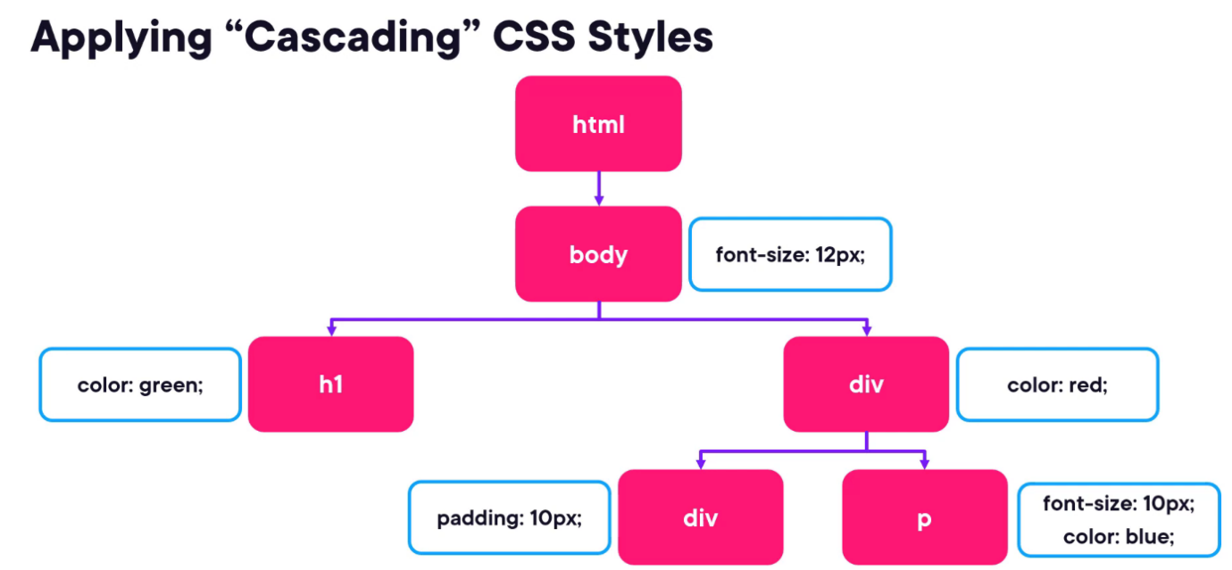](https://github.com/Naresh-Chaurasia/FullStack-Development-1/blob/main/html/img/css1.png)

#### 3.2. CSS Types of Selector

[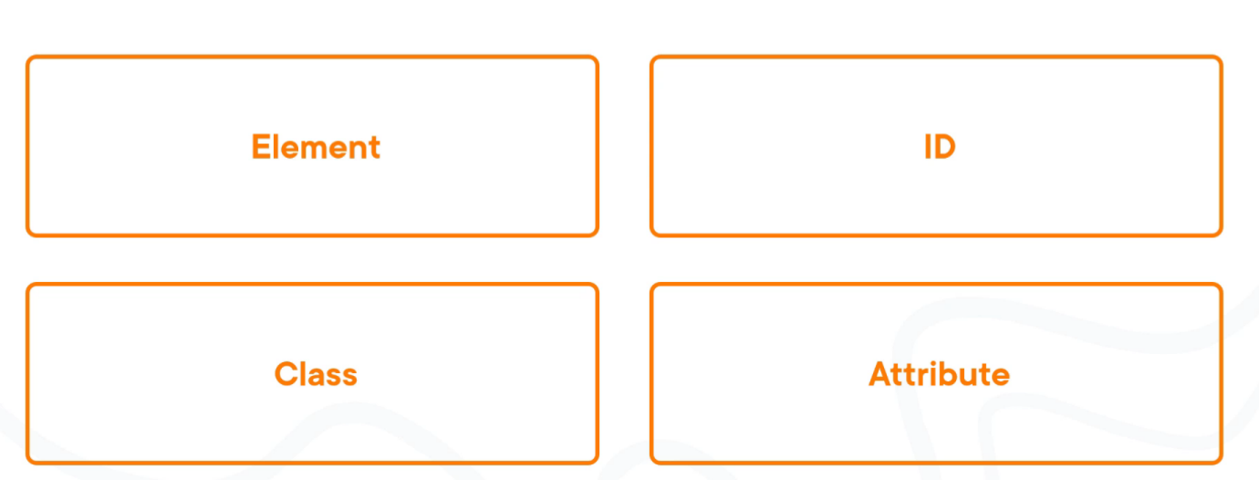](https://github.com/Naresh-Chaurasia/FullStack-Development-1/blob/main/html/css/css3.png)

[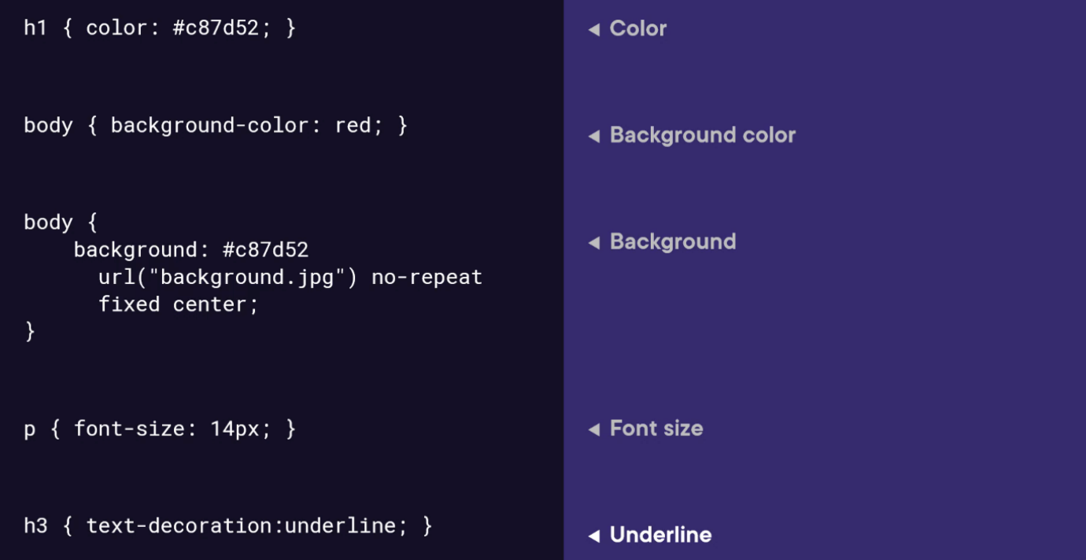](https://github.com/Naresh-Chaurasia/FullStack-Development-1/blob/main/html/css/css4.png)

##### HTML Element Selector:

The HTML element selector selects elements based on their HTML tag name.

<!DOCTYPE html>

<html lang="en">

<head>

<meta charset="UTF-8">

<meta name="viewport" content="width=device-width, initial-scale=1.0">

<title>HTML Element Selector Example</title>

<style>

/* Selects all <p> elements */

p {

color: blue;

}

</style>

</head>

<body>

<p>This is a paragraph with blue text.</p>

<p>This is another paragraph with blue text.</p>

</body>

</html>

##### ID Selector:

The ID selector selects an element based on its unique ID attribute.

<!DOCTYPE html>

<html lang="en">

<head>

<meta charset="UTF-8">

<meta name="viewport" content="width=device-width, initial-scale=1.0">

<title>ID Selector Example</title>

<style>

/* Selects the element with id="intro" */

#intro {

font-weight: bold;

}

</style>

</head>

<body>

<p id="intro">This paragraph has bold text.</p>

<p>This paragraph does not have bold text.</p>

</body>

</html>

##### Class Selector:

The class selector selects elements based on their class attribute.

<!DOCTYPE html>

<html lang="en">

<head>

<meta charset="UTF-8">

<meta name="viewport" content="width=device-width, initial-scale=1.0">

<title>Class Selector Example</title>

<style>

/* Selects all elements with class="highlight" */

.highlight {

background-color: yellow;

}

</style>

</head>

<body>

<p class="highlight">This paragraph has a yellow background.</p>

<p class="highlight">So does this paragraph.</p>

</body>

</html>

##### Attribute Selector:

The attribute selector selects elements based on their attributes.

<!DOCTYPE html>

<html lang="en">

<head>

<meta charset="UTF-8">

<meta name="viewport" content="width=device-width, initial-scale=1.0">

<title>Attribute Selector Example</title>

<style>

/* Selects all elements with the title attribute */

[title] {

color: red;

}

</style>

</head>

<body>

<p title="Tooltip text">This paragraph has red text.</p>

<p>This paragraph does not have red text.</p>

</body>

</html>

<!DOCTYPE html>

<html lang="en">

<head>

<meta charset="UTF-8">

<meta name="viewport" content="width=device-width, initial-scale=1.0">

<title>Attribute Equals Selector Example</title>

<style>

/* Selects input elements with type="text" */

input[type="text"] {

background-color: #f0f0f0;

border: 1px solid #ccc;

padding: 5px;

}

</style>

</head>

<body>

<label for="username">Username:</label>

<input type="text" id="username" name="username"><br>

<label for="password">Password:</label>

<input type="password" id="password" name="password">

</body>

</html>

In each example:

* CSS rules are applied to specific elements based on the selector used.
* You can see how each selector type targets elements differently based on their characteristics, such as tag name, ID, class, or attributes.

#### 3.3. Universal Selector

Certainly! The universal selector (*) selects all elements in an HTML document. It can be useful when you want to apply a style to all elements without specifying each element individually. Here’s an example:

<!DOCTYPE html>

<html lang="en">

<head>

<meta charset="UTF-8">

<meta name="viewport" content="width=device-width, initial-scale=1.0">

<title>Universal Selector Example</title>

<style>

/* Applies red text color to all elements */

* {

color: red;

}

</style>

</head>

<body>

<h1>This is a heading</h1>

<p>This is a paragraph.</p>

<a href="#">This is a link</a>

<div>This is a div</div>

<span>This is a span</span>

</body>

</html>

In this example:

* The universal selector * selects all elements in the HTML document.
* The CSS rule color: red; applies red text color to all elements.

While the universal selector can be useful for applying styles globally, it should be used with caution, as it can potentially override other styles unintentionally. It’s generally recommended to use more specific selectors whenever possible to target specific elements or groups of elements.

#### 3.4. CSS combinators

Sure! CSS combinators are used to specify relationships between different elements in the document tree. There are several types of combinators, including descendant combinator, child combinator, adjacent sibling combinator, and general sibling combinator. Here’s a simple example demonstrating each type of combinator:

**Descendant Combinator (space):**

Selects all elements that are descendants of a specified element.

<!DOCTYPE html>

<html lang="en">

<head>

<meta charset="UTF-8">

<meta name="viewport" content="width=device-width, initial-scale=1.0">

<title>Descendant Combinator Example</title>

<style>

/* Selects all paragraphs inside a div */

div p {

color: blue;

}

</style>

</head>

<body>

<div>

<p>This paragraph is blue.</p>

</div>

</body>

</html>

**Child Combinator (>):**

Selects all elements that are direct children of a specified element.

<!DOCTYPE html>

<html lang="en">

<head>

<meta charset="UTF-8">

<meta name="viewport" content="width=device-width, initial-scale=1.0">

<title>Child Combinator Example</title>

<style>

/* Selects all paragraphs that are direct children of a div */

div > p {

color: red;

}

</style>

</head>

<body>

<div>

<p>This paragraph is red.</p>

<div>

<p>This paragraph is not red.</p>

</div>

</div>

</body>

</html>

**Adjacent Sibling Combinator (+):**

Selects an element that is immediately preceded by a specified element.

<!DOCTYPE html>

<html lang="en">

<head>

<meta charset="UTF-8">

<meta name="viewport" content="width=device-width, initial-scale=1.0">

<title>Adjacent Sibling Combinator Example</title>

<style>

/* Selects the span immediately following a div */

div + span {

font-weight: bold;

}

</style>

</head>

<body>

<div>This div is followed by a bold span</div>

<span>This span is bold</span>

</body>

</html>

**General Sibling Combinator (~)**

Selects all elements that are siblings of a specified element.

<!DOCTYPE html>

<html lang="en">

<head>

<meta charset="UTF-8">

<meta name="viewport" content="width=device-width, initial-scale=1.0">

<title>General Sibling Combinator Example</title>

<style>

/* Selects all spans that are siblings of a div */

div ~ span {

color: green;

}

</style>

</head>

<body>

<div>This div is followed by a green span</div>

<span>This span is green</span>

<span>This span is also green</span>

</body>

</html>

These examples demonstrate how CSS combinators can be used to target specific elements based on their relationships with other elements in the document tree.

#### 3.5. Pseudo Classes

<!DOCTYPE html>

<html lang="en">

<head>

<meta charset="UTF-8">

<meta name="viewport" content="width=device-width, initial-scale=1.0">

<title>HTML Pseudo-class Examples</title>

<style>

/* Changes link color on hover */

a:hover {

color: red;

}

/* Changes link color when clicked */

a:active {

color: blue;

}

/* Adds outline when link is focused */

a:focus {

outline: 2px solid green;

}

/* Changes color of visited links */

a:visited {

color: purple;

}

</style>

</head>

<body>

<a href="https://example1.com">Hover over me</a><br><br>

<a href="https://example2.com">Click me</a><br><br>

<a href="https://example3.com">Tab and focus on me</a><br><br>

<a href="https://example4.com">Visited link</a>

</body>

</html>

#### 3.6. Animation 1

Certainly! Here’s an example of a CSS animation that makes a simple square element rotate continuously:

HTML:

<!DOCTYPE html>

<html lang="en">

<head>

<meta charset="UTF-8">

<meta name="viewport" content="width=device-width, initial-scale=1.0">

<title>CSS Animation Example</title>

<link rel="stylesheet" href="styles.css">

</head>

<body>

<div class="square"></div>

</body>

</html>

CSS (styles.css):

.square {

width: 100px;

height: 100px;

background-color: red;

animation: rotateSquare 2s linear infinite; /* Animation name, duration, timing function, and iteration count */

}

@keyframes rotateSquare {

/* Define animation keyframes */

from {

transform: rotate(0deg); /* Initial state */

}

to {

transform: rotate(360deg); /* Final state */

}

}

In this example:

* We have an HTML <div> element with the class "square".
* In the CSS, we define the initial appearance of the square (red color, 100x100px size).
* We use the @keyframes rule to define the animation named "rotateSquare". This animation rotates the square from 0 degrees to 360 degrees.
* The animation is applied to the square using the animation property, specifying the animation name, duration (2 seconds), timing function (linear), and iteration count (infinite).
* As a result, the square will continuously rotate clockwise around its center. You can adjust the animation properties and keyframes to create different effects.

#### 3.7. Animation 2

Certainly! Here’s another example that utilizes various properties of CSS animations:

HTML:

<!DOCTYPE html>

<html lang="en">

<head>

<meta charset="UTF-8">

<meta name="viewport" content="width=device-width, initial-scale=1.0">

<title>CSS Animation Example</title>

<link rel="stylesheet" href="styles.css">

</head>

<body>

<div class="circle"></div>

</body>

</html>

CSS (styles.css):

.circle {

width: 100px;

height: 100px;

background-color: blue;

border-radius: 50%; /* Create a circle shape */

animation: bounceCircle 2s ease-in-out infinite alternate; /* Animation properties */

animation-delay: 1s; /* Delay before animation starts */

animation-fill-mode: both; /* Apply animation styles before and after the animation */

}

@keyframes bounceCircle {

0% {

transform: translateY(0); /* Initial state */

}

50% {

transform: translateY(-100px); /* Midway state */

background-color: red; /* Change color midway */

}

100% {

transform: translateY(0); /* Final state */

}

}

In this example:

* We have an HTML <div> element with the class "circle".
* In the CSS, we define the initial appearance of the circle (blue color, 100x100px size, border-radius to make it a circle).
* We use the @keyframes rule to define the animation named "bounceCircle". This animation moves the circle up by 100px, changes its color to red midway, and then moves it back down.
* The animation is applied to the circle using the animation property, specifying the animation name ("bounceCircle"), duration (2 seconds), timing function (ease-in-out), iteration count (infinite), and direction (alternate).
* Additionally, we use animation-delay to start the animation after a delay of 1 second, and animation-fill-mode to apply the animation styles before and after the animation.

Eg:

<!DOCTYPE html>

<html>

<head>

<style>

div {

width:200px;

height:200px;

position: absolute;

background-color: orange;

animation:anim 5s linear infinite;

}

@keyframes anim {

    0% {background-color: red;  top:0px;}

 75% {background-color: green;  top:100px;}

 100% {background-color: grey;  top:0px;}

}

</style>

</head>

<body>

<h2>CSS Animation</h2>

<div></div>

<p>Adding keyframes are must for the

CSS animation. The keyframe decides the

style or animation of the element at

certain times. </p>

</body>

</html>

<!DOCTYPE html>

<html lang="en">

<head>

    <meta charset="UTF-8">

    <meta name="viewport" content="width=device-width, initial-scale=1.0">

    <title>Document</title>

    <style>

#one{

    width: 100px;

    height:100px;

    background-color: blue;

    animation: ram 2s ease-in-out infinite;

    position: absolute;

}

@keyframes ram {

    form{

        top:0px;

    }

    to{

        top: 100px;

    }

}

    </style>

</head>

<body>

    <div id="one">

    </div>

</body>

</html>

Media query:

<!DOCTYPE html>

<html>

<head>

<style>

body {

  background-color: tan;

  color: black;

}

/* On screens that are 992px wide or less, the background color is blue */

@media screen and (max-width: 992px) {

  body {

    background-color: blue;

    color: white;

  }

}

/* On screens that are 600px wide or less, the background color is olive */

@media screen and (max-width: 600px) {

  body {

    background-color: olive;

    color: white;

  }

}

</style>

</head>

<body>

<h1>Resize the browser window to see the effect!</h1>

<p>By default, the background color of the document is "tan". If the screen size is 992px or less, the color will change to "blue". If it is 600px or less, it will change to "olive".</p>

</body>

</html>

**3.13. Sectioning Semantic Elements**

[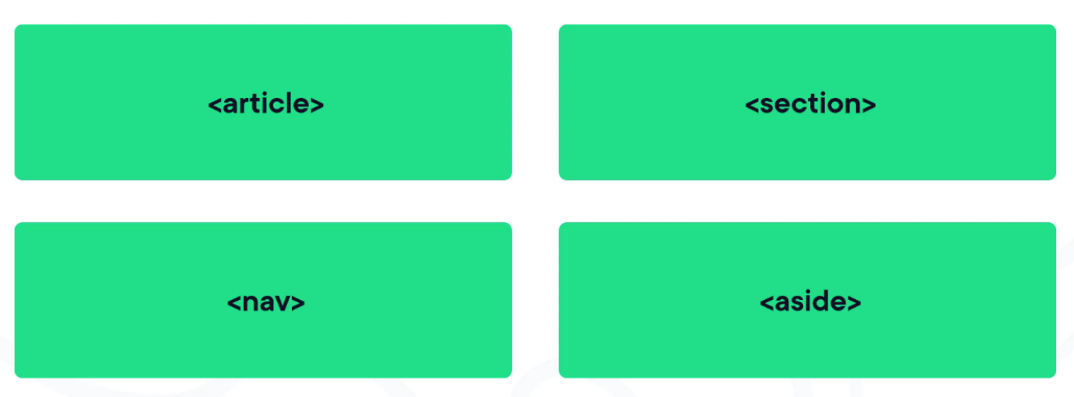](https://github.com/Naresh-Chaurasia/FullStack-Development-1/blob/main/html/img/sections.png)

Which semantic elements can we use instead to place on our page then. Well, HTML comes with four elements in the sectioning content category. **Article** is used to contain standalone content to an article really, this could be a blog post or a story. Inside this, we can, of course, use our headings or paragraphs. Next, the **section**. This is a very generic element used to define, well, a section in the page. Don’t use a section for just layout purposes though. That is where we will still use the div element. The **nav** element is used to contain navigational links and the main menu and it’s typically used in the header of the page. Not all links on the page go in a nav section though. Only the real menu of links within your site will typically go in there. Finally, the **aside** is used to contain related content, so related to the main content of the document. It’s typically used for things, such as quotes, or can also contain links separate from the main content.

**3.14. Flow Content**

[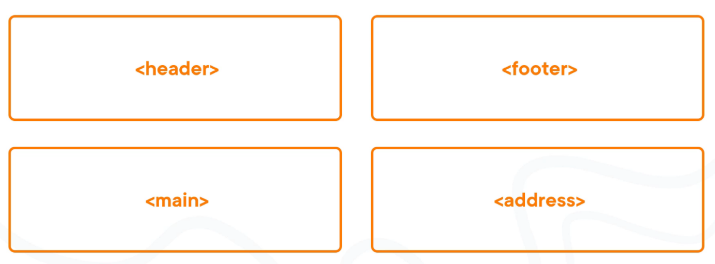](https://github.com/Naresh-Chaurasia/FullStack-Development-1/blob/main/html/img/flow.png)

**3.15. CSS Box Model**

[](https://github.com/Naresh-Chaurasia/FullStack-Development-1/blob/main/html/img/box-model.png)

[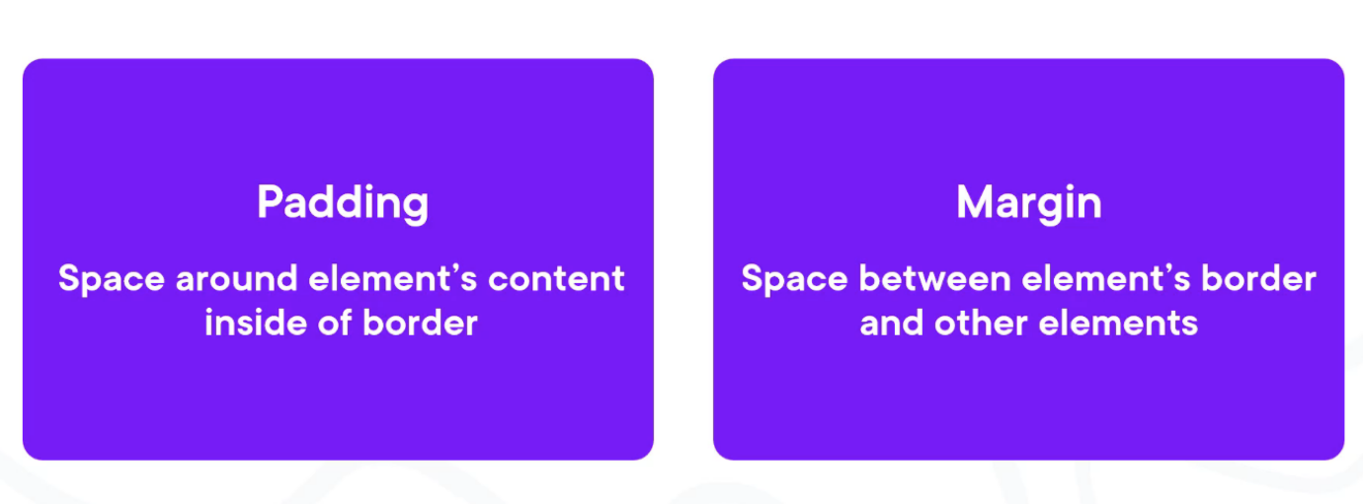](https://github.com/Naresh-Chaurasia/FullStack-Development-1/blob/main/html/img/padding-margin.png)

**4. Padding & Margin**

<!DOCTYPE html>

<html lang="en">

<head>

<meta charset="UTF-8">

<meta name="viewport" content="width=device-width, initial-scale=1.0">

<title>Padding and Margin Example</title>

<style>

.box {

width: 200px;

height: 100px;

background-color: lightblue;

border: 2px solid blue;

padding: 20px;

margin: 50px;

}

</style>

</head>

<body>

<div class="box">This is a box with padding and margin.</div>

</body>

</html>

Hsl:h:0-360,100%,100%

#ff0000-red

Background:url

Background-position:left left

Background-repeat:repeat-x,y,no-repeat

Border:

Border-style:double,dashed,dotted,solid,groove,ridge,outset,inset,none

Border-width:thick solid medium

Border-color:

# JavaScript

Table of Contents

* [1. How to Start](https://github.com/Naresh-Chaurasia/FullStack-Development-1/blob/main/JavaScript/JavaScript.adoc#how-to-start)
* [2. var V/s let, var-let, let-var](https://github.com/Naresh-Chaurasia/FullStack-Development-1/blob/main/JavaScript/JavaScript.adoc#var-vs-let-var-let-let-var)
* [3. Infinity](https://github.com/Naresh-Chaurasia/FullStack-Development-1/blob/main/JavaScript/JavaScript.adoc#infinity)
* [4. Undefined](https://github.com/Naresh-Chaurasia/FullStack-Development-1/blob/main/JavaScript/JavaScript.adoc#undefined)
* [5. Data Types](https://github.com/Naresh-Chaurasia/FullStack-Development-1/blob/main/JavaScript/JavaScript.adoc#data-types)
* [6. JavaScript Engines](https://github.com/Naresh-Chaurasia/FullStack-Development-1/blob/main/JavaScript/JavaScript.adoc#javascript-engines)
* [7. Script in <body/> tag](https://github.com/Naresh-Chaurasia/FullStack-Development-1/blob/main/JavaScript/JavaScript.adoc#script-in-body-tag)
* [8. JS typeof](https://github.com/Naresh-Chaurasia/FullStack-Development-1/blob/main/JavaScript/JavaScript.adoc#js-typeof)
* [9. Objects 1](https://github.com/Naresh-Chaurasia/FullStack-Development-1/blob/main/JavaScript/JavaScript.adoc#objects-1)
* [10. Objects 2](https://github.com/Naresh-Chaurasia/FullStack-Development-1/blob/main/JavaScript/JavaScript.adoc#objects-2)
* [11. Array, Arrays](https://github.com/Naresh-Chaurasia/FullStack-Development-1/blob/main/JavaScript/JavaScript.adoc#array-arrays)
  + [11.1. Array Sort](https://github.com/Naresh-Chaurasia/FullStack-Development-1/blob/main/JavaScript/JavaScript.adoc#array-sort)
  + [11.2. Array Concat](https://github.com/Naresh-Chaurasia/FullStack-Development-1/blob/main/JavaScript/JavaScript.adoc#array-concat)
* [12. Spread Operator](https://github.com/Naresh-Chaurasia/FullStack-Development-1/blob/main/JavaScript/JavaScript.adoc#spread-operator)
* [13. JS Function](https://github.com/Naresh-Chaurasia/FullStack-Development-1/blob/main/JavaScript/JavaScript.adoc#js-function)
* [14. JS Function Default Values](https://github.com/Naresh-Chaurasia/FullStack-Development-1/blob/main/JavaScript/JavaScript.adoc#js-function-default-values)
* [15. JS Factory Function](https://github.com/Naresh-Chaurasia/FullStack-Development-1/blob/main/JavaScript/JavaScript.adoc#js-factory-function)
* [16. Object Enumeration](https://github.com/Naresh-Chaurasia/FullStack-Development-1/blob/main/JavaScript/JavaScript.adoc#object-enumeration)
* [17. Object Cloning](https://github.com/Naresh-Chaurasia/FullStack-Development-1/blob/main/JavaScript/JavaScript.adoc#object-cloning)
* [18. Constructors](https://github.com/Naresh-Chaurasia/FullStack-Development-1/blob/main/JavaScript/JavaScript.adoc#constructors)
* [19. Constructor V/s Factory](https://github.com/Naresh-Chaurasia/FullStack-Development-1/blob/main/JavaScript/JavaScript.adoc#constructor-vs-factory)
* [20. IF-ELSE](https://github.com/Naresh-Chaurasia/FullStack-Development-1/blob/main/JavaScript/JavaScript.adoc#if-else)
* [21. SWITCH-CASE](https://github.com/Naresh-Chaurasia/FullStack-Development-1/blob/main/JavaScript/JavaScript.adoc#switch-case)
* [22. Difference: IF-ELSE V/s SWITCH-CASE](https://github.com/Naresh-Chaurasia/FullStack-Development-1/blob/main/JavaScript/JavaScript.adoc#difference-if-else-vs-switch-case)
* [23. For Loop](https://github.com/Naresh-Chaurasia/FullStack-Development-1/blob/main/JavaScript/JavaScript.adoc#for-loop)
* [24. While](https://github.com/Naresh-Chaurasia/FullStack-Development-1/blob/main/JavaScript/JavaScript.adoc#while)
* [25. Do While](https://github.com/Naresh-Chaurasia/FullStack-Development-1/blob/main/JavaScript/JavaScript.adoc#do-while)
* [26. Break and Continue](https://github.com/Naresh-Chaurasia/FullStack-Development-1/blob/main/JavaScript/JavaScript.adoc#break-and-continue)
* [27. For In, For-In](https://github.com/Naresh-Chaurasia/FullStack-Development-1/blob/main/JavaScript/JavaScript.adoc#for-in-for-in)
* [28. For Of, For-Of](https://github.com/Naresh-Chaurasia/FullStack-Development-1/blob/main/JavaScript/JavaScript.adoc#for-of-for-of)
* [29. For In V/s For Of](https://github.com/Naresh-Chaurasia/FullStack-Development-1/blob/main/JavaScript/JavaScript.adoc#for-in-vs-for-of)
* [30. Iterable](https://github.com/Naresh-Chaurasia/FullStack-Development-1/blob/main/JavaScript/JavaScript.adoc#iterable)
* [31. Value V/s Reference Types](https://github.com/Naresh-Chaurasia/FullStack-Development-1/blob/main/JavaScript/JavaScript.adoc#value-vs-reference-types)
* [32. JavaScript Math](https://github.com/Naresh-Chaurasia/FullStack-Development-1/blob/main/JavaScript/JavaScript.adoc#javascript-math)
* [33. JavaScript String](https://github.com/Naresh-Chaurasia/FullStack-Development-1/blob/main/JavaScript/JavaScript.adoc#javascript-string)
* [34. JavaScript Operators](https://github.com/Naresh-Chaurasia/FullStack-Development-1/blob/main/JavaScript/JavaScript.adoc#javascript-operators)
* [35. Template Literal](https://github.com/Naresh-Chaurasia/FullStack-Development-1/blob/main/JavaScript/JavaScript.adoc#template-literal)
* [36. Asynchronous JavaScript: Promises, Callbacks, Async Await](https://github.com/Naresh-Chaurasia/FullStack-Development-1/blob/main/JavaScript/JavaScript.adoc#asynchronous-javascript-promises-callbacks-async-await)
  + [36.1. Sync & Async](https://github.com/Naresh-Chaurasia/FullStack-Development-1/blob/main/JavaScript/JavaScript.adoc#sync-async)
  + [36.2. Event Loop](https://github.com/Naresh-Chaurasia/FullStack-Development-1/blob/main/JavaScript/JavaScript.adoc#event-loop)
  + [36.3. Call Stack](https://github.com/Naresh-Chaurasia/FullStack-Development-1/blob/main/JavaScript/JavaScript.adoc#call-stack)
  + [36.4. Task Queue](https://github.com/Naresh-Chaurasia/FullStack-Development-1/blob/main/JavaScript/JavaScript.adoc#task-queue)
* [37. JS-Functions, JavaScript-Functions](https://github.com/Naresh-Chaurasia/FullStack-Development-1/blob/main/JavaScript/JavaScript.adoc#js-functions-javascript-functions)
  + [37.1. Arrow Functions](https://github.com/Naresh-Chaurasia/FullStack-Development-1/blob/main/JavaScript/JavaScript.adoc#arrow-functions)
  + [37.2. Functions](https://github.com/Naresh-Chaurasia/FullStack-Development-1/blob/main/JavaScript/JavaScript.adoc#functions)
  + [37.3. Hoisting](https://github.com/Naresh-Chaurasia/FullStack-Development-1/blob/main/JavaScript/JavaScript.adoc#hoisting)
* [38. Try, Catch, Finally](https://github.com/Naresh-Chaurasia/FullStack-Development-1/blob/main/JavaScript/JavaScript.adoc#try-catch-finally)
* [39. Local V/s Global](https://github.com/Naresh-Chaurasia/FullStack-Development-1/blob/main/JavaScript/JavaScript.adoc#local-vs-global)
* [40. Local Scope:](https://github.com/Naresh-Chaurasia/FullStack-Development-1/blob/main/JavaScript/JavaScript.adoc#local-scope)
* [41. Global Scope:](https://github.com/Naresh-Chaurasia/FullStack-Development-1/blob/main/JavaScript/JavaScript.adoc#global-scope)
* [42. This Keyword](https://github.com/Naresh-Chaurasia/FullStack-Development-1/blob/main/JavaScript/JavaScript.adoc#this-keyword)
* [43. Garbage Collection](https://github.com/Naresh-Chaurasia/FullStack-Development-1/blob/main/JavaScript/JavaScript.adoc#garbage-collection)
* [44. ES6 Javascript](https://github.com/Naresh-Chaurasia/FullStack-Development-1/blob/main/JavaScript/JavaScript.adoc#es6-javascript)
  + [44.1. Array Iteraror, Iterator-Functions](https://github.com/Naresh-Chaurasia/FullStack-Development-1/blob/main/JavaScript/JavaScript.adoc#array-iteraror-iterator-functions)

### 1. How to Start

<!DOCTYPE html>

<html lang="en">

<head>

<script src="./first.js"></script>

</head>

<body>

Inspect and See Console

</body>

</html>

let count=1;

console.log(count);

### 2. var V/s let, var-let, let-var

In JavaScript, both var and let are used for variable declaration, but they have some differences in terms of scoping and hoisting.

**var**

* Variables declared with var are function-scoped or globally scoped, meaning they are accessible anywhere within the function in which they are declared, or globally if declared outside of any function.

Here’s an example:

function example() {

if (true) {

var x = 10;

}

console.log(x); // Outputs 10

}

example();

console.log(x); // Throws ReferenceError: x is not defined

In this example, even though x is declared inside the if block, it is accessible outside of it due to hoisting. This is because var declarations are hoisted to the top of the function.

**let**

* Variables declared with let are block-scoped, meaning they are only accessible within the block (enclosed by curly braces) in which they are declared.

Example:

function example() {

if (true) {

let y = 20;

}

console.log(y); // Throws ReferenceError: y is not defined

}

example();

In this example, y is declared with let inside the if block, so it’s only accessible within that block. Trying to access it outside the block results in a ReferenceError because y is not defined in that scope.

So, in summary:

* Use var for variables that need to have function or global scope and may be accessed before they are declared due to hoisting.
* Use let for variables that need block scope and should not be accessed before their declaration within the block. It’s generally preferred over var due to its more predictable scoping behavior.

**Summary**: The introduction of let in ES6 (ECMAScript 2015) provided JavaScript developers with more predictable and manageable variable scoping behavior, addressing some of the pitfalls associated with var. let is generally preferred over var in modern JavaScript development due to its block scoping and improved handling of variable declarations. However, var is still widely used, especially in legacy codebases or for specific use cases where function-scoped behavior is desired

### 3. Infinity

Certainly! In JavaScript, Infinity represents the mathematical concept of positive infinity. It’s a special numeric value that represents a number greater than any other number. Here’s an example:

let positiveInfinity = Infinity;

console.log(positiveInfinity); // Output: Infinity

console.log(10 / 0); // Output: Infinity

console.log(Number.POSITIVE_INFINITY); // Output: Infinity

In this example:

* positiveInfinity is assigned the value Infinity.
* Performing division by zero (10 / 0) in JavaScript results in Infinity.
* Number.POSITIVE_INFINITY is a predefined constant representing positive infinity.

### 4. Undefined

let x;

console.log(x); // Output: undefined

function example() {

let y;

console.log(y); // Output: undefined

}

example();

### 5. Data Types

// Number

let integer = 10;

let floatingPoint = 3.14;

// String

let message = "Hello, world!";

// Boolean

let isTrue = true;

let isFalse = false;

// Undefined

let undefinedVar;

// Null

let nullVar = null;

// Perform some operations

console.log("Sum of integer and floatingPoint:", integer + floatingPoint);

console.log("Concatenation of message and name:", message + " " + person.name);

### 6. JavaScript Engines

[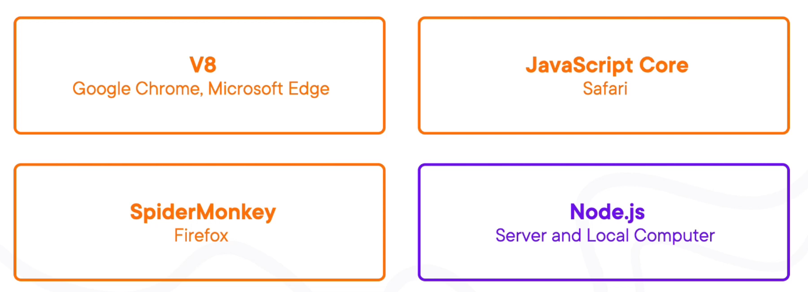](https://github.com/Naresh-Chaurasia/FullStack-Development-1/blob/main/JavaScript/images/engines.png)

### 7. Script in <body/> tag

Yes, you can add <script> tags directly within the <body> tag of an HTML document. Placing scripts in the <body> tag is common, especially for scripts that are specific to the content of the page or that need to be executed after the page content has loaded.

Here’s an example of how you can include a script within the <body> tag:

<!DOCTYPE html>

<html lang="en">

<head>

<meta charset="UTF-8">

<meta name="viewport" content="width=device-width, initial-scale=1.0">

<title>Script in Body Tag</title>

</head>

<body>

<h1>Hello, world!</h1>

<!-- JavaScript code placed within the body tag -->

<script>

console.log("This script is placed within the body tag.");

// Your JavaScript code goes here

</script>

</body>

</html>

Placing scripts at the end of the <body> tag can also improve the loading performance of your webpage because it allows the browser to render the HTML content first before loading and executing any scripts. This way, users can see the content of the page more quickly while scripts are being downloaded and processed in the background.

### 8. JS typeof

Certainly! The typeof operator in JavaScript is used to determine the data type of a variable or expression. It returns a string indicating the type of the operand. Here’s an example demonstrating the use of typeof with different types of variables:

// Example variables of different types

let num = 10; // Number

let str = "Hello"; // String

let bool = true; // Boolean

let arr = [1, 2, 3]; // Array

let obj = { key: "value" }; // Object

let func = function() {}; // Function

let undef; // Undefined

let nul = null; // Null

// Using typeof to determine the type of each variable

console.log(typeof num); // Output: "number"

console.log(typeof str); // Output: "string"

console.log(typeof bool); // Output: "boolean"

console.log(typeof arr); // Output: "object" (Arrays are of type "object")

console.log(typeof obj); // Output: "object"

console.log(typeof func); // Output: "function"

console.log(typeof undef); // Output: "undefined"

console.log(typeof nul); // Output: "object" (Historical quirk in JavaScript)

Here are the results you would expect:

* typeof num: returns "number"
* typeof str: returns "string"
* typeof bool: returns "boolean"
* typeof arr: returns "object" (Arrays are technically objects in JavaScript)
* typeof obj: returns "object"
* typeof func: returns "function"
* typeof undef: returns "undefined"
* typeof nul: returns "object" (This is a historical quirk in JavaScript; null is considered an object)

Understanding the data types of variables in JavaScript is crucial for writing robust and error-free code, and typeof is a handy tool for such purposes.

### 9. Objects 1

|  |  |
| --- | --- |
| Note | If you want to make object dynamic, you have to use Factory Function |

Sure! Below is an example of creating an object representing a student in JavaScript and performing some operations on that object:

// Define the student object

let student = {

name: "John Doe",

age: 20,

grade: "A",

courses: ["Math", "Science", "English"],

// Method to display student information

displayInfo: function() {

console.log("Name: " + this.name);

console.log("Age: " + this.age);

console.log("Grade: " + this.grade);

console.log("Courses: " + this.courses.join(", "));

},

// Method to add a new course

addCourse: function(course) {

this.courses.push(course);

console.log(course + " has been added to the courses.");

},

// Method to change the grade

changeGrade: function(newGrade) {

this.grade = newGrade;

console.log("Grade has been updated to " + newGrade);

}

};

// Display student information

console.log("Initial student information:");

student.displayInfo();

// Add a new course

student.addCourse("History");

// Change the grade

student.changeGrade("B");

// Display updated student information

console.log("Updated student information:");

student.displayInfo();

In this example:

* The student object contains properties such as name, age, grade, and courses. It also contains methods like displayInfo, addCourse, and changeGrade.
* The displayInfo method displays the student’s information.
* The addCourse method adds a new course to the courses array of the student.
* The changeGrade method updates the student’s grade.
* We create an instance of the student object and then perform operations such as displaying information, adding a new course, and changing the grade.

This example demonstrates how objects in JavaScript can encapsulate both data (properties) and behavior (methods), allowing you to organize and manipulate related data and actions efficiently.

### 10. Objects 2

Certainly! Here’s an example of handling object attributes without using methods:

// Define the student object

let student = {

name: "John Doe",

age: 20,

grade: "A",

courses: ["Math", "Science", "English"]

};

// Display student information

console.log("Student information:");

console.log("Name: " + student.name);

console.log("Age: " + student.age);

console.log("Grade: " + student.grade);

console.log("Courses: " + student.courses.join(", "));

// Add a new course

student.courses.push("History");

console.log("Course added: History");

// Change the grade

student.grade = "B";

console.log("Grade changed to B");

// Display updated student information

console.log("Updated student information:");

console.log("Name: " + student.name);

console.log("Age: " + student.age);

console.log("Grade: " + student.grade);

console.log("Courses: " + student.courses.join(", "));

In this example:

* We define the student object with properties such as name, age, grade, and courses.
* We access and display the values of these properties directly using dot notation (student.name, student.age, etc.).
* We modify the courses array by using the push method to add a new course.
* We directly assign a new value to the grade property to change the student’s grade.
* Finally, we display the updated information about the student.

This approach works well for simple operations on object attributes. However, as the complexity of the operations increases, using methods to encapsulate the behavior becomes more beneficial for code organization and reusability.

Example 1

Let's see an example to display the sum of given numbers.

**<script>**

var add=new Function("num1","num2","return num1+num2");

document.writeln(add(2,5));

**</script>**

Example 2

Let's see an example to display the power of provided value.

1. **<script>**
2. var pow=new Function("num1","num2","return Math.pow(num1,num2)");
3. document.writeln(pow(2,3));
4. **</script>**

## **1) JavaScript Object by object literal**

The syntax of creating object using object literal is given below:

1. object={property1:value1,property2:value2.....propertyN:valueN}

As you can see, property and value is separated by : (colon).

Let’s see the simple example of creating object in JavaScript.

1. **<script>**
2. emp={id:102,name:"Shyam Kumar",salary:40000}
3. document.write(emp.id+" "+emp.name+" "+emp.salary);
4. **</script>**

[**Test it Now**](https://www.javatpoint.com/oprweb/test.jsp?filename=object1js)

#### Output of the above example

102 Shyam Kumar 40000

## **2) By creating instance of Object**

The syntax of creating object directly is given below:

1. var objectname=new Object();

Here, **new keyword** is used to create object.

Let’s see the example of creating object directly.

1. **<script>**
2. var emp=new Object();
3. emp.id=101;
4. emp.name="Ravi Malik";
5. emp.salary=50000;
6. document.write(emp.id+" "+emp.name+" "+emp.salary);
7. **</script>**

[**Test it Now**](https://www.javatpoint.com/oprweb/test.jsp?filename=object2js)

#### Output of the above example

101 Ravi 50000

## **3) By using an Object constructor**

Here, you need to create function with arguments. Each argument value can be assigned in the current object by using this keyword.

The **this keyword** refers to the current object.

The example of creating object by object constructor is given below.

1. **<script>**
2. function emp(id,name,salary){
3. this.id=id;
4. this.name=name;
5. this.salary=salary;
6. }
7. e=new emp(103,"Vimal Jaiswal",30000);
9. document.write(e.id+" "+e.name+" "+e.salary);
10. **</script>**

[**Test it Now**](https://www.javatpoint.com/oprweb/test.jsp?filename=object3js)

#### Output of the above example

103 Vimal Jaiswal 30000

## **Accessing JavaScript Properties**

The syntax for accessing the property of an object is:

// *objectName.property*  
let age = person.age;

or

//*objectName*["*property*"]  
let age = person["age"];

or

//*objectName*[*expression*]  
let age = person[x];

### Examples

person.firstname + " is " + person.age + " years old.";

[Try it Yourself »](https://www.w3schools.com/js/tryit.asp?filename=tryjs_object_properties1)

person["firstname"] + " is " + person["age"] + " years old.";

[Try it Yourself »](https://www.w3schools.com/js/tryit.asp?filename=tryjs_object_properties2)

person["firstname"] + " is " + person["age"] + " years old.";

[Try it Yourself »](https://www.w3schools.com/js/tryit.asp?filename=tryjs_object_properties6)

Adding new var and fun to object:

<!DOCTYPE html>

<html>

<body>

<h1>JavaScript Object Properties</h1>

<h2>Adding a new Property</h2>

<p id="demo"></p>

<script>

const person = {

firstname: "John",

lastname: "Doe",

age: 50,

eyecolor: "blue"

};

person.nationality = "English";

person.ram=function(){

document.write("Ram");

}

document.getElementById("demo").innerHTML =

person.firstname + " is " + person.nationality + "."+person.ram();

</script>

</body>

</html>

Deleting from object:

<!DOCTYPE html>

<html>

<body>

<h1>JavaScript Object Properties</h1>

<h2>Deleting a Property</h2>

<p id="demo"></p>

<script>

const person = {

firstname: "John",

lastname: "Doe",

age: 50,

eyecolor: "blue"

};

delete person.age;

document.getElementById("demo").innerHTML =

person.firstname + " is " + person.age + " years old.";

</script>

</body>

</html>

Object in Object:

<!DOCTYPE html>

<html>

<body>

<h1>JavaScript Objects</h1>

<h2>Accessing Nested Objects</h2>

<p id="demo"></p>

<script>

// Create nested Objects

const myObj = {

name: "John",

age: 30,

myCars: {

car1: "Ford",

car2: "BMW",

car3: "Fiat"

}

}

document.getElementById("demo").innerHTML = myObj.myCars.car2;

</script>

</body>

</html>

Example:

<!DOCTYPE html>

<html>

<body>

<h1>JavaScript Objects</h1>

<p id="demo"></p>

<script>

// Create an Object

const person = {

firstName: "John",

lastName: "Doe",

id: 5566,

};

// Add a Method

person.name = function() {

return (this.firstName + " " + this.lastName).toUpperCase();

};

// Display Object Data

document.getElementById("demo").innerHTML =

"My father is " + person.name();

</script>

</body>

</html>

### 11. Array, Arrays

## **Using the JavaScript Keyword new**

The following example also creates an Array, and assigns values to it:

### Example

const cars = new Array("Saab", "Volvo", "BMW");

eg:

<!DOCTYPE html>

<html>

<body>

<h1>JavaScript Arrays</h1>

<h2>Bracket Indexing</h2>

<p>JavaScript array elements are accessed using numeric indexes (starting from 0).</p>

<p id="demo"></p>

<script>

const cars = ["Saab", "Volvo", "BMW"];

cars[0] = ["Opel",1];

document.getElementById("demo").innerHTML = cars;

document.getElementById("demo").innerHTML =typeof cars[1]

</script>

</body>

</html>

o/p:

# JavaScript Arrays

## Bracket Indexing

JavaScript array elements are accessed using numeric indexes (starting from 0).

string

Sure! Here’s an example of a JavaScript array:

// Creating an array of numbers

let numbers = [1, 2, 3, 4, 5];

// Accessing elements of the array

console.log("First element:", numbers[0]); // Output: 1

console.log("Third element:", numbers[2]); // Output: 3

// Modifying elements of the array

numbers[1] = 10; // Changing the second element to 10

console.log("Modified array:", numbers); // Output: [1, 10, 3, 4, 5]

// Adding elements to the array

numbers.push(6); // Adding 6 to the end of the array

console.log("Array after adding element:", numbers); // Output: [1, 10, 3, 4, 5, 6]

// Removing elements from the array

let removedElement = numbers.pop(); // Removing the last element (6) from the array

console.log("Array after removing element:", numbers); // Output: [1, 10, 3, 4, 5]

console.log("Removed element:", removedElement); // Output: 6

// Iterating over the array

console.log("Array elements:");

for (let i = 0; i < numbers.length; i++) {

console.log(numbers[i]);

}

In this example:

* We create an array called numbers containing integers from 1 to 5.
* We access elements of the array using square brackets notation (numbers[0], numbers[2]).
* We modify elements of the array by assigning new values to specific indices (numbers[1] = 10).
* We add elements to the end of the array using the push method (numbers.push(6)).
* We remove elements from the end of the array using the pop method (numbers.pop()).
* We iterate over the array using a for loop, accessing each element using its index (numbers[i]).

#### 11.1. Array Sort

let numbers = [5, 3, 9, 1, 7];

// Sort the number array

numbers.sort();

console.log("Sorted numbers:", numbers); // Output: [1, 3, 5, 7, 9]

let fruits = ["Banana", "Orange", "Apple", "Mango"];

// Sort the string array

fruits.sort();

console.log("Sorted fruits:", fruits); // Output: ["Apple", "Banana", "Mango", "Orange"]

#### 11.2. Array Concat

let array1 = [1, 2, 3];

let array2 = [4, 5, 6];

// Concatenate array2 to array1

let newArray = array1.concat(array2);

console.log(newArray); // Output: [1, 2, 3, 4, 5, 6]

let array1 = [1, 2, 3];

let array2 = [4, 5, 6];

let array3 = [7, 8, 9];

// Concatenate array2 and array3 to array1

let newArray = array1.concat(array2, array3);

console.log(newArray); // Output: [1, 2, 3, 4, 5, 6, 7, 8, 9]

The splice() method in JavaScript is used to change the contents of an array by removing or replacing existing elements and/or adding new elements. It modifies the original array and returns an array containing the removed elements, if any.

Here’s an example of using the splice() method:

// Define an array

const fruits = ['apple', 'banana', 'cherry', 'date'];

// Remove elements starting from index 1 (banana) and add 'orange' and 'grape' in their place

const removedFruits = fruits.splice(1, 2, 'orange', 'grape');

// Output the modified array

console.log(fruits); // Output: ['apple', 'orange', 'grape', 'date']

// Output the removed elements

console.log(removedFruits); // Output: ['banana', 'cherry']

In this example:

* The splice(1, 2, 'orange', 'grape') call removes two elements starting from index 1 (inclusive) in the fruits array ('banana' and 'cherry') and replaces them with 'orange' and 'grape'. So, after the operation, the fruits array becomes ['apple', 'orange', 'grape', 'date'].
* The splice() method returns an array containing the removed elements ('banana' and 'cherry' in this case), which is stored in the removedFruits variable.
* Both the modified array (fruits) and the array of removed elements (removedFruits) are logged to the console for demonstration.

To add elements at a specific location in an array in JavaScript, you can use the splice() method. The splice() method not only removes elements but also allows you to insert new elements at a specified index.

Here’s an example of adding elements at a specific location in an array:

// Define an array

let fruits = ['apple', 'banana', 'cherry', 'date'];

// Insert 'orange' and 'grape' between 'banana' and 'cherry'

fruits.splice(2, 0, 'orange', 'grape');

// Output the modified array

console.log(fruits); // Output: ['apple', 'banana', 'orange', 'grape', 'cherry', 'date']

In this example:

* The splice(2, 0, 'orange', 'grape') call inserts the elements 'orange' and 'grape' at index 2 (after 'banana') in the fruits array without removing any elements.
* After the operation, the fruits array becomes ['apple', 'banana', 'orange', 'grape', 'cherry', 'date'] with 'orange' and 'grape' inserted between 'banana' and 'cherry'.
* The modified array (fruits) is logged to the console for demonstration.

So, splice() allows you to add elements at a specific location in an array while optionally removing existing elements at the same time.

### 12. Spread Operator

The spread operator (…​) is a feature introduced in ECMAScript 6 (ES6) that allows an iterable (like an array or string) to be expanded into individual elements.

Here’s how the spread operator is used:

**1. Array Literals**:

let arr1 = [1, 2, 3];

let arr2 = [...arr1, 4, 5, 6]; // Spread arr1 into individual elements

console.log(arr2); // Output: [1, 2, 3, 4, 5, 6]

**2. Function Arguments**:

function sum(a, b, c) {

return a + b + c;

}

let numbers = [1, 2, 3];

console.log(sum(...numbers)); // Spread numbers array into function arguments

**3. Concatenating Arrays**:

let arr1 = [1, 2, 3];

let arr2 = [4, 5, 6];

let combinedArray = [...arr1, ...arr2]; // Spread both arrays into a new array

console.log(combinedArray); // Output: [1, 2, 3, 4, 5, 6]

**4. Copying Arrays**:

let originalArray = [1, 2, 3];

let copyArray = [...originalArray]; // Spread original array into a new array

console.log(copyArray); // Output: [1, 2, 3]

console.log(originalArray === copyArray); // Output: false (different reference)

### 13. JS Function

Sure! Here’s a JavaScript function that simulates the steps to make a cup of coffee:

function makeCoffee() {

// Step 1: Boil water

console.log("Step 1: Boiling water...");

// Step 2: Grind coffee beans

console.log("Step 2: Grinding coffee beans...");

// Step 3: Brew coffee

console.log("Step 3: Brewing coffee...");

// Step 4: Pour coffee into a cup

console.log("Step 4: Pouring coffee into a cup...");

// Step 5: Add sugar and milk (optional)

console.log("Step 5: Adding sugar and milk (optional)...");

// Step 6: Enjoy your coffee!

console.log("Step 6: Your coffee is ready! Enjoy!");

}

// Call the function to make coffee

makeCoffee();

In this function:

* Step 1: Boiling water is simulated by logging a message to the console.
* Step 2: Grinding coffee beans is simulated similarly.
* Step 3: Brewing coffee is simulated.
* Step 4: Pouring coffee into a cup is simulated.
* Step 5: Adding sugar and milk (optional) is simulated.
* Step 6: A message is logged indicating that the coffee is ready to be enjoyed.

You can call makeCoffee() to execute these steps and simulate making a cup of coffee.

### 14. JS Function Default Values

// Function with default parameter values

function greet(name = "Guest", greeting = "Hello") {

console.log(`${greeting}, ${name}!`);

}

// Calling the function without arguments

greet(); // Output: Hello, Guest!

// Calling the function with one argument

greet("Alice"); // Output: Hello, Alice!

// Calling the function with two arguments

greet("Bob", "Hi"); // Output: Hi, Bob!

### 15. JS Factory Function

Certainly! Factory functions in JavaScript are functions that return objects. They’re called "factory" functions because they’re used to create and return new instances of objects. Here’s a very simple example:

// Factory function to create person objects

function createPerson(name, age) {

return {

name: name,

age: age,

// Method to display person's information

displayInfo: function() {

console.log(`Name: ${this.name}, Age: ${this.age}`);

}

};

}

// Create a person using the factory function

let person1 = createPerson("Alice", 30);

// Display person's information

person1.displayInfo(); // Output: Name: Alice, Age: 30

In this example:

* The createPerson function is a factory function that takes name and age parameters and returns an object representing a person.
* Inside the factory function, we create and return an object literal with properties for name and age, along with a method displayInfo to display the person’s information.
* We use the factory function to create a person1 object with the name "Alice" and age 30.
* We then call the displayInfo method of the person1 object to display its information.

Factory functions are commonly used in JavaScript to encapsulate object creation logic and provide a way to create multiple instances of objects with similar characteristics.

### 16. Object Enumeration

let car = {

brand: "Toyota",

model: "Camry",

year: 2020,

start: function() {

console.log("Starting the " + this.brand + " " + this.model);

},

stop: function() {

console.log("Stopping the " + this.brand + " " + this.model);

}

};

// Enumerating properties of the car object

for (let key in car) {

if (typeof car[key] !== "function") {

console.log(key + ": " + car[key]);

}

}

### 17. Object Cloning

In JavaScript, you can clone an object using various methods. One common approach is to use the spread operator (…​) or Object.assign() method for shallow copying. Here’s an example using the spread operator to clone a simple object:

// Original object

let originalObject = {

name: "John",

age: 30,

city: "New York"

};

// Cloning the object using the spread operator

let clonedObject = { ...originalObject };

// Modifying the cloned object

clonedObject.name = "Alice";

// Outputting the original and cloned objects

console.log("Original Object:", originalObject);

console.log("Cloned Object:", clonedObject);

This will output:

Original Object: { name: 'John', age: 30, city: 'New York' }

Cloned Object: { name: 'Alice', age: 30, city: 'New York' }

In this example, the originalObject is cloned into clonedObject using the spread operator (…​). Any modifications made to clonedObject do not affect the originalObject, as they are separate instances.

### 18. Constructors

Sure! In JavaScript, you can use constructor functions to create objects with a common structure or blueprint. Constructor functions are similar to classes in other programming languages. Here’s an example of a simple constructor function for creating person objects:

// Constructor function for creating person objects

function Person(name, age, gender) {

this.name = name;

this.age = age;

this.gender = gender;

// Method to display person's information

this.displayInfo = function() {

console.log("Name: " + this.name);

console.log("Age: " + this.age);

console.log("Gender: " + this.gender);

};

}

// Creating person objects using the constructor function

let person1 = new Person("John", 30, "male");

let person2 = new Person("Alice", 25, "female");

// Displaying information about the person objects

person1.displayInfo();

person2.displayInfo();

In this example:

* We define a constructor function Person that takes parameters name, age, and gender.
* Inside the constructor function, we use the this keyword to assign values to properties of the newly created object.
* We also define a method displayInfo within the constructor function to display the person’s information.
* We create two person objects person1 and person2 using the new keyword followed by the constructor function, passing the necessary parameters.
* Finally, we call the displayInfo method on each person object to display their information.

Constructor functions are commonly used in JavaScript to create objects with a predefined structure and behavior. They allow you to create multiple instances of objects with similar characteristics.

### 19. Constructor V/s Factory

Both constructor functions and factory functions in JavaScript are used to create objects, but they differ in their approach to object creation and the way they handle object initialization.

1. **Constructor Function**:
   * Constructor functions are defined using the function keyword and are invoked using the new keyword.
   * They are used to create and initialize objects with a common structure or blueprint.
   * Properties and methods are assigned to the object using this inside the constructor function.
   * Each instance created with a constructor function has its own copy of methods, which can lead to memory inefficiency when creating multiple instances.
   * Example:

function Person(name, age) {

this.name = name;

this.age = age;

this.greet = function() {

console.log("Hello, my name is " + this.name);

};

}

let person1 = new Person("John", 30);

1. **Factory Function**:
   * Factory functions are regular JavaScript functions that return objects.
   * They are used to create and return new objects without using the new keyword.
   * Properties and methods are defined within the factory function and added to the object before returning it.
   * Example:

function createPerson(name, age) {

return {

name: name,

age: age,

greet: function() {

console.log("Hello, my name is " + this.name);

}

};

}

let person2 = createPerson("Alice", 25);

The choice between them depends on the specific requirements of your application and coding style preferences.

| **Characteristic** | **Constructor** | **Factory Function** |
| --- | --- | --- |
| Syntax | Defined using the function keyword and typically starts with a capital letter. | Defined using the function keyword, no specific naming convention. |
| Usage of new keyword | Requires the new keyword to create new instances. | Does not require the new keyword. |
| Return value | Implicitly returns the newly created object. | Returns the object explicitly using the return keyword. |

### 20. IF-ELSE

// Example of if...else statement

let temperature = 25;

if (temperature > 30) {

console.log("It's hot outside!");

} else if (temperature > 20) {

console.log("It's warm outside.");

} else {

console.log("It's cold outside.");

}

### 21. SWITCH-CASE

// Example of switch statement

let day = "Monday";

switch (day) {

case "Monday":

console.log("It's Monday!");

break;

case "Tuesday":

console.log("It's Tuesday!");

break;

case "Wednesday":

console.log("It's Wednesday!");

break;

case "Thursday":

console.log("It's Thursday!");

break;

case "Friday":

console.log("It's Friday!");

break;

case "Saturday":

case "Sunday":_

console.log("It's the weekend!");

break;

default:

console.log("Invalid day!");

}

### 22. Difference: IF-ELSE V/s SWITCH-CASE

|  |  |  |
| --- | --- | --- |
| Feature | if…​else | switch…​case |
| Syntax | if (condition) { | switch (expression) { |
|  | // code block | case value1: |
|  | } else if (condition) { | // code block |
|  | // code block | case value2: |
|  | } else { | // code block |
|  | // code block | default: |
|  | } | // code block |
| Expression | Supports arbitrary conditions and | Compares a single expression to |
|  | expressions using logical operators | multiple possible values |
| Control Flow | Linear control flow with branching | Jump-based control flow with case |
|  | for each condition | labels and branching for matched cases |
| Matching | Supports complex conditions and | Limited to simple value comparisons |
|  | expression evaluation | (equality comparisons only) |
| Default Behavior | Executes the first matching condition | Executes the code block associated |
|  | or the else block if none match | with the first matching case label or |
|  |  | the default block if no match found |
| Efficiency | Suitable for evaluating conditions | More efficient for multiple |
|  | with few possible outcomes | conditions with fixed values |
| Flexibility | More flexible for complex conditions | Less flexible due to limited syntax |
|  | and expressions | and comparison options |

### 23. For Loop

// Using a for loop to iterate from 1 to 5

for (let i = 1; i <= 5; i++) {

console.log("Iteration " + i);

}

### 24. While

// Initialize a counter variable

let counter = 0;

// Define the while loop

while (counter < 5) {

console.log("Counter is: " + counter);

counter++; // Increment the counter

}

console.log("Loop ended.");

### 25. Do While

// Initialize a counter variable

let counter = 0;

// Define the do-while loop

do {

console.log("Counter is: " + counter);

counter++; // Increment the counter

} while (counter < 5);

console.log("Loop ended.");

### 26. Break and Continue

// Example of using break

for (let i = 0; i < 10; i++) {

console.log(i);

if (i === 5) {

console.log("Reached 5, breaking loop");

break; // Exit the loop when i equals 5

}

}

// Example of using continue

for (let i = 0; i < 10; i++) {

if (i === 5) {

console.log("Skipping 5");

continue; // Skip the rest of the loop body when i equals 5

}

console.log(i);

}

### 27. For In, For-In

// Define an object

let person = {

name: "John",

age: 30,

gender: "male"

};

// Iterate over the properties of the object

for (let key in person) {

console.log(key + ": " + person[key]);

}

### 28. For Of, For-Of

// Define an array

let fruits = ["Apple", "Banana", "Orange"];

// Iterate over the elements of the array

for (let fruit of fruits) {

console.log(fruit);

}

### 29. For In V/s For Of

|  |  |  |
| --- | --- | --- |
| Feature | for…​of | for…​in |
| Used for iterating over | Iterable objects (arrays, strings, maps, sets, etc.) | Enumerable properties of objects |
| Iterates over | Values of the iterable | Keys of the object |
| Order of iteration | Preserves the order of elements in the iterable | May not preserve the order of properties |
| Used with | Arrays, strings, maps, sets, etc. | Objects (enumerable) |
| Example | let arr = [1, 2, 3]; for (let val of arr) { console.log(val); } | let obj = { key1: 'value1', key2: 'value2', key3: 'value3' }; for (let key in obj) { console.log(key + ': ' + obj[key]); } |

### 30. Iterable

Imagine you have a basket full of fruits - apples, bananas, and oranges. Now, let’s say you want to go through each fruit in the basket, one by one. You start with the first fruit, then move to the next one, and so on until you’ve checked them all.

In programming, we often deal with collections of things, like this basket of fruits. An iterable is like a collection that lets you go through its elements, just like you would go through the fruits in the basket.

For example, think of a book with chapters. Each chapter is like an element in the collection. An iterable book allows you to "read" through each chapter one after another.

So, when we say something is iterable in programming, it means you can go through its parts, like flipping through the pages of a book or picking fruits from a basket, one at a time.

In JavaScript, arrays are a common type of iterable. You can loop through each item in an array, just like going through each fruit in the basket. Other iterable things in JavaScript might be lists of items, like a list of tasks or a list of friends' names.

### 31. Value V/s Reference Types

In JavaScript, variables can hold two types of values: primitive values and reference values. Understanding the difference between these two types is crucial for understanding how values are stored and manipulated in JavaScript.

Here’s a summary of value vs reference types in JavaScript:

**Value Types (Primitive Types)**:

* Primitive types are immutable and stored directly in the variable’s memory location.
* When you assign a primitive value to a variable, a copy of the value is made.
* Examples of primitive types include:
* String: Represents a sequence of characters.
* Number: Represents numeric data.
* Boolean: Represents a logical value (true or false).
* Undefined: Represents an uninitialized variable.
* Null: Represents the intentional absence of any object value.
* Symbol (introduced in ECMAScript 6): Represents a unique identifier.
* Operations on primitive types directly manipulate the value stored in the variable.
* Example:

let num1 = 10;

let num2 = num1; // Copying the value of num1 to num2

num2 = 20; // Changing the value of num2 does not affect num1

console.log(num1); // Output: 10

**Reference Types (Objects)**:

* Reference types are mutable and are stored as a reference to the object’s location in memory.
* When you assign a reference value to a variable, you are storing a reference to the object’s memory location, not the actual object.
* Examples of reference types include:
* Object: Represents a collection of key-value pairs.
* Array: Represents a collection of elements.
* Function: Represents a reusable block of code.
* Date: Represents a date and time.
* User-defined objects.
* Operations on reference types manipulate the reference to the object, not the object itself.
* Example:

let obj1 = { name: 'John' };

let obj2 = obj1; // Copying the reference of obj1 to obj2

obj2.name = 'Alice'; // Modifying obj2 affects obj1 as well

console.log(obj1.name); // Output: Alice

**Summary**:

* Value types are copied by value, meaning changes to one variable do not affect another.
* Reference types are copied by reference, meaning changes to one variable may affect others referencing the same object.

Understanding the distinction between value and reference types is essential for writing efficient and bug-free JavaScript code.

### 32. JavaScript Math

// Math.round(): Rounds a number to the nearest integer

let num1 = 4.7;

console.log(Math.round(num1)); // Output: 5

// Math.ceil(): Rounds a number up to the nearest integer

let num2 = 4.1;

console.log(Math.ceil(num2)); // Output: 5

// Math.floor(): Rounds a number down to the nearest integer

let num3 = 4.9;

console.log(Math.floor(num3)); // Output: 4

// Math.max(): Returns the highest value from a list of numbers

console.log(Math.max(10, 5, 20)); // Output: 20

// Math.min(): Returns the lowest value from a list of numbers

console.log(Math.min(10, 5, 20)); // Output: 5

// Math.random(): Generates a random floating-point number between 0 (inclusive) and 1 (exclusive)

console.log(Math.random()); // Output: A random number between 0 and 1

// Math.pow(): Returns the result of raising the first argument to the power of the second argument

console.log(Math.pow(2, 3)); // Output: 8 (2 raised to the power of 3)

// Math.sqrt(): Returns the square root of a number

console.log(Math.sqrt(16)); // Output: 4

// Math.abs(): Returns the absolute (positive) value of a number

console.log(Math.abs(-10)); // Output: 10

### 33. JavaScript String

var str="Hi all, Ram is good boy, hi how are u";

console.log(str.charAt(1));

console.log(str.charCodeAt(1));

console.log(str.concat("raj"));

console.log(str.endsWith("boy"));

console.log(str.startsWith("all"));

console.log(str.toLocaleLowerCase());

console.log(str.toLowerCase());

console.log(str.toLocaleUpperCase());

console.log(str.toUpperCase());

console.log(str.indexOf("i"));

console.log(str.indexOf("i",4));

console.log(str.lastIndexOf("i"));

console.log(str.includes("hi"));

console.log(str.search(/hi/gi));

console.log(str.match(/hi/gi));

console.log(str.match(/hi/g));

console.log(str.match(/hi/));

console.log(str.match("hi"));

console.log(str.padStart(50,"-"));

console.log(str.padEnd(50,"-"));

console.log(str.substr(1,5));

console.log(str.substring(1,5));

### o/p:

### i

### first.js:38 105

### first.js:39 Hi all, Ram is good boy, hi how are uraj

### first.js:40 false

### first.js:41 false

### first.js:42 hi all, ram is good boy, hi how are u

### first.js:43 hi all, ram is good boy, hi how are u

### first.js:44 HI ALL, RAM IS GOOD BOY, HI HOW ARE U

### first.js:45 HI ALL, RAM IS GOOD BOY, HI HOW ARE U

### first.js:46 1

### first.js:47 12

### first.js:48 26

### first.js:49 true

### first.js:50 0

### first.js:51 (2) ['Hi', 'hi']

### first.js:52 ['hi']

### first.js:53 ['hi', index: 25, input: 'Hi all, Ram is good boy, hi how are u', groups: undefined]

### first.js:54 ['hi', index: 25, input: 'Hi all, Ram is good boy, hi how are u', groups: undefined]

### first.js:55 -------------Hi all, Ram is good boy, hi how are u

### first.js:56 Hi all, Ram is good boy, hi how are u-------------

### first.js:57 i all

### first.js:58 i al

// String length

let str = "Hello, world!";

console.log("Length of string:", str.length); // Output: 13

// Convert to uppercase

console.log("Uppercase:", str.toUpperCase()); // Output: HELLO, WORLD!

// Convert to lowercase

console.log("Lowercase:", str.toLowerCase()); // Output: hello, world!

// Get a substring

console.log("Substring:", str.substring(7)); // Output: world!

// Get a substring with start and end index

console.log("Substring with indices:", str.substring(7, 12)); // Output: world

// Split a string into an array

console.log("Split into array:", str.split(", ")); // Output: ["Hello", "world!"]

// Replace a substring

console.log("Replace substring:", str.replace("world", "universe")); // Output: Hello, universe!

// Check if a string contains a substring

console.log("Contains 'world'?", str.includes("world")); // Output: true

// Trim leading and trailing whitespace

let str3 = " Trimmed string ";

console.log("Trimmed string:", str3.trim()); // Output: Trimmed string

### 34. JavaScript Operators

Certainly! Here are examples of some common JavaScript operators:

1. **Arithmetic Operators**:

let x = 10;

let y = 5;

console.log("Addition:", x + y); // Addition: 15

console.log("Subtraction:", x - y); // Subtraction: 5

console.log("Multiplication:", x * y); // Multiplication: 50

console.log("Division:", x / y); // Division: 2

console.log("Modulus:", x % y); // Modulus: 0 (remainder of division)

console.log("Increment:", ++x); // Increment: 11

console.log("Decrement:", --y); // Decrement: 4

1. **Comparison Operators**:

let a = 5;

let b = 10;

console.log("Equal to:", a === b); // Equal to: false

console.log("Not equal to:", a !== b); // Not equal to: true

console.log("Greater than:", a > b); // Greater than: false

console.log("Less than:", a < b); // Less than: true

console.log("Greater than or equal to:", a >= b); // Greater than or equal to: false

console.log("Less than or equal to:", a <= b); // Less than or equal to: true

1. **Logical Operators**:

let p = true;

let q = false;

console.log("Logical AND:", p && q); // Logical AND: false

console.log("Logical OR:", p || q); // Logical OR: true

console.log("Logical NOT:", !p); // Logical NOT: false

1. **Assignment Operators**:

let num = 10;

num += 5; // Equivalent to num = num + 5

console.log(num); // 15

num -= 3; // Equivalent to num = num - 3

console.log(num); // 12

num *= 2; // Equivalent to num = num * 2

console.log(num); // 24

num /= 4; // Equivalent to num = num / 4

console.log(num); // 6

num %= 5; // Equivalent to num = num % 5

console.log(num); // 1

These examples cover arithmetic, comparison, logical, and assignment operators in JavaScript.

### 35. Template Literal

Certainly! Template literals are a convenient way to create strings in JavaScript, especially when you need to include variables or expressions within the string. Here’s an example:

let name = "Alice";

let age = 30;

// Using template literals to create a string

let greeting = `Hello, my name is ${name} and I am ${age} years old.`;

console.log(greeting);

### 36. Asynchronous JavaScript: Promises, Callbacks, Async Await

#### 36.1. Sync & Async

function print1() {

const number1 = 1;

console.log(number1);

}

function print2() {

function getNumber2() {

return 2;

}

const number2 = getNumber2();

console.log(number2);

}

function print3() {

const fs = require('fs');

fs.readFile('./number3.txt', 'utf-8', function (err, number3) {

console.log(number3);

});

}

function print4() {

const number4 = 4;

console.log(number4);

}

print1();

print2();

print3();

print4();

[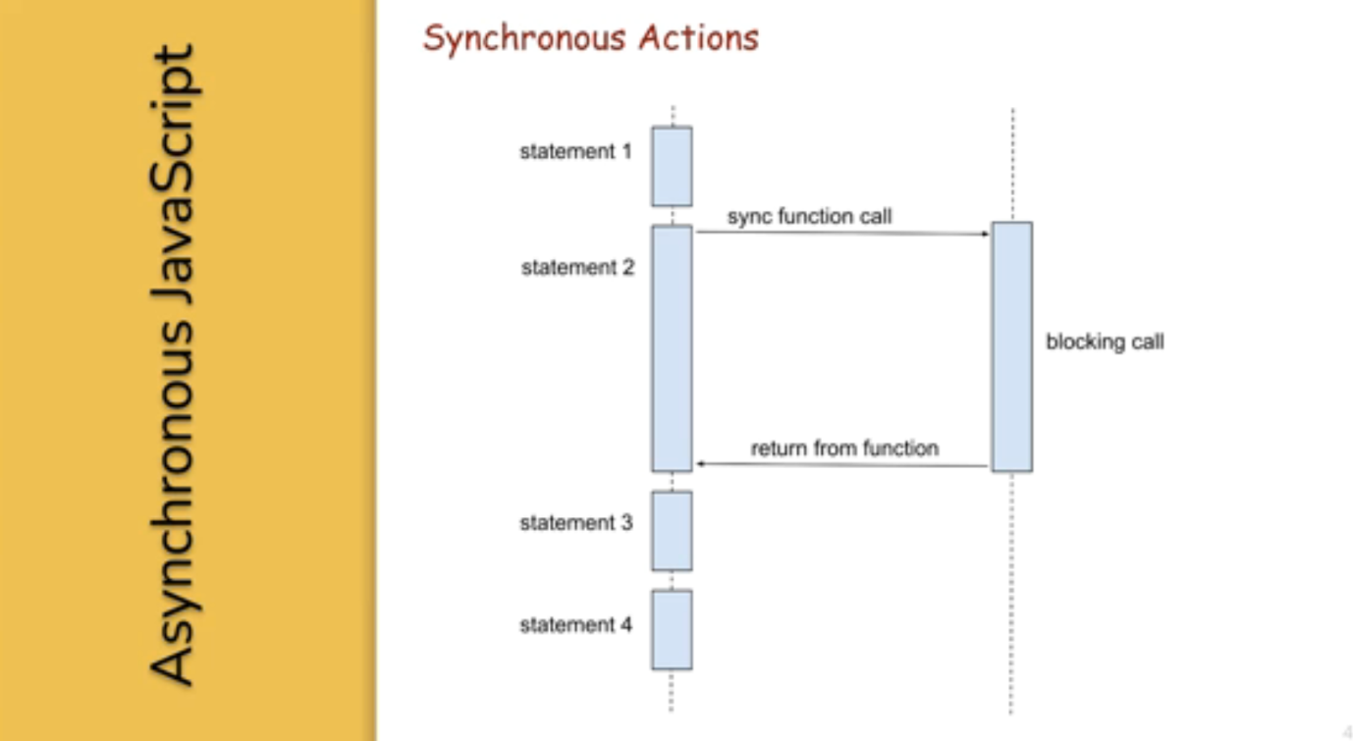](https://github.com/Naresh-Chaurasia/FullStack-Development-1/blob/main/JavaScript/images/async1.png)

[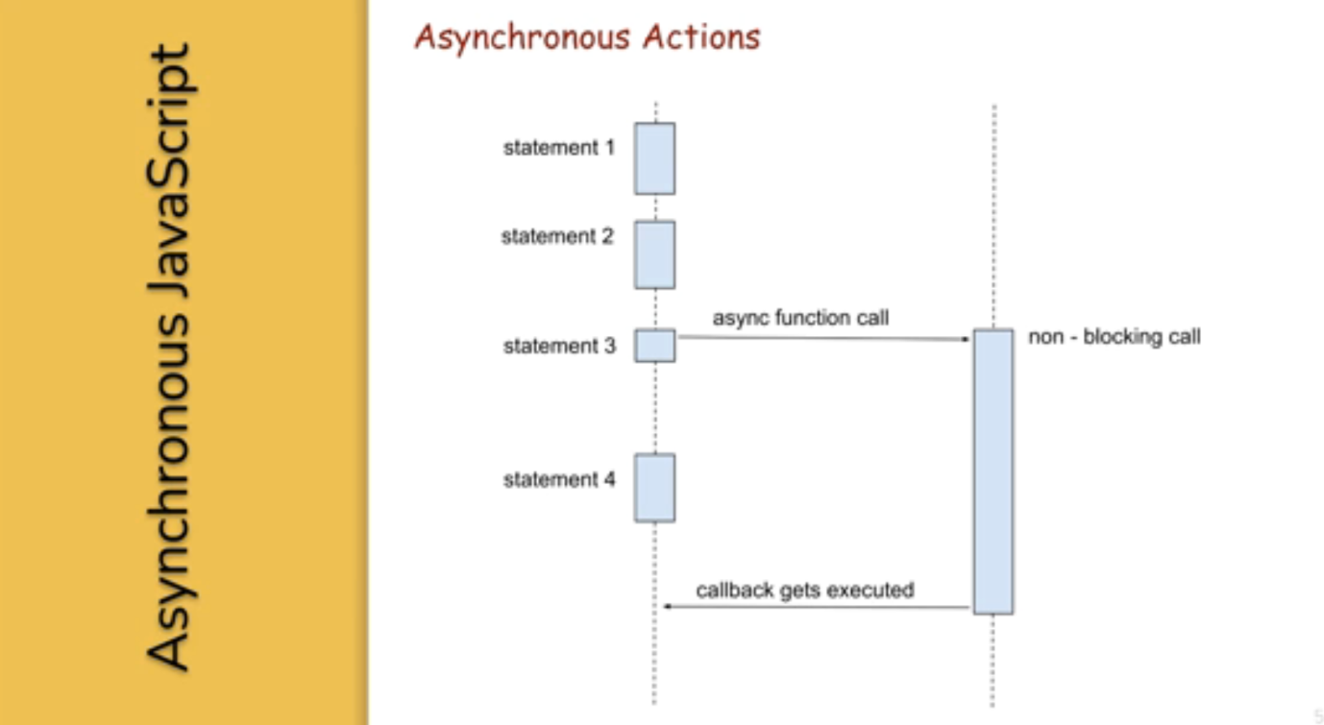](https://github.com/Naresh-Chaurasia/FullStack-Development-1/blob/main/JavaScript/images/async2.png)

#### 36.2. Event Loop

#### 36.3. Call Stack

#### 36.4. Task Queue

### 37. JS-Functions, JavaScript-Functions

#### 37.1. Arrow Functions

**Arrow Functions / Anonymous Functions / Lambda Functions**

**A**

function helloWorld() {

console.log("Hello, World!");

}

const helloWorld = () => {

console.log("Hello, World!");

};

**B**

// Normal function with two integer arguments

function add(a, b) {

return a + b;

}

// Call the add function with two integer arguments

let result = add(5, 3);

console.log("Result:", result); // Output: Result: 8

// Arrow function with two integer arguments

const add = (a, b) => {

return a + b;

};

// Call the arrow function with two integer arguments

let result = add(5, 3);

console.log("Result:", result); // Output: Result: 8

#### 37.2. Functions

**Named Function and Function Expression (Anonymous Function)**

// Named function definition

function greet(name) {

console.log("Hello, " + name + "!");

}

// Call the named function

greet("Alice"); // Output: Hello, Alice!

// Function expression (anonymous function)

let greet = function(name) {

console.log("Hello, " + name + "!");

};

// Call the function expression

greet("Bob"); // Output: Hello, Bob

| **Characteristic** | **Named Functions** | **Function Expressions** |
| --- | --- | --- |
| Clarity | Provides a clear and descriptive name for the function. | Offers flexibility in defining functions without necessarily giving them a name. |
| Recursion | Suitable for recursion as they can refer to themselves by name. | Can also support recursion if assigned to a variable, but it’s not as straightforward. |
| Hoisting | The entire function is hoisted to the top of its scope. | Only the variable declaration (if any) is hoisted, not the function definition. |
| Flexibility | Limited flexibility as the function must have a name. | Offers more flexibility, especially when creating functions dynamically or anonymously. |

#### 37.3. Hoisting

JavaScript hoisting is a behavior where variable and function declarations are moved to the top of their containing scope during the compilation phase, before the code is executed. This means that regardless of where variables and functions are declared in the code, they are effectively "hoisted" to the top of their containing scope, making them accessible throughout the entire scope.

Here’s an example to illustrate hoisting with function declarations and let variables:

// Function declaration

greet(); // Output: Hello!

function greet() {

console.log("Hello!");

}

// Variable declaration with let

console.log(x); // Error: Cannot access 'x' before initialization

let x = 5;

console.log(x); // Output: 5

In this example:

* The function greet is declared using the function keyword before it’s called. Even though the function is called before its declaration in the code, JavaScript hoisting moves the function declaration to the top of its containing scope during the compilation phase. As a result, greet is accessible and can be called before its actual declaration.
* The variable x is declared with let but not initialized before it’s used. Therefore, trying to access it before the declaration results in a ReferenceError. Once x is declared and initialized with let x = 5;, it can be accessed and used normally within its scope.

Hoisting applies to both function and variable declarations but behaves differently for variables declared with let and const compared to var. With let and const, the variable is hoisted to the top of its containing block but remains uninitialized (in a "temporal dead zone") until its actual declaration in the code.

### 38. Try, Catch, Finally

Certainly! Here’s a simple example of using try and catch in JavaScript:

try {

// Code that might throw an error

let result = 10 / 0; // This will throw a division by zero error

console.log("Result:", result); // This line won't be executed

} catch (error) {

// Code to handle the error

console.log("An error occurred:", error.message);

} finally {

// Code that will always execute, regardless of whether an error occurred or not

console.log("Finally block executed.");

}

In this example:

* We have a try block containing the code that might throw an error. In this case, we attempt to divide 10 by 0, which results in a division by zero error.
* If an error occurs within the try block, the control is transferred to the catch block. The catch block contains code to handle the error. In this example, we log the error message to the console.
* The finally block contains code that will always execute, regardless of whether an error occurred or not. In this example, we log a message indicating that the finally block is executed.
* If no error occurs within the try block, the catch block is skipped, and the control moves directly to the finally block.

This structure allows you to gracefully handle errors in your JavaScript code and execute cleanup tasks even if an error occurs.

### 39. Local V/s Global

In JavaScript, variables can have either local scope or global scope, depending on where they are declared.

### 40. Local Scope:

Variables declared inside a function have local scope. This means they can only be accessed within the function in which they are declared.

function myFunction() {

let localVar = "I'm a local variable";

console.log(localVar); // Accessible within the function

}

myFunction(); // Output: I'm a local variable

console.log(localVar); // Error: localVar is not defined (outside the function)

In this example, localVar is a local variable defined inside the myFunction function. It can be accessed and used only within the myFunction function. Attempting to access it outside of the function results in a ReferenceError.

### 41. Global Scope:

Variables declared outside of any function have global scope. This means they can be accessed from anywhere in the script.

let globalVar = "I'm a global variable";

function myFunction() {

console.log(globalVar); // Accessible within the function

}

myFunction(); // Output: I'm a global variable

console.log(globalVar); // Output: I'm a global variable

In this example, globalVar is a global variable declared outside of any function. It can be accessed from both inside and outside of the myFunction function.

It’s important to be cautious when using global variables, as they can lead to naming conflicts and make it harder to debug and maintain your code. It’s generally recommended to limit the use of global variables and prefer local variables whenever possible to encapsulate logic and prevent unintended side effects.

### 42. This Keyword

In JavaScript, the this keyword refers to the context within which a function is executed, while an object is a collection of key-value pairs where each value can be accessed using its corresponding key.

To demonstrate that this can refer to an object, you can define a method within an object and access properties of that object using this.

With out this in object creation in function we cannot use it.

Eg:

const person = {

firstName: "John",

lastName: "Doe",

id: 5566,

fullName : function() {

return firstName + " " + lastName;

}

};

No o/p

Eg2:

var firstName;

var lastName;

const person = {

firstName: "John",

lastName: "Doe",

id: 5566,

fullName : function() {

return firstName + " " + lastName;

}

};

o/p:

undefined undefined

Here’s an example:

const myObject = {

property1: 'value1',

property2: 'value2',

method: function() {

console.log(this.property1); // accessing property1 using this

console.log(this.property2); // accessing property2 using this

}

};

myObject.method(); // calling the method

In this example:

* myObject is an object containing properties property1 and property2, as well as a method method.
* Inside the method, this refers to the myObject itself.
* By using this, you can access properties (property1 and property2) of the myObject from within the method.

When you call myObject.method(), it logs the values of property1 and property2 to the console, proving that this refers to the object itself.

This demonstrates that this can indeed refer to the object in which it is used.

Certainly! In the global context, this typically refers to the global object, which is window in browsers and global in Node.js. Here’s an example in a browser environment:

console.log(this === window); // true

function test() {

console.log(this === window); // true

}

test();

In this example:

* Outside of any function or object, this refers to the global object (window in browsers).
* Inside the test function, which is called without an explicit context, this also refers to the global object (window).

When you run this code in a browser environment, both console.log statements will output true, indicating that this refers to the global object (window) in both cases.

### 43. Garbage Collection

Sure! Let’s imagine you have a big box (which represents your computer’s memory) where you can store different things (like numbers, words, or lists) while you’re working on your computer.

1. **Storing Things**: When you create something in JavaScript, like a variable or an object, it gets put into this big box in your computer’s memory.
2. **Using Things**: As you work on your program, you might create new things or use the ones you’ve already made. These things stay in the box as long as your program needs them.
3. **Cleaning Up**: Sometimes, though, you don’t need certain things anymore because your program doesn’t use them. In JavaScript, when things are no longer needed, the computer’s "cleaner" (called the garbage collector) comes along and removes them from the memory box. This helps keep the box organized and prevents it from getting too full.
4. **Freeing Up Space**: By removing things you don’t need anymore, the garbage collector frees up space in the memory box for new things you might create later. This helps your program run smoothly and efficiently.

In simple terms, garbage collection in JavaScript is like having a helper that comes by to tidy up your computer’s memory by removing things you don’t need anymore, so there’s always room for the things you’re currently using.

## 44. ES6 Javascript

|  |  |
| --- | --- |
| Note | forEach. Iterate each element in the list. |

[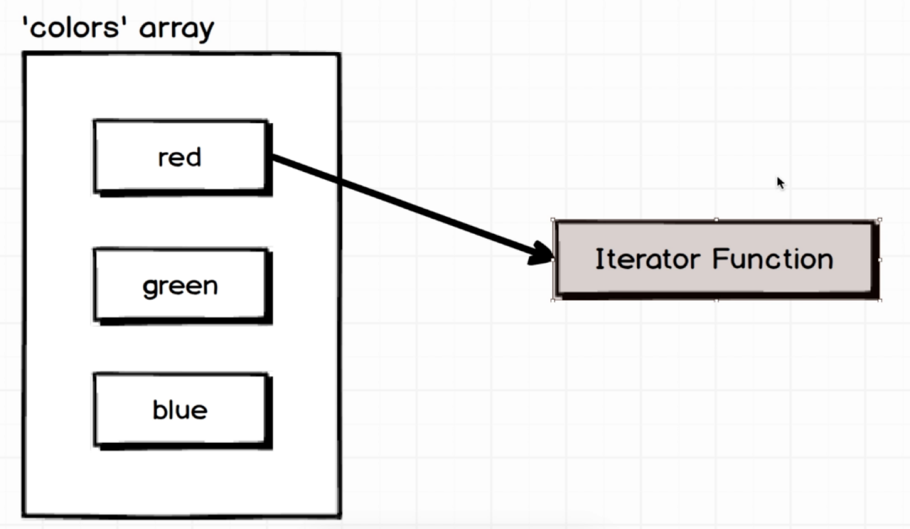](https://github.com/Naresh-Chaurasia/FullStack-Development-1/blob/main/JavaScript/images/forEach-iter.png)

var posts = ['a','b','c'];

//There is iterator involved here.

posts.forEach(function(post){

console.log(post)

});

|  |  |
| --- | --- |
| Note | map. Iternate each element in the list. Perform some operation and create new list. |

[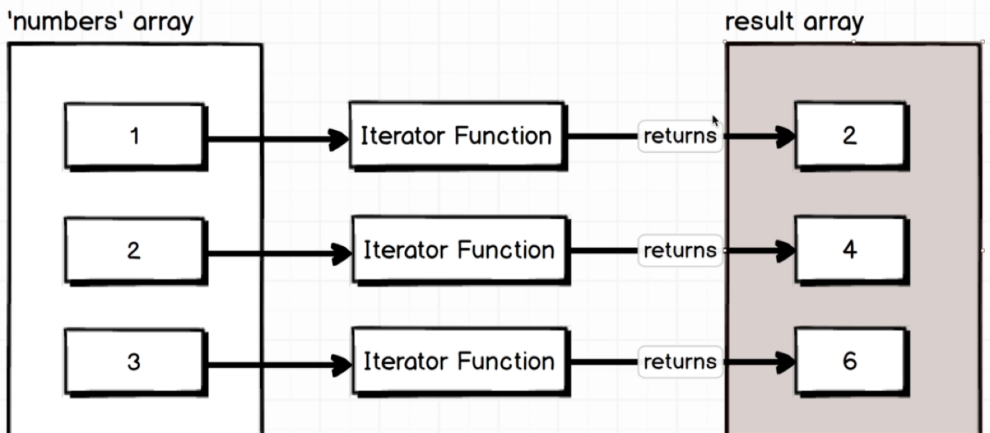](https://github.com/Naresh-Chaurasia/FullStack-Development-1/blob/main/JavaScript/images/map-iter.png)

var numbers = [1,2,3];

// There is an iterator involved here.

// This code uses the map() function in JavaScript to create a new array

var doubled = numbers.map(function(number){

console.log('I came here...');

return number * 2;

}

);

console.log(doubled)

|  |  |
| --- | --- |
| Note | filter. Return ALL that is true. |

[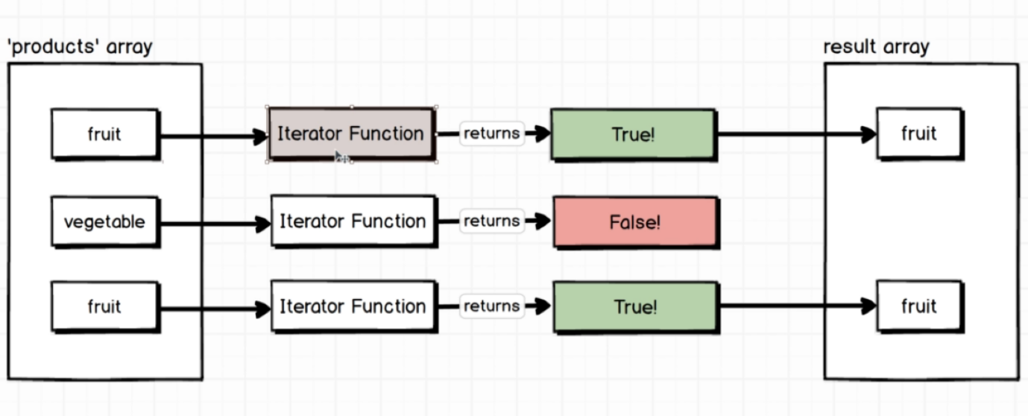](https://github.com/Naresh-Chaurasia/FullStack-Development-1/blob/main/JavaScript/images/filter-iter.png)

var users = [

{ id: 1, admin: true },

{ id: 2, admin: false },

{ id: 3, admin: false },

{ id: 4, admin: false },

{ id: 5, admin: true },

];

var filteredUsers = users.filter(function (user) {

return user.admin;

});

console.log(filteredUsers);

|  |  |
| --- | --- |
| Note | find. Return 1st matching |

[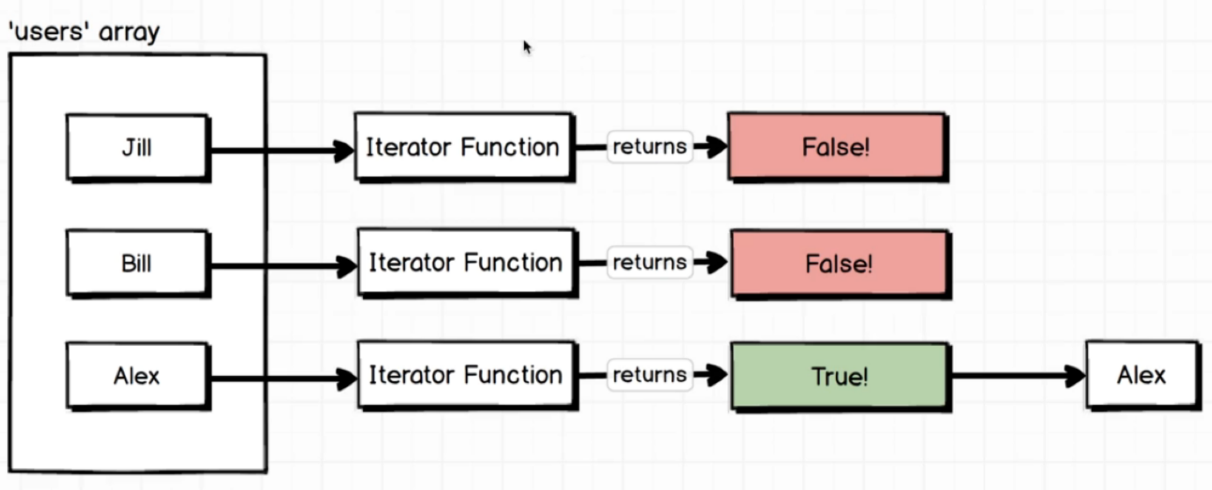](https://github.com/Naresh-Chaurasia/FullStack-Development-1/blob/main/JavaScript/images/find-iter.png)

// Sample array of objects

const users = [

{ id: 1, name: 'Alice' },

{ id: 3, name: 'Charlie' },

{ id: 3, name: 'Bob' },

{ id: 4, name: 'David' }

];

// Using find to get the first user with id equal to 3

const foundUser = users.find(function(user){

return user.id === 3;

});

console.log(foundUser); // Output: { id: 3, name: 'Charlie' }

|  |  |
| --- | --- |
| Note | every / some |

[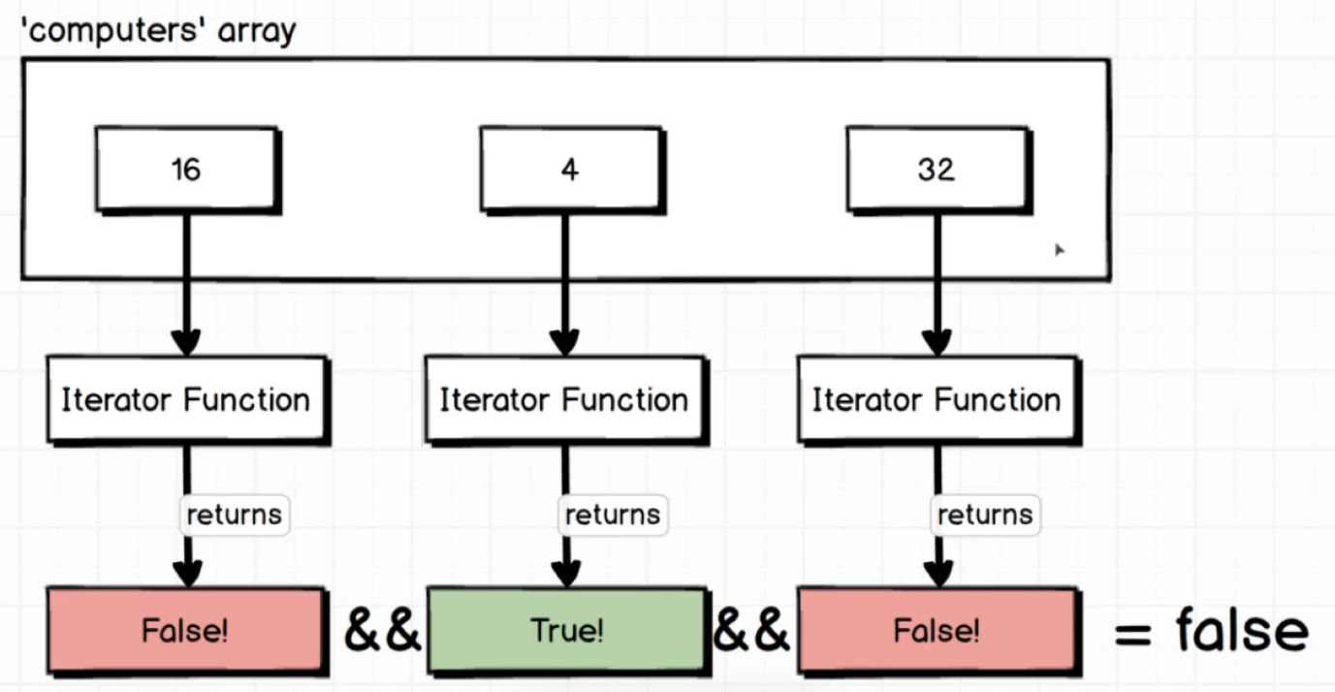](https://github.com/Naresh-Chaurasia/FullStack-Development-1/blob/main/JavaScript/images/every-iter.png)

|  |  |
| --- | --- |
| Note | reduce - so the initial value was that second argument that I passed to reduce. |

[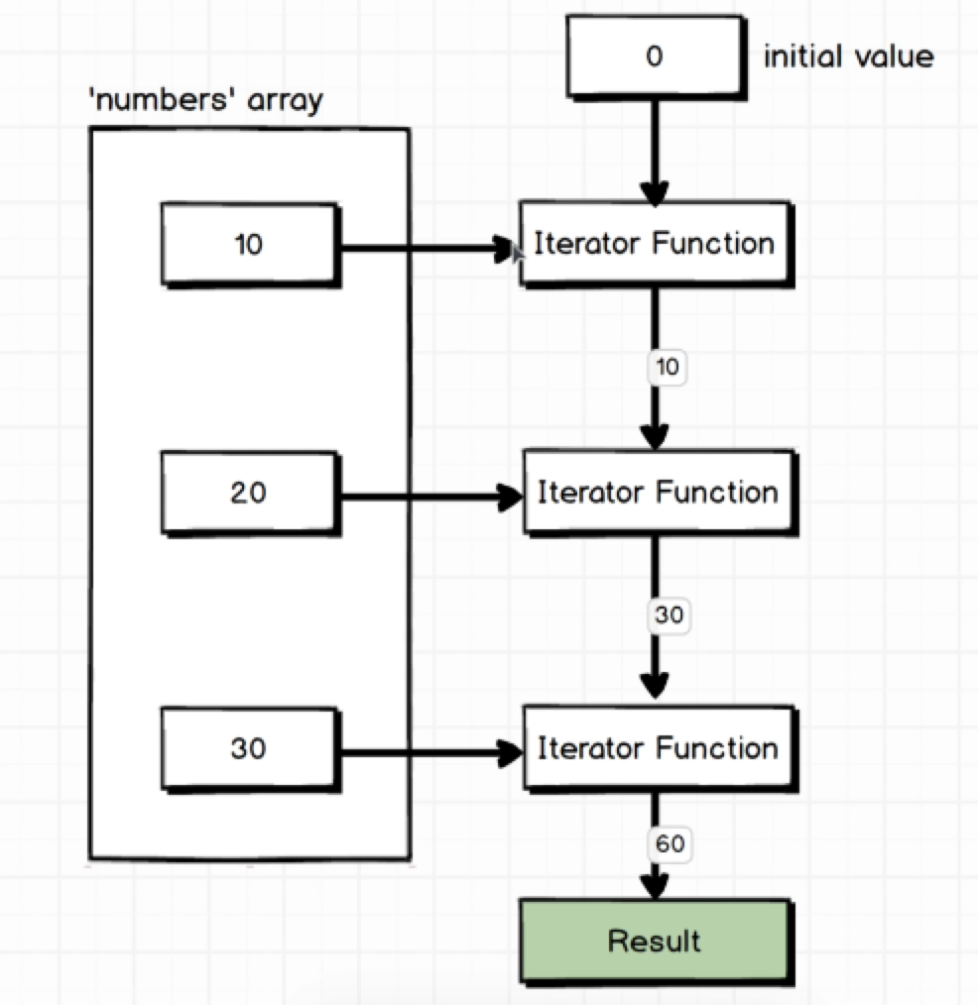](https://github.com/Naresh-Chaurasia/FullStack-Development-1/blob/main/JavaScript/images/reduce.png)

### 44.1. Array Iteraror, Iterator-Functions

In JavaScript, you can iterate over arrays using various methods, including loops and array iterator methods. Array iterator methods provide a more concise and expressive way to iterate over arrays compared to traditional loops like for and while.

Here are some commonly used array iterator methods in JavaScript:

**forEach()**: Executes a provided function once for each array element.

const numbers = [1, 2, 3, 4, 5];

numbers.forEach(number => console.log(number));

**map()**: Creates a new array by calling a provided function on every element in the calling array.

const numbers = [1, 2, 3, 4, 5];

const doubledNumbers = numbers.map(number => number * 2);

**filter()**: Creates a new array with all elements that pass the test implemented by the provided function.

const numbers = [1, 2, 3, 4, 5];

const evenNumbers = numbers.filter(number => number % 2 === 0);

**reduce()**: Executes a reducer function on each element of the array, resulting in a single output value.

|  |  |
| --- | --- |
| Note | After Callback. |

const numbers = [1, 2, 3, 4, 5];

const sum = numbers.reduce((accumulator, currentValue) => accumulator + currentValue, 0);

**find()**: Returns the first element in the array that satisfies the provided testing function.

const numbers = [1, 2, 3, 4, 5];

const foundNumber = numbers.find(number => number > 3);

**forEach()**: Executes a provided function once for each array element.

const numbers = [1, 2, 3, 4, 5];

numbers.forEach(number => console.log(number));

These array iterator methods provide a more functional and declarative way to work with arrays, making your code easier to read and maintain. You can choose the appropriate method based on your specific requirements and the operation you want to perform on the array.

Arrays:

## **JavaScript Array delete()**

### Warning !

Using delete() leaves undefined holes in the array.

Use pop() or shift() instead.

### Example

const fruits = ["Banana", "Orange", "Apple", "Mango"];  
delete fruits[0];

const fruits = ["Banana", "Orange", "Apple", "Mango"];

let size = fruits.length;

console.log(size)

console.log(fruits.at(3))

console.log(fruits.at(5))

console.log(typeof fruits)

console.log(typeof fruits.toString())

console.log(typeof fruits)

console.log(fruits.join(" * "));

fruits.pop();

console.log(fruits);

fruits.push("Kiwi");

console.log(fruits);

let fruit = fruits.shift();

console.log(fruits);

console.log(fruit);

const arr1 = ["Cecilie", "Lone"];

const arr2 = ["Emil", "Tobias", "Linus"];

const arr3 = ["Robin", "Morgan"];

const myChildren = arr1.concat(arr2, arr3);

console.log(myChildren)

let arr=[...fruits]

console.log(arr)

const myArr = [[1,2],[3,4],[5,6]];

const newArr = myArr.flat();

console.log(newArr)

const fruits1 = ["Banana", "Orange", "Apple", "Mango"];

fruits1.splice(2, 0, "Lemon", "Kiwi");

console.log(fruits1)

const citrus = fruits.slice(1, 3);

console.log(fruits)

console.log(typeof fruits)

let position = fruits.indexOf("Apple") + 1;

console.log(position)

let position1 = fruits.lastIndexOf("Apple") + 1;

console.log(position1)

fruits.sort();

console.log(fruits)

console.log(fruits.reverse())

console.log(fruits)

console.log(fruits.reverse())

const sorted = fruits.toSorted();

const reversed = fruits.toReversed();

console.log(fruits)

console.log(sorted)

console.log(reversed)

o/p:

4

first.js:4 Mango

first.js:5 undefined

first.js:6 object

first.js:7 string

first.js:8 object

first.js:9 Banana * Orange * Apple * Mango

first.js:11 (3) ['Banana', 'Orange', 'Apple']

first.js:13 (4) ['Banana', 'Orange', 'Apple', 'Kiwi']

first.js:15 (3) ['Orange', 'Apple', 'Kiwi']

first.js:16 Banana

first.js:21 (7) ['Cecilie', 'Lone', 'Emil', 'Tobias', 'Linus', 'Robin', 'Morgan']

first.js:23 (3) ['Orange', 'Apple', 'Kiwi']

first.js:26 (6) [1, 2, 3, 4, 5, 6]

first.js:29 (6) ['Banana', 'Orange', 'Lemon', 'Kiwi', 'Apple', 'Mango']

first.js:31 (3) ['Orange', 'Apple', 'Kiwi']

first.js:32 object

first.js:34 2

first.js:36 2

first.js:38 (3) ['Apple', 'Kiwi', 'Orange']

first.js:39 (3) ['Orange', 'Kiwi', 'Apple']

first.js:40 (3) ['Orange', 'Kiwi', 'Apple']

first.js:41 (3) ['Apple', 'Kiwi', 'Orange']

first.js:44 (3) ['Apple', 'Kiwi', 'Orange']

first.js:45 (3) ['Apple', 'Kiwi', 'Orange']

first.js:46 (3) ['Orange', 'Kiwi', 'Apple']

An array can be emptied by setting its length to zero: a.length = 0

An array can be emptied by using the splice() method: a.splice(0,a.length)

Pop method removes each element of the array using the pop() method.

while (arr.length > 0) { arr.pop(); }

Spread operator:

The spread operator is used to pass many arguments to the function.

Example: Function sum (a,b,c ) {

console.log( a+b+c );

}

const num = [ 2, 4 ,8, 9 ];

Sum (....num) // 14

let emptytxt = "";

let  Arr = [23, 212, 9, 628, 22314];

function itrtFunction(v) {

    if(v>100){

        console.log(v*2);

    }

}

function itrtFunction1(v) {

        console.log(v*2);

}

Arr.filter(itrtFunction)

Arr.filter(itrtFunction1)

Arr.forEach((v,i)=>{

    if(v>30 && i<3){

        console.log(v);

    }

})

Arr.map((v,i)=>{

    if(v>30 && i<3){

        console.log(v);

    }

})

Arr.map((v,i)=>{

        console.log(v*3);

})

var d=Arr.map((v,i)=>{

   return v*3;

})

console.log(d)

Arr1=[1.1,2.2,3.3,4.4,5.5]

let ans=Arr1.reduce((t,v,i)=>{

    return t+Math.round(v);

},2)

console.log(ans);

let ans1=Arr1.reduce((t,v,i)=>{

    return t+Math.round(v);

})

console.log(ans1)

o/p:

424

first.js:6 1256

first.js:6 44628

first.js:12 46

first.js:12 424

first.js:12 18

first.js:12 1256

first.js:12 44628

first.js:20 212

first.js:26 212

first.js:31 69

first.js:31 636

first.js:31 27

first.js:31 1884

first.js:31 66942

first.js:39 (5) [69, 636, 27, 1884, 66942]

first.js:46 18

first.js:52 16.1

## **JavaScript Callbacks**

A callback is a function passed as an argument to another function.

Using a callback, you could call the calculator function (myCalculator) with a callback (myCallback), and let the calculator function run the callback after the calculation is finished:

### Example

function myDisplayer(some) {  
  document.getElementById("demo").innerHTML = some;  
}  
  
function myCalculator(num1, num2, myCallback) {  
  let sum = num1 + num2;  
  myCallback(sum);  
}  
  
myCalculator(5, 5, myDisplayer);

[Try it Yourself »](https://www.w3schools.com/js/tryit.asp?filename=tryjs_callback4)

In the example above, myDisplayer is a called a **callback function**.

It is passed to myCalculator() as an **argument**.

## **Note**

When you pass a function as an argument, remember not to use parenthesis.

Right: myCalculator(5, 5, myDisplayer);

Wrong: ;

### Example

// Create an Array  
const myNumbers = [4, 1, -20, -7, 5, 9, -6];  
  
// Call removeNeg with a callback  
const posNumbers = removeNeg(myNumbers, (x) => x >= 0);  
  
// Display Result  
document.getElementById("demo").innerHTML = posNumbers;  
  
// Keep only positive numbers  
function removeNeg(numbers, callback) {  
  const myArray = [];  
  for (const x of numbers) {  
    if (callback(x)) {  
      myArray.push(x);  
    }  
  }  
  return myArray;  
}

[Try it Yourself »](https://www.w3schools.com/js/tryit.asp?filename=tryjs_callback10)

In the example above, (x) => x >= 0 is a **callback function**.

It is passed to removeNeg() as an **argument**.

## **When to Use a Callback?**

The examples above are not very exciting.

They are simplified to teach you the callback syntax.

Where callbacks really shine are in asynchronous functions, where one function has to wait for another function (like waiting for a file to load).

## **Asynchronous JavaScript**

The examples used in the previous chapter, was very simplified.

The purpose of the examples was to demonstrate the syntax of callback functions:

### Example

function myDisplayer(something) {  
  document.getElementById("demo").innerHTML = something;  
}  
  
function myCalculator(num1, num2, myCallback) {  
  let sum = num1 + num2;  
  myCallback(sum);  
}  
  
myCalculator(5, 5, myDisplayer);

[Try it Yourself »](https://www.w3schools.com/js/tryit.asp?filename=tryjs_callback4)

In the example above, myDisplayer is the name of a function.

It is passed to myCalculator() as an argument.

In the real world, callbacks are most often used with asynchronous functions.

A typical example is JavaScript setTimeout().

## **Waiting for a Timeout**

When using the JavaScript function setTimeout(), you can specify a callback function to be executed on time-out:

### Example

setTimeout(myFunction, 3000);  
  
function myFunction() {  
  document.getElementById("demo").innerHTML = "I love You !!";  
}

[Try it Yourself »](https://www.w3schools.com/js/tryit.asp?filename=tryjs_callback5)

In the example above, myFunction is used as a callback.

myFunction is passed to setTimeout() as an argument.

3000 is the number of milliseconds before time-out, so myFunction() will be called after 3 seconds.

## **Note**

When you pass a function as an argument, remember not to use parenthesis.

Right: setTimeout(myFunction, 3000);

Wrong: ;

Instead of passing the name of a function as an argument to another function, you can always pass a whole function instead:

### Example

setTimeout(function() { myFunction("I love You !!!"); }, 3000);  
  
function myFunction(value) {  
  document.getElementById("demo").innerHTML = value;  
}

[Try it Yourself »](https://www.w3schools.com/js/tryit.asp?filename=tryjs_callback9)

In the example above, function(){ myFunction("I love You !!!"); } is used as a callback. It is a complete function. The complete function is passed to setTimeout() as an argument.

3000 is the number of milliseconds before time-out, so myFunction() will be called after 3 seconds.

|  |
| --- |
| myReject(error object) |

## **Promise Object Properties**

A JavaScript Promise object can be:

* Pending
* Fulfilled
* Rejected

The Promise object supports two properties: **state** and **result**.

While a Promise object is "pending" (working), the result is undefined.

When a Promise object is "fulfilled", the result is a value.

When a Promise object is "rejected", the result is an error object.

|  |  |
| --- | --- |
| **myPromise.state** | **myPromise.result** |
| "pending" | undefined |
| "fulfilled" | a result value |
| "rejected" | an error object |

You cannot access the Promise properties **state** and **result**.

You must use a Promise method to handle promises.

## **Promise How To**

Here is how to use a Promise:

myPromise.then(  
  function(value) { /* code if successful */ },  
  function(error) { /* code if some error */ }  
);

Promise.then() takes two arguments, a callback for success and another for failure.

Both are optional, so you can add a callback for success or failure only.

### Example

function myDisplayer(some) {  
  document.getElementById("demo").innerHTML = some;  
}  
  
let myPromise = new Promise(function(myResolve, myReject) {  
  let x = 0;  
  
// The producing code (this may take some time)  
  
  if (x == 0) {  
    myResolve("OK");  
  } else {  
    myReject("Error");  
  }  
});  
  
myPromise.then(  
  function(value) {myDisplayer(value);},  
  function(error) {myDisplayer(error);}  
);

[Try it Yourself »](https://www.w3schools.com/js/tryit.asp?filename=tryjs_promise2)

ADVERTISEMENT

## **JavaScript Promise Examples**

To demonstrate the use of promises, we will use the callback examples from the previous chapter:

* Waiting for a Timeout
* Waiting for a File

## **Waiting for a Timeout**

### Example Using Callback

setTimeout(function() { myFunction("I love You !!!"); }, 3000);  
  
function myFunction(value) {  
  document.getElementById("demo").innerHTML = value;  
}

[Try it Yourself »](https://www.w3schools.com/js/tryit.asp?filename=tryjs_callback9)

### Example Using Promise

let myPromise = new Promise(function(myResolve, myReject) {  
  setTimeout(function() { myResolve("I love You !!"); }, 3000);  
});  
  
myPromise.then(function(value) {  
  document.getElementById("demo").innerHTML = value;  
});

# TypeScript

Table of Contents

* [1. Install TypeScript](https://github.com/Naresh-Chaurasia/FullStack-Development-1/blob/main/typescript/TypeScript.adoc#install-typescript)
* [2. Online TypeScript](https://github.com/Naresh-Chaurasia/FullStack-Development-1/blob/main/typescript/TypeScript.adoc#online-typescript)
* [3. Source Code](https://github.com/Naresh-Chaurasia/FullStack-Development-1/blob/main/typescript/TypeScript.adoc#source-code)
* [4. Functions](https://github.com/Naresh-Chaurasia/FullStack-Development-1/blob/main/typescript/TypeScript.adoc#functions)
* [5. Passing Function as Argument](https://github.com/Naresh-Chaurasia/FullStack-Development-1/blob/main/typescript/TypeScript.adoc#passing-function-as-argument)
* [6. Constructor](https://github.com/Naresh-Chaurasia/FullStack-Development-1/blob/main/typescript/TypeScript.adoc#constructor)
* [7. External-Module, External Module](https://github.com/Naresh-Chaurasia/FullStack-Development-1/blob/main/typescript/TypeScript.adoc#external-module-external-module)
* [8. Internal Module, Internal-Module](https://github.com/Naresh-Chaurasia/FullStack-Development-1/blob/main/typescript/TypeScript.adoc#internal-module-internal-module)
* [9. Internal V/s External Module](https://github.com/Naresh-Chaurasia/FullStack-Development-1/blob/main/typescript/TypeScript.adoc#internal-vs-external-module)

### 1. Install TypeScript

npm install -g typescript

tsc -v

### 2. Online TypeScript

* <https://www.typescriptlang.org/>

### 3. Source Code

let myNumber: number = 42;

let myBoolean: boolean = true;

let myArray: number[] = [1, 2, 3, 4, 5]; // Array of numbers

let myArray2: string[] = ["apple", "banana", "orange"]; // Array of strings

let myAny: any = 10; // Any type can hold any kind of value

myAny = "Hello"; // No error, since myAny can be anything

let myArray: number[] = [1, 2, 3, 4, 5];

let myArray: Array<number> = [1, 2, 3, 4, 5];

let myArray: Array<any> = [1, "two", true];

#Enum

// Define an enum named 'Direction'

enum Direction {

Up, // 0

Down, // 1

Left, // 2

Right // 3

}

// Using the enum

let playerDirection: Direction = Direction.Up;

console.log(playerDirection); // Output: 0

// Enums can also be accessed by their values

console.log(Direction[2]); // Output: "Left"

### 4. Functions

function greet(name: string): string {

return `Hello, ${name}!`;

}

const message = greet("Alice");

console.log(message); // Output: Hello, Alice!

//----------------------------------------------

function calculateRectangleArea(width: number, height: number): number {

return width * height;

}

const area = calculateRectangleArea(5, 10);

console.log("Area of rectangle:", area); // Output: Area of rectangle: 50

### 5. Passing Function as Argument

function add(a:number,b:number):number{

return a+b;

}

function calculator(fun:any):void{

console.log("Passing function to Calculator");

console.log(fun(10,20));

}

calculator(add);

### 6. Constructor

class Car {

// Properties

brand: string;

model: string;

year: number;

// Constructor

constructor(brand: string, model: string, year: number) {

this.brand = brand;

this.model = model;

this.year = year;

}

// Method

displayInfo(): void {

console.log(`Brand: ${this.brand}, Model: ${this.model}, Year: ${this.year}`);

}

}

// Create an instance of the Car class

const myCar = new Car("Toyota", "Camry", 2020);

// Access properties and call method

myCar.displayInfo(); // Output: Brand: Toyota, Model: Camry, Year: 2020

### 7. External-Module, External Module

In TypeScript, a module is a way to organize code into reusable units. Modules allow you to encapsulate related code and prevent naming conflicts between different parts of your program. They also enable you to structure your codebase into smaller, manageable pieces, making it easier to maintain and scale your application.

There are different ways to define and work with modules in TypeScript, but one common approach is to use the ES6 module syntax. Here’s an example:

Suppose you have a file named math.ts, and you want to define some mathematical functions in this module:

math.ts

export function add(a: number, b: number): number {

return a + b;

}

export function subtract(a: number, b: number): number {

return a - b;

}

export const PI = 3.14159;

In this module:

* We define two functions, add and subtract, that perform addition and subtraction operations, respectively.
* We also export a constant PI with the value of π.

The export keyword is used to make functions, variables, or classes available outside of the module. In this case, add, subtract, and PI are exported, which means they can be imported and used in other modules.

Now, let’s create another file named app.ts where we want to use the functions and constant defined in the math module:

file.ts

import { add, subtract, PI } from "./math";

console.log("2 + 3 =", add(2, 3)); // Output: 2 + 3 = 5

console.log("5 - 3 =", subtract(5, 3)); // Output: 5 - 3 = 2

console.log("Value of PI is", PI); // Output: Value of PI is 3.14159

In this file:

* We use the import keyword to import specific items (add, subtract, and PI) from the math module.
* We then use these imported items just like any other functions or variables.

When you run app.ts, it will execute and output the results of the mathematical operations and the value of π, utilizing the functions and constant exported from the math module.

This is a basic example of how modules work in TypeScript, allowing you to organize and reuse code across different files in your project.

**37. Promise**

**37.1. State Of The Promise**

[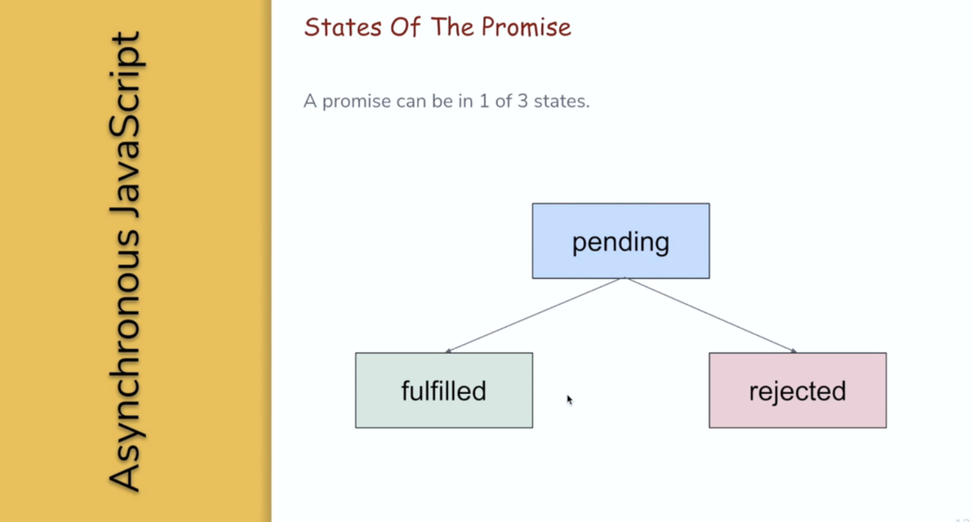](https://github.com/Naresh-Chaurasia/FullStack-Development-1/blob/main/JavaScript/images/promise.png)

* So what is a promise? A promise, is a special JavaScript object that represents an eventual result of an asynchronous action. A promise is kind of a proxy for a value that you don’t have yet.
* Let’s imagine that we have an asynchronous function that reads the contents of an external file. The process of reading from file can take some time. Let’s say 3 seconds. During those 3 seconds, we won’t have any results from that function. So how should we handle this? Actually, we have at least two options in this case. The first option is to pass a callback into the asynchronous function. This callback will be invoked after 3 seconds with the results of the function as an argument. Inside the callback, but we can do everything we want with the result.
* The second option is to return a promise immediately. This promise will represent the result of the function. It will not contain the specific value during those 3 seconds, but at least we will have something that we can use as a substitute of that value. The benefit of this approach is that we can use this value right away. We can already pass this promise as an argument to other functions and assign it to variables.
* A promise object has two internal properties. The first property is the promised status and the second property is the promise value. If everything goes well, the value property will contain the real value of the promise. Also, you need to know that any promise can be in one of three states pending, fulfilled and rejected. Pending status means that the promise is neither fulfilled nor rejected.
* In our example, during those 3 seconds, a promise would be in pending state. While the promise is independent state, the value property will be undefined. Fulfilled state means that the action completed successfully. In our example, if everything goes well during this 3 seconds and we get the contents of the file, then the province will change its state from pending to full field. When the promise changes, the state to fulfilled the value property will contain a real value that we are interested in. Rejected status means that this action has failed for some reason. Rejected promise will contain the reason why it has failed inside of the value property.

**37.2. How To Create Promise**

Chrome Developer Tool - A

const myPromise = new Promise(function(resolve,reject){

});

console.log(myPromise);

Chrome Developer Tool - B

const myP2 = new Promise(function(resolve,reject){

resolve('value');

});

console.log(myP2);

Chrome Developer Tool - C

const myP2 = new Promise(function(resolve,reject){

reject('reject');

});

console.log(myP2);

* There is a special class in JavaScript which is called promise. If you want to create a promise, you simply need to create an instance of this class. The Promise constructor takes only one argument, and that’s a function. This argument is required and you can’t create a promise without it. **This function is called executor function**, and it’s invoked at that very moment when we are creating a promise.
* **This function takes two arguments resolve and reject. Both of them are functions as well**. So here we are creating a variable called My Promise that will contain a promise. Initially, my promise variable is in pending state. In order to transfer this promise from dependent to the fulfilled state, you should invoke resolve function or you can invoke reject function in order to transfer this promise to the rejected state.
* Let’s explore this by example. I’m going to add console.log statements to our code that will print the promise to the browser console. Let’s run our code and see what happens. So it prints promise pending in the browser console. If we expand the output, we can see two internal properties of the promise, promise status and promise value promise. Status is equal to binding and promise. Value is equal to undefined. I would like to mention that promises work both in the browser and inside Node.js. We are using Google Chrome developer tools in this video because here we can see the internal properties of the promise. I mean promise status and promise value. Let’s change our promise and invoke resolve function inside. Resolve function takes one argument, which is the value of the premise. Let’s run this code again. Now you can see that promise status is resolved and parameter value is equal to string value.
* Let’s change our promise one more time and this time invoke, reject, function instead of resolve. Reject function also takes one argument, and this argument represents the reason why the premise was rejected. Let’s run our code. Now we can see that prime status is rejected and prime is value is equal to string. Reason that we specify it here. If you have a rejected promise that you would have an uncaught **error in the browser console**.

**38. Final State of Promise**

* In the previous video I have mentioned that promise can be in one of three states pending, fulfilled or rejected. Two of these states are final. If the promise is in full field or in a rejected state, it can’t change its state again. Only if the promise is in pending state, then this state can be changed, either to fulfilled or to reject it.

Chrome Developer Tool - B

const myP2 = new Promise(function(resolve,reject){

resolve('value1');

resolve('value2');

reject('reject');

});

console.log(myP2);

* Let’s explore this by example. Let’s create a premise that tries to be resolved and rejected multiple times. This promise tries to become resolved two times with different values, and then it tries to become rejected with the reason. If I run this code now, we will see that the status of this promise is resolved and the value is equal to string value, which is taken from the first resolved function. Even though we called resolve function two times and then also called reject function. The promise became fulfilled after the first call to the resolve function, and then it never changed its state again.
* And this illustrates that fulfilled state is the final state of the promise, and it cannot be changed.

Chrome Developer Tool - B

const myP2 = new Promise(function(resolve,reject){

reject('reject');

resolve('value1');

resolve('value2');

});

console.log(myP2);

* But what about the rejected state? Let’s create a premise similar to what we had before, but now it will first get rejected and only then get resolved. So I will put the reject function before this to resolve functions. If I run this code now, we will see that the status of the promise is rejected. And the value of this promise is a strong reason. Even though we called a resolve function two times after we called reject function, the promise became rejected after the first call to the reject function, and then it never changed its date and value again.
* This illustrates that a rejected state is also the final state of the promise, and it cannot be changed again. Basically the only state of the promise that can be changed later is so called pending State. pending State is not the final state, and it can be changed either to fulfilled or rejected.

**39. How to Consume JavaScript Promises: Promise.then**

[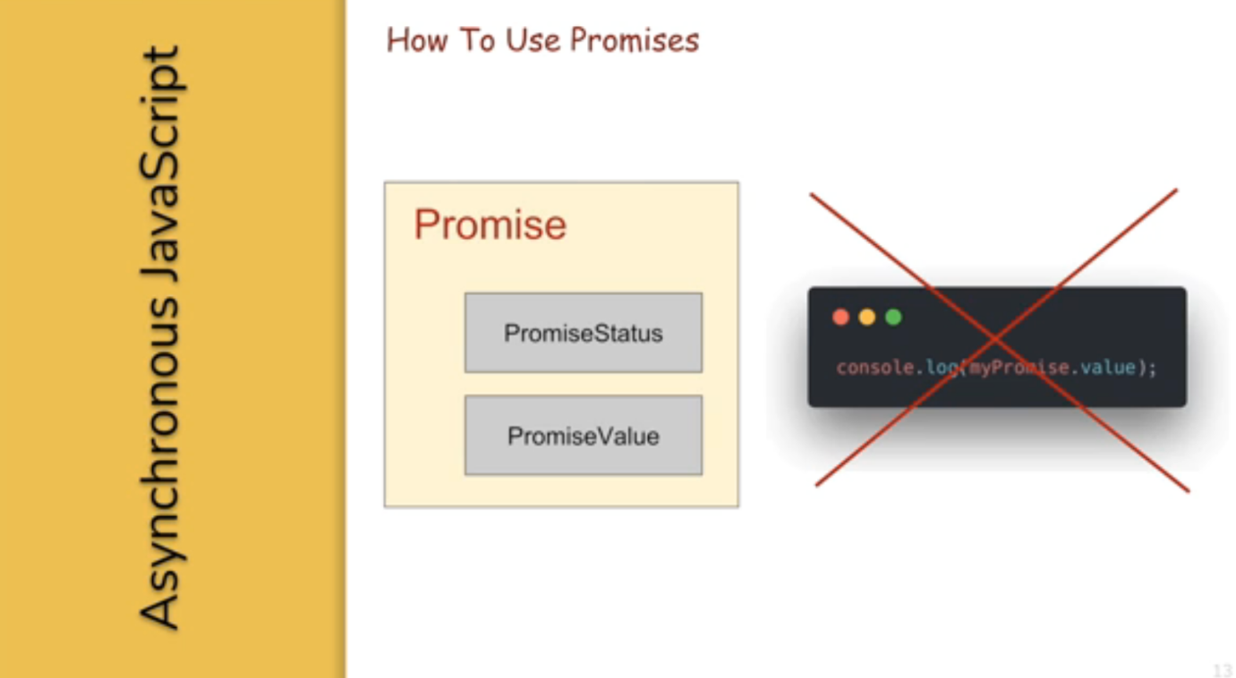](https://github.com/Naresh-Chaurasia/FullStack-Development-1/blob/main/JavaScript/images/promise2.png)

* Let’s take as an example, a simple premise that resolves with a string. Hello world. As soon as this problem becomes resolved, we would like to print Hello world to the browser console. But how can we do it? Promise, status and promise. Value properties that we have seen in the browser are internal properties of the promise. We cannot simply print the value of the promise to the browser console like shown here. These properties are not exposed to the outside world, so we can’t use them directly. Instead, promise object has a couple of methods that can be used in order to access Promise value and Promise status. One of these very useful methods is called Then.
* Then method takes to arguments onFullfilled and onRejected. Both of these arguments should be functions on full field function will be invoked when premise is fulfilled. It has only one argument the fulfillment value. And on the rejected function will be invoked if the premise is rejected. It also has only one argument the reason of rejection.
* If you’re interested only in successful cases, you can provide only the first function which would be onFulfilled. Let’s say you want to take the fulfillment value of our promise, which is Hello world and print it to the browser console. In order to do this, we are going to use then method of the promise object and provide only on full field function to it. You see here we are invoking then method on a promise and we are passing one function to it which is on full field function. This function takes only one argument and this is the value of the promise. Now inside of this function, we can do anything we want.

const myP2 = new Promise(function(resolve,reject){

resolve('value');

});

console.log(myP2);

myP2.then(function(value){

console.log(value);

});

* Is this value? If we apply this code to our promise and run this in the browser, we will see. Hello World string in the browser console. So I will write here the same code that we’ve just seen and run it here in the browser console. Here we are providing only unfulfilled function. We are going to have a look at an example which requires both functions in the next videos. By means of providing on full field and on rejected functions. We are kind of subscribing to the results of the promise. **These functions will be invoked asynchronously after the premise becomes either fulfilled or rejected. They are being added to the message queue and will be executed only after the call stack becomes empty**.

const myP2 = new Promise(function(resolve,reject){

resolve('value');

});

console.log(myP2);

myP2.then(function(value){

console.log(value);

});

console.log('This is console log');

Let’s have a look at this in action. I will use our Hello World promise and add to console dot log statements to. The first console.log I will put inside on full field function. All right here. And I will write here. This is inside on full field function. And the second console.log statement I will put at the end of our code. After we invoked then method. Right here. And I will write here. This is written after my prime to then. So let’s see what happens if I run this code. As you can see, first gets printed. The message this is written after my promise Dot. Then and only after this message, you can see another message saying this is inside on fulfilled function. In other words, all then handlers, be it on full field or on rejected, will be invoked only after all other code in the code stack gets executed. So in this video, we have learned how we can use the value of the premise by utilizing then method.

GIT:

## **What is Git?**

Git is a popular version control system. It was created by Linus Torvalds in 2005, and has been maintained by Junio Hamano since then.

It is used for:

* Tracking code changes
* Tracking who made changes
* Coding collaboration

### What does Git do?

* Manage projects with **Repositories**
* **Clone** a project to work on a local copy
* Control and track changes with **Staging** and **Committing**
* **Branch** and **Merge** to allow for work on different parts and versions of a project
* **Pull** the latest version of the project to a local copy
* **Push** local updates to the main project

### Working with Git

* Initialize Git on a folder, making it a **Repository**
* Git now creates a hidden folder to keep track of changes in that folder
* When a file is changed, added or deleted, it is considered **modified**
* You select the modified files you want to **Stage**
* The **Staged** files are **Committed**, which prompts Git to store a **permanent** snapshot of the files
* Git allows you to see the full history of every commit.
* You can revert back to any previous commit.
* Git does not store a separate copy of every file in every commit, but keeps track of changes made in each commit!

git --version

git version 2.30.2.windows.1

If Git is installed, it should show something like git version X.Y

## **Configure Git**

Now let Git know who you are. This is important for version control systems, as each Git commit uses this information:

### Example

git config --global user.name "w3schools-test"

git config --global user.email "test@w3schools.com"

Change the user name and e-mail address to your own. You will probably also want to use this when registering to GitHub later on.

**Note:** Use global to set the username and e-mail for **every repository** on your computer.

If you want to set the username/e-mail for just the current repo, you can remove global

## **Creating Git Folder**

Now, let's create a new folder for our project:

### Example

mkdir myproject

cd myproject

mkdir **make**s a **new directory**.

cd **changes** the **current working directory**.

## **Initialize Git**

Once you have navigated to the correct folder, you can initialize Git on that folder:

### Example

git init

git add –all

**Note:** The shorthand command for git add --all is git add -A

## **Git Commit**

Since we have finished our work, we are ready move from stage to commit for our repo.

git commit -m "First release of Hello World!"

git help –all

Git main commands:

git init

git add README.md

git commit -m "first commit"

git branch

git remote add origin https://github.com/superheropuliyaswanth/ram.git

git push -u origin main

git checkout -b feature/f2

git pull origin master

Angular:

Angular is js framework or typescript framework which allows us to create reactive single page Applications.

Reactive application are designed to be highly responsive,very difficult,adaptable

Advantange:

Dependency injection

Two way binding

Model view controller-there is one controller file where we we will write business logic

View file:

Front end code

Two way binding is connection between controller file and view file

Commands:

npm install -g @angular/cli

ng new my first-app --no-strict --no-standalone

cd my-first-app

PS C:\Users\HP\OneDrive\Desktop\my_first_angular\my-first-app> ng serve

ng : File C:\Users\HP\AppData\Roaming\npm\ng.ps1 cannot be loaded

because running scripts is disabled on this system. For more

information, see about_Execution_Policies at

https:/go.microsoft.com/fwlink/?LinkID=135170.

At line:1 char:1

+ ng serve

+ ~~

+ CategoryInfo : SecurityError: (:) [], PSSecurityExcep

tion

+ FullyQualifiedErrorId : UnauthorizedAccess

PS C:\Users\HP\OneDrive\Desktop\my_first_angular\my-first-app> ng serve

ng : File C:\Users\HP\AppData\Roaming\npm\ng.ps1 cannot be loaded because running scripts is disabled on this system. For more information, see about_Execution_Policies at

https:/go.microsoft.com/fwlink/?LinkID=135170.

At line:1 char:1

+ ng serve

+ ~~

+ CategoryInfo : SecurityError: (:) [], PSSecurityException

+ FullyQualifiedErrorId : UnauthorizedAccess

PS C:\Users\HP\OneDrive\Desktop\my_first_angular\my-first-app> ng serve

ng : File C:\Users\HP\AppData\Roaming\npm\ng.ps1 cannot be loaded because running scripts is disabled on

this system. For more information, see about_Execution_Policies at

https:/go.microsoft.com/fwlink/?LinkID=135170.

At line:1 char:1

+ ng serve

+ ~~

+ CategoryInfo : SecurityError: (:) [], PSSecurityException

+ FullyQualifiedErrorId : UnauthorizedAccess

PS C:\Users\HP\OneDrive\Desktop\my_first_angular\my-first-app> ng serve;

ng : File C:\Users\HP\AppData\Roaming\npm\ng.ps1 cannot be loaded because running scripts is disabled on

this system. For more information, see about_Execution_Policies at

https:/go.microsoft.com/fwlink/?LinkID=135170.

At line:1 char:1

+ ng serve;

+ ~~

+ CategoryInfo : SecurityError: (:) [], PSSecurityException

+ FullyQualifiedErrorId : UnauthorizedAccess

PS C:\Users\HP\OneDrive\Desktop\my_first_angular\my-first-app> ng --version

ng : File C:\Users\HP\AppData\Roaming\npm\ng.ps1 cannot be loaded because running scripts is disabled on

this system. For more information, see about_Execution_Policies at

https:/go.microsoft.com/fwlink/?LinkID=135170.

At line:1 char:1

+ ng --version

+ ~~

+ CategoryInfo : SecurityError: (:) [], PSSecurityException

+ FullyQualifiedErrorId : UnauthorizedAccess

PS C:\Users\HP\OneDrive\Desktop\my_first_angular\my-first-app> set-ExecutionPolicy RemoteSigned -Scope CurrentUser

PS C:\Users\HP\OneDrive\Desktop\my_first_angular\my-first-app> Get-ExecutionPolicy

RemoteSigned

PS C:\Users\HP\OneDrive\Desktop\my_first_angular\my-first-app> Get-ExecutionPolicy -list

Scope ExecutionPolicy

----- ---------------

MachinePolicy Undefined

UserPolicy Undefined

Process Undefined

CurrentUser RemoteSigned

LocalMachine Undefined

PS C:\Users\HP\OneDrive\Desktop\my_first_angular\my-first-app> ng --version

Error: You need to specify a command before moving on. Use '--help' to view the available commands.

PS C:\Users\HP\OneDrive\Desktop\my_first_angular\my-first-app> set-ExecutionPolicy RemoteSigned -Scope CurrentUser

PS C:\Users\HP\OneDrive\Desktop\my_first_angular\my-first-app> Get-ExecutionPolicy

RemoteSigned

PS C:\Users\HP\OneDrive\Desktop\my_first_angular\my-first-app> Get-ExecutionPolicy -list

Scope ExecutionPolicy

----- ---------------

MachinePolicy Undefined

UserPolicy Undefined

Process Undefined

CurrentUser RemoteSigned

LocalMachine Undefined

PS C:\Users\HP\OneDrive\Desktop\my_first_angular\my-first-app> ng serve

Initial chunk files | Names | Raw size

polyfills.js | polyfills | 86.03 kB |

main.js | main | 2.29 kB |

styles.css | styles | 95 bytes |

| Initial total | 88.41 kB

Application bundle generation complete. [2.347 seconds]

Watch mode enabled. Watching for file changes...

➜ Local: http://localhost:4200/

➜ press h + enter to show help

h

Shortcuts

press r + enter to force reload browser

press u + enter to show server url

press o + enter to open in browser

press c + enter to clear console

press q + enter to quit

o

🡪

ng generate component servers

we can create our own component. Every component is associated with the html and css. We can use this component anywhere we needed.

We need to use below command to generate component:

ng generate component servers

selector: 'app-servers',

->tag

selector: '[app-servers]',

->div element

<div app-servers></div>

selector: '.app-servers',

<div class=”app-servers”></div>

To use ngModel we need to impoert import { FormsModule } from '@angular/forms';

Keep forms module in import

